UNITED STATES
SECURITIES AND EXCHANGE COMMISSION
WASHINGTON, D.C. 20549

FORM 10-K/A
(Amendment No. 1)

(Mark One)
☒ | ANNUAL REPORT PURSUANT TO SECTION 13 OR 15(d) OF THE SECURITIES EXCHANGE ACT OF 1934
FOR THE FISCAL YEAR ENDED SEPTEMBER 30, 2020
OR
☐ | TRANSITION REPORT PURSUANT TO SECTION 13 OR 15(d) OF THE SECURITIES EXCHANGE ACT OF 1934
FOR THE TRANSITION PERIOD FROM TO
COMMISSION FILE NUMBER: 814-00736

PENNANTPARK INVESTMENT CORPORATION
(Exact name of registrant as specified in its charter)

MARYLAND |  | 20-8250744
(State or other jurisdiction of incorporation or organization) |  | (I.R.S. Employer Identification No.)
590 Madison Avenue, 15th Floor  New York, N.Y. |  | 10022
(Address of principal executive offices) |  | (Zip Code)
(212) 905-1000
(Registrant’s Telephone Number, Including Area Code)

Securities registered pursuant to Section 12(b) of the Act:

Title of Each Class | Trading Symbol(s) | Name of Each Exchange on Which Registered
Common Stock, par value $0.001 per share | PNNT | The Nasdaq Stock Market LLC
5.50% Notes due 2024 | PNNTG | The Nasdaq Stock Market LLC

Securities registered pursuant to Section 12(g) of the Act: None
Indicate by check mark if the registrant is a well-known seasoned issuer, as defined in Rule 405 of the Securities Act. Yes ☐ No ☒.
Indicate by check mark if the registrant is not required to file reports pursuant to Section 13 or Section 15(d) of the Act. Yes ☐ No ☒.
Indicate by check mark whether the registrant (1) has filed all reports required to be filed by Section 13 or 15(d) of the Securities Exchange Act of 1934 during the preceding 12 months (or for such shorter period that the registrant was required to file such reports), and (2) has been subject to such filing requirements for the past 90 days. Yes ☒ No ☐.
Indicate by check mark whether the registrant has submitted electronically every Interactive Data File required to be submitted pursuant to Rule 405 of Regulation S-T (§232.405 of this chapter) during the preceding 12 months (or for such shorter period that the registrant was required to submit such files). Yes ☐ No ☐
Indicate by check mark whether the registrant is a large accelerated filer, an accelerated filer, a non-accelerated filer, smaller reporting company, or an emerging growth company. See the definitions of “large accelerated filer,” “accelerated filer,” “smaller reporting company” and “emerging growth company” in Rule 12b-2 of the Exchange Act.

Large accelerated filer |  | ☐ |  | Accelerated filer |  | ☒
Non-accelerated filer |  | ☐ |  | Smaller reporting company |  | ☐
Emerging growth company |  | ☐

If an emerging growth company, indicate by check mark if the registrant has elected not to use the extended transition period for complying with any new or revised financial accounting standards provided pursuant to Section 13(a) of the Exchange Act. ☐

Indicate by check mark whether the registrant has filed a report on and attestation to its management’s assessment of the effectiveness of its internal control over financial reporting under Section 404(b) of the Sarbanes-Oxley Act (15 U.S.C. 7262(b)) by the registered public accounting firm that prepared or issued its audit report. ☒
Indicate by check mark whether the registrant is a shell company (as defined in Rule 12b-2 of the Exchange Act). Yes ☐ No ☒.
The aggregate market value of common stock held by non-affiliates of the Registrant on March 31, 2020 based on the closing price on that date of $2.59 on The Nasdaq Global Select Market was approximately $169 million. For the purposes of calculating the aggregate market value of common stock held by non-affiliates, all directors and executive officers of the Registrant have been treated as affiliates. There were 67,045,105 shares of the Registrant’s common stock outstanding as of March 26, 2021.

Documents Incorporated by Reference: Portions of the Registrant’s Proxy Statement relating to its 2021 Annual Meeting of Stockholders, filed pursuant to Regulation 14A with the Securities and Exchange Commission on December 8, 2020, are incorporated by reference into Part III of this Annual Report on Form 10-K.

EXPLANATORY NOTE
PennantPark Investment Corporation, a Maryland corporation, or together with its subsidiaries, where applicable, or the Company, which may also be referred to as “we,” “us” or “our,” is filing this Amendment No. 1, or the Amendment, to our Annual Report on Form 10-K for the fiscal year ended September 30, 2020, or the Form 10-K, which was initially filed with the Securities and Exchange Commission, or the SEC, on November 19, 2020.
We are filing this Amendment to provide stand-alone audited financial statements for our investment in an unconsolidated controlled portfolio company, PT Networks Intermediate Holdings, LLC, or PT Networks, as of and for the years ended December 31, 2020 and 2019 (as Exhibit 99.6) as well as stand-alone unaudited financial statements for PT Networks as of and for the year ended December 31, 2018 (as Exhibit 99.7).
We have determined that this unconsolidated controlled portfolio company has met the conditions of a significant subsidiary under Rule 1-02(w) of Regulation S-X for which we are required, pursuant to Rule 3-09 of Regulation S-X, to provide separate audited financial statements as exhibits to the Form 10-K. In accordance with Rule 3-09(b)(1), the separate audited financial statements of PT Networks are being filed as an amendment to the Form 10-K, within 90 days after the end of PT Networks’ fiscal year.
This Amendment also includes the filing of new Exhibits 31.1, 31.2, 32.1 and 32.2, certifications of our Chief Executive Officer and Chief Financial Officer, pursuant to Rule 13a-14(a) and (b) of the Securities Exchange Act of 1934, as amended.
Except as described above, no other changes have been made to the Form 10-K. This Amendment does not reflect subsequent events that may have occurred after the original filing date of the Form 10-K or modify or update in any way disclosures made in the Form 10-K, except as required to reflect the revisions discussed above. Among other things, forward-looking statements made in the Form 10-K have not been revised to reflect events that occurred or facts that became known to us after filing of the Form 10-K, and such forward-looking statements should be read in their historical context. Furthermore, this Amendment should be read in conjunction with the Form 10-K and with our subsequent filings with the SEC.

PART IV
Item 15.Exhibits and Financial Statement Schedules
The following documents are filed or incorporated by reference as part of this Annual Report:
The following documents are filed as part of this Annual Report:
 | (1) | Financial Statements—Refer to Item 8 starting on page 54 of the Registrant’s Annual Report on Form 10-K filed on November 19, 2020.
 | (2) | Financial Statement Schedules—None.
 | (3) | Exhibits
The following exhibits are filed as part of this report or hereby incorporated by reference to exhibits previously filed with the SEC:

3.1 |  | Articles of Incorporation (Incorporated by reference to Exhibit 99(a) to the Registrant’s Pre-Effective Amendment No. 3 to the Registration Statement on Form N-2/A (File No. 333-140092), filed on April 5, 2007).
3.2 |  | Second Amended and Restated Bylaws of the Registrant (Incorporated by reference to Exhibit 3.2 to the Registrant’s Quarterly Report on Form 10-Q (File No. 814-00736), filed on May 11, 2020).
4.1 |  | Form of Share Certificate (Incorporated by reference to Exhibit 99(d)(1) to the Registrant’s Registration Statement on Form N-2 (File No. 333-150033), filed on April 2, 2008).
4.2 |  | Base Indenture, dated as of January 22, 2013, relating to the 6.25% Senior Notes due 2025, between the Registrant and American Stock Transfer & Trust Company, LLC, as trustee (Incorporated by reference to Exhibit 99(d)(8) to the Registrant’s Post-Effective Amendment No.4 to the Registration Statement on Form N-2/A (File No.333-172524), filed on January 22, 2013).
4.3 |  | Second Supplemental Indenture, dated as of September 23, 2014, relating to the 4.50% Notes due 2019, between the Registrant and American Stock Transfer & Trust Company, LLC, as trustee (Incorporated by reference to Exhibit 99 (d)(11) to the Registrant’s Post-Effective Amendment No. 2 to Form N-2 (File No. 333-192782), filed on September 23, 2014.
4.4 |  | Form of 4.50% Notes due 2019 (included as part of Exhibit 4.3).
4.5 |  | Third Supplemental Indenture, dated as of September 27, 2019, by and between the Company and American Stock Transfer & Trust Company, LLC, as trustee (Incorporated by reference to Exhibit 4.1 to the Registrant’s Form 8-K (File No. 814-00736), filed September 27, 2019).
4.6 |  | Form of 5.50% Notes due 2024 (included as part of Exhibit 4.5).
4.7 |  | Description of Securities (Incorporated by reference to Exhibit 4.7 to the Registrant’s Form 10-K (File No. 814-00736), filed November 21, 2019).
10.1 |  | Form of Administration Agreement between the Registrant and PennantPark Investment Administration LLC (Incorporated by reference to Exhibit 99(k)(1) to the Registrant’s Registration Statement on Form N-2 (File No. 333-150033), filed on April 2, 2008).
10.2 |  | Dividend Reinvestment Plan (Incorporated by reference to Exhibit 99(e) to the Registrant’s Registration Statement on Form N-2 (File No. 333-150033), filed on April 2, 2008).
10.3 |  | First Omnibus Amendment to Second Amended and Restated Senior Secured Revolving Credit Agreement and Second Amended and Restated Guarantee and Security Agreement, dated as of May 25, 2017, among the Registrant, the lenders party thereto and SunTrust Bank, as administrative agent for the lenders (Incorporated by reference to Exhibit 10.1 to the Registrant’s Quarterly Report on Form 10-Q (File No. 814-00736), filed on August 7, 2017).
10.4 |  | Indemnification Agreement, dated as of November 15, 2016, between PennantPark Investment Corporation and each of the directors and officers listed on Schedule A attached thereto (Incorporated by reference to Exhibit 10.5 to the Registrant’s Annual Report on Form 10-K (File No. 814-00736) filed on November 21, 2016).

10.5 |  | Revolving Credit and Security Agreement by and among PennantPark Investment Funding I, LLC, as borrower, the lenders from time to time parties thereto, BNP Paribas, as administrative agent, PennantPark Investment Corporation, as equityholder, PennantPark Investment Advisers, LLC, as servicer, and The Bank of New York Mellon Trust Company, National Association, as collateral agent, dated as of February 22, 2019 (Incorporated by reference to Exhibit 10.1 to the Registrant’s Current Report on Form 8-K (File No. 814-00736), filed on February 26, 2019).
10.6 |  | Account Control Agreement by and among PennantPark Investment Funding I, LLC, as pledgor, The Bank of New York Mellon Trust Company, National Association, as secured party, PennantPark Investment Advisers, LLC, as servicer, and The Bank of New York Mellon Trust Company, National Association, as securities intermediary, dated as of February 22, 2019 (Incorporated by reference to Exhibit 10.2 to the Registrant’s Current Report on Form 8-K (File No. 814-00736), filed on February 26, 2019).
10.7 |  | Custodian Agreement by and among PennantPark Investment Funding I, LLC, The Bank of New York Mellon Trust Company, National Association, as custodian, and The Bank of New York Mellon Trust Company, National Association, as collateral agent, dated as of February 22, 2019 (Incorporated by reference to Exhibit 10.3 to the Registrant’s Current Report on Form 8-K (File No. 814-00736), filed on February 26, 2019).
10.8 |  | Purchase and Sale Agreement by and between PennantPark Investment Funding I, LLC, as the purchaser, and PennantPark Investment Corporation, as the seller, dated as of February 22, 2019 (Incorporated by reference to Exhibit 10.4 to the Registrant’s Current Report on Form 8-K (File No. 814-00736), filed on February 26, 2019).
10.9 |  | Third Amended and Restated Investment Advisory Management Agreement, dated as of April 12, 2019, between the Registrant and PennantPark Investment Advisers, LLC (Incorporated by reference to Exhibit (g)(3) to the Registrant’s Pre-Effective Amendment No. 1 to the Registration Statement on Form N-2 (File No. 333-230014), filed on April 12, 2019).
10.10 |  | Second Amendment to Second Amended and Restated Senior Secured Revolving Credit Agreement, dated as of September 4, 2019, by and among PennantPark Investment Corporation, as borrower, the lenders party thereto, SunTrust Bank, as administrative agent and collateral agent, and solely with respect to Section 4.9, PNNT CI (GALLS) Prime Investment Holdings, LLC, PNNT Investment Holdings, LLC, PNNT New Gulf Resources, LLC, PNNT ecoserve, LLC and PNNT Cascade Environmental Holdings, LLC (Incorporated by reference to Exhibit 10.1 to the Registrant’s Form 8-K (File No.  814-00736), filed on September 4, 2019).
10.11 |  | Amended and Restated Limited Liability Company Agreement of PennantPark Senior Loan Fund, LLC, dated as of July 31, 2020, by and among PennantPark Investment Corporation, Pantheon Private Debt Program SCSp SICAV – RAIF In Respect Of Its Compartment Pantheon Senior Debt Secondaries II (USD) and Solutio Premium Private Debt I SCSp (Incorporated by reference to Exhibit 10.1 to the Registrant’s Form 8-K (File No. 814-00736), filed on August 4, 2020).
10.12 |  | First Amendment to the Amended and Restated Limited Liability Company Agreement of PennantPark Senior Loan Fund, LLC, dated as of October 31, 2020, by and among PennantPark Investment Corporation, Pantheon Private Debt Program SCSp SICAV – RAIF In Respect Of Its Compartment Pantheon Senior Debt Secondaries II (USD), Pantheon Private Debt Program SCSp SICAV-RAIF In Respect Of Its Compartment Pantheon Credit Opportunities II (USD), Pantheon Private Debt Program SCSp SICAV-RAIF In Respect Of Its Compartment Tubera Credit 2020 and Solutio Premium Private Debt I SCSp. (Incorporated by reference to Exhibit 10.12 to the Registrant’s Form 10-K (File No. 814-00736), filed November 19, 2020).
10.13 |  | First Omnibus Amendment, dated as of July 31, 2020, by and among PennantPark Investment Funding I, LLC, as borrower, PennantPark Senior Loan Fund, LLC, as equityholder of the borrower, PennantPark Investment Corporation, PennantPark Investment Advisers, LLC, as servicer, and The Bank of New York Mellon Trust Company, National Association, as collateral agent, Sterling National Bank, as lender and BNP Paribas, as administrative agent and as lender (Incorporated by reference to Exhibit 10.2 to the Registrant’s Form 8-K (File No. 814-00736), filed on August 4, 2020).
14.1 |  | Joint Code of Ethics of the Registrant (Incorporated by reference to Exhibit 14.1 to the Registrant’s Form 10-K (File No. 814-00736), filed November 19, 2020).
21.1 |  | Subsidiaries of the Registrant (Incorporated by reference to Exhibit 21.1 to the Registrant’s Form 10-K (File No. 814-00736), filed November 19, 2020).
23.1 |  | Consent of RSM US LLP (Incorporated by reference to Exhibit 23.1 to the Registrant’s Form 10-K (File No. 814-00736), filed November 19, 2020).
23.2 |  | Consent of BDO USA, LLP (Incorporated by reference to Exhibit 23.2 to the Registrant’s Form 10-K (File No. 814-00736), filed November 19, 2020).

31.1* |  | Certification of Chief Executive Officer pursuant to Rule 13a-14 of the Securities Exchange Act of 1934, as amended.
31.2* |  | Certification of Chief Financial Officer pursuant to Rule 13a-14 of the Securities Exchange Act of 1934, as amended.
32.1* |  | Certification of Chief Executive Officer pursuant to section 906 of the Sarbanes-Oxley Act of 2002.
32.2* |  | Certification of Chief Financial Officer pursuant to section 906 of the Sarbanes-Oxley Act of 2002.
99.1 |  | Privacy Policy of the Registrant (Incorporated by reference to Exhibit 99.1 to the Registrant’s Annual Report on Form 10-K (File No. 814-00736), filed on November 16, 2011).
99.2 |  | Audited Consolidated Financial Statements of RAM Energy Holdings LLC and Subsidiaries for the Year Ended September 30, 2020 (Incorporated by reference to Exhibit 99.2 to the Registrant’s Form 10-K (File No. 814-00736), filed November 19, 2020).
99.3 |  | Audited Consolidated Financial Statements of RAM Energy Holdings LLC and Subsidiaries for the Year Ended September 30, 2019 (Incorporated by reference to Exhibit 99.3 to the Registrant’s Form 10-K (File No. 814-00736), filed November 19, 2020).
99.4 |  | Unaudited Consolidated Financial Statements of RAM Energy Holdings LLC and Subsidiaries for the Year Ended September 30, 2018 (Incorporated by reference to Exhibit 99.4 to the Registrant’s Form 10-K (File No. 814-00736), filed November 19, 2020).
99.5 |  | Report of RSM US LLP on Senior Securities Table (Incorporated by reference to Exhibit 99.5 to the Registrant’s Form 10-K (File No. 814-00736), filed November 19, 2020).
99.6* |  | Audited Consolidated Financial Reports of PT Networks Intermediate Holdings, LLC for the Years Ended December 31, 2020 and 2019.
99.7* |  | Unaudited Consolidated Financial Report of PT Networks Intermediate Holdings, LLC for the Year Ended December 31, 2018.
99.8* |  | Consent of Dixon Hughes Goodman LLP.

* | Filed herewith

SIGNATURES
Pursuant to the requirements of Section 13 or 15(d) of the Securities Exchange Act of 1934, the registrant has duly caused this report to be signed on its behalf by the undersigned, thereunto duly authorized.

By: | /s/ ARTHUR H. PENN
Name: | Arthur H. Penn
Title: | Chief Executive Officer and
 | Chairman of the Board of Directors

Pursuant to the requirements of the Securities Exchange Act of 1934, this report has been signed below by the following persons on behalf of the registrant and in the capacities and on the dates indicated.

Signature |  | Title |  | Date
/s/ ARTHUR H. PENN |  | Chief Executive Officer and Chairman of the Board of Directors |  | March 26, 2021
Arthur H. Penn |  | (Principal Executive Officer)
/s/ AVIV EFRAT |  | Chief Financial Officer and Treasurer |  | March 26, 2021
Aviv Efrat |  | (Principal Financial Officer and Accounting Officer)
/s/ ADAM K. BERNSTEIN |  | Chairman |  | March 26, 2021
Adam K. Bernstein
/s/ JEFFREY FLUG |  | Director |  | March 26, 2021
Jeffrey Flug
/s/ MARSHALL BROZOST |  | Director |  | March 26, 2021
Marshall Brozost
/s/ SAMUEL L. KATZ |  | Director |  | March 26, 2021
Samuel L. Katz

EXHIBIT 31.1
CERTIFICATION PURSUANT TO SECTION 302
CHIEF EXECUTIVE OFFICER CERTIFICATION
I, Arthur H. Penn, Chief Executive Officer and Chairman of the Board of Directors of PennantPark Investment Corporation, certify that:
1. I have reviewed this Annual Report on Form 10-K/A of PennantPark Investment Corporation;
2. Based on my knowledge, this report does not contain any untrue statement of a material fact or omit to state a material fact necessary to make the statements made, in light of the circumstances under which such statements were made, not misleading with respect to the period covered by this report;
3. Based on my knowledge, the financial statements, and other financial information included in this report, fairly present in all material respects the financial condition, results of operations and cash flows of the registrant as of, and for, the periods presented in this report;
4. The registrant’s other certifying officer and I are responsible for establishing and maintaining disclosure controls and procedures (as defined in Exchange Act Rules 13a-15(e) and 15d-15(e)) and internal control over financial reporting (as defined in Exchange Act Rules 13a-15(f) and 15d-15(f)) for the registrant and have:
a) Designed such disclosure controls and procedures, or caused such disclosure controls and procedures to be designed under our supervision, to ensure that material information relating to the registrant, including its consolidated subsidiaries, is made known to us by others within those entities, particularly during the period in which this report is being prepared; and
b) Designed such internal control over financial reporting, or caused such internal control over financial reporting to be designed under our supervision, to provide reasonable assurance regarding the reliability of financial reporting and the preparation of financial statements for external purposes in accordance with generally accepted accounting principles; and
c) Evaluated the effectiveness of the registrant’s disclosure controls and procedures and presented in this report our conclusions about the effectiveness of the disclosure controls and procedures, as of the end of the period covered by this report based on such evaluation; and
d) Disclosed in this report any change in the registrant’s internal control over financial reporting that occurred during the registrant’s most recent fiscal quarter (the registrant’s fourth fiscal quarter in the case of an annual report) that has materially affected, or is reasonably likely to materially affect, the registrant’s internal control over financial reporting; and
5. The registrant’s other certifying officer and I have disclosed, based on our most recent evaluation of internal control over financial reporting, to the registrant’s auditors and the audit committee of the registrant’s board of directors (or persons performing the equivalent functions):
a) All significant deficiencies and material weaknesses in the design or operation of internal control over financial reporting which are reasonably likely to adversely affect the registrant’s ability to record, process, summarize and report financial information; and
b) Any fraud, whether or not material, that involves management or other employees who have a significant role in the registrant’s internal control over financial reporting.
Date: March 26, 2021

/s/ Arthur H. Penn
Name: |  | Arthur H. Penn
Title: |  | Chief Executive Officer

EXHIBIT 31.2
CERTIFICATION PURSUANT TO SECTION 302
CHIEF FINANCIAL OFFICER CERTIFICATION
I, Aviv Efrat, Chief Financial Officer of PennantPark Investment Corporation, certify that:
1. I have reviewed this Annual Report on Form 10-K/A of PennantPark Investment Corporation;
2. Based on my knowledge, this report does not contain any untrue statement of a material fact or omit to state a material fact necessary to make the statements made, in light of the circumstances under which such statements were made, not misleading with respect to the period covered by this report;
3. Based on my knowledge, the financial statements, and other financial information included in this report, fairly present in all material respects the financial condition, results of operations and cash flows of the registrant as of, and for, the periods presented in this report;
4. The registrant’s other certifying officer and I are responsible for establishing and maintaining disclosure controls and procedures (as defined in Exchange Act Rules 13a-15(e) and 15d-15(e)) and internal control over financial reporting (as defined in Exchange Act Rules 13a-15(f) and 15d-15(f)) for the registrant and have:
a) Designed such disclosure controls and procedures, or caused such disclosure controls and procedures to be designed under our supervision, to ensure that material information relating to the registrant, including its consolidated subsidiaries, is made known to us by others within those entities, particularly during the period in which this report is being prepared; and
b) Designed such internal control over financial reporting, or caused such internal control over financial reporting to be designed under our supervision, to provide reasonable assurance regarding the reliability of financial reporting and the preparation of financial statements for external purposes in accordance with generally accepted accounting principles; and
c) Evaluated the effectiveness of the registrant’s disclosure controls and procedures and presented in this report our conclusions about the effectiveness of the disclosure controls and procedures, as of the end of the period covered by this report based on such evaluation; and
d) Disclosed in this report any change in the registrant’s internal control over financial reporting that occurred during the registrant’s most recent fiscal quarter (the registrant’s fourth fiscal quarter in the case of an annual report) that has materially affected, or is reasonably likely to materially affect, the registrant’s internal control over financial reporting; and
5. The registrant’s other certifying officer and I have disclosed, based on our most recent evaluation of internal control over financial reporting, to the registrant’s auditors and the audit committee of the registrant’s board of directors (or persons performing the equivalent functions):
a) All significant deficiencies and material weaknesses in the design or operation of internal control over financial reporting which are reasonably likely to adversely affect the registrant’s ability to record, process, summarize and report financial information; and
b) Any fraud, whether or not material, that involves management or other employees who have a significant role in the registrant’s internal control over financial reporting.
Date: March 26, 2021

/s/ Aviv Efrat
Name: |  | Aviv Efrat
Title: |  | Chief Financial Officer

EXHIBIT 32.1
CERTIFICATION OF CHIEF EXECUTIVE OFFICER
Pursuant to
Section 906 of the Sarbanes-Oxley Act of 2002 (18 U.S.C. Section 1350)
In connection with the Annual Report on Form 10-K/A of PennantPark Investment Corporation for the annual period ended September 30, 2020 as filed with the Securities and Exchange Commission on the date hereof (the “Report”), I, Arthur H. Penn, as Chief Executive Officer of the Registrant hereby certify, to the best of my knowledge that:
(1) The Report fully complies with the requirements of Section 13(a) or 15(d) of the Securities Exchange Act of 1934; and
(2) The information contained in the Report fairly presents, in all material respects, the financial condition and results of operations of the Registrant.

/s/ Arthur H. Penn
Name: |  | Arthur H. Penn
Title: |  | Chief Executive Officer
Date: |  | March 26, 2021

EXHIBIT 32.2
CERTIFICATION OF CHIEF FINANCIAL OFFICER
Pursuant to
Section 906 of the Sarbanes-Oxley Act of 2002 (18 U.S.C. Section 1350)
In connection with the Annual Report on Form 10-K/A of PennantPark Investment Corporation for the annual period ended September 30, 2020 as filed with the Securities and Exchange Commission on the date hereof (the “Report”), I, Aviv Efrat, as Chief Financial Officer of the Registrant hereby certify, to the best of my knowledge that:
(1) The Report fully complies with the requirements of Section 13(a) or 15(d) of the Securities Exchange Act of 1934; and
(2) The information contained in the Report fairly presents, in all material respects, the financial condition and results of operations of the Registrant.

/s/ Aviv Efrat
Name: |  | Aviv Efrat
Title: |  | Chief Financial Officer
Date: |  | March 26, 2021

EXHIBIT 99.6

PT Network Intermediate Holdings, LLC
Consolidated Financial Reports
December 31, 2020 and 2019

Contents
Independent Auditors’ Report |  | 1
Financial Statements of PT Network Intermediate Holdings, LLC
Consolidated Balance Sheets as of December 31, 2020 and 2019 |  | 2
Consolidated Statements of Operations for the Years Ended December 31, 2020 and 2019 |  | 3
Consolidated Statements of Mezzanine Equity and Permanent Equity for the Years Ended December 31, 2020 and 2019 |  | 4
Consolidated Statements of Cash Flows for the Years Ended December 31, 2020 and 2019 |  | 5
Notes to Consolidated Financial Statements |  | 6-25
Schedule I: Condensed Parent Company Financial Statements |  | 26-28
Notes to Schedule I: Condensed Parent Company Financial Statements |  | 29-30

Independent Auditors’ Report
To the Members and Board of Managers
PT Network Intermediate Holdings, LLC
We have audited the accompanying consolidated balance sheets of PT Network Intermediate Holdings, LLC (the “Company”) as of December 31, 2020 and 2019, and the related consolidated statements of operations, mezzanine equity and permanent equity, and cash flows for the years then ended, and the related notes and schedule I listed in the table of contents (collectively referred to as the "financial statements").
Management’s Responsibility for the Financial Statements
Management is responsible for the preparation and fair presentation of these financial statements in accordance with accounting principles generally accepted in the United States of America; this includes the design, implementation, and maintenance of internal control relevant to the preparation and fair presentation of financial statements that are free from material misstatement, whether due to fraud or error.
Auditors’ Responsibility
Our responsibility is to express an opinion on these financial statements based on our audits. We conducted our audits in accordance with auditing standards generally accepted in the United States of America. Those standards require that we plan and perform the audit to obtain reasonable assurance about whether the financial statements are free from material misstatement.
An audit involves performing procedures to obtain audit evidence about the amounts and disclosures in the financial statements. The procedures selected depend on the auditors’ judgment, including the assessment of the risks of material misstatement of the financial statements, whether due to fraud or error. In making those risk assessments, the auditor considers internal control relevant to the entity’s preparation and fair presentation of the financial statements in order to design audit procedures that are appropriate in the circumstances, but not for the purpose of expressing an opinion on the effectiveness of the entity’s internal control. Accordingly, we express no such opinion. An audit also includes evaluating the appropriateness of accounting policies used and the reasonableness of significant accounting estimates made by management, as well as evaluating the overall presentation of the financial statements.
We believe that the audit evidence we have obtained is sufficient and appropriate to provide a basis for our audit opinion.
Opinion
In our opinion, the financial statements referred to above present fairly, in all material respects, the financial position of the Company as of December 31, 2020 and 2019, and the results of its operations and its cash flows for the years then ended in accordance with accounting principles generally accepted in the United States of America.

/s/ Dixon Hughes Goodman LLP

Tampa, Florida
March 22, 2021

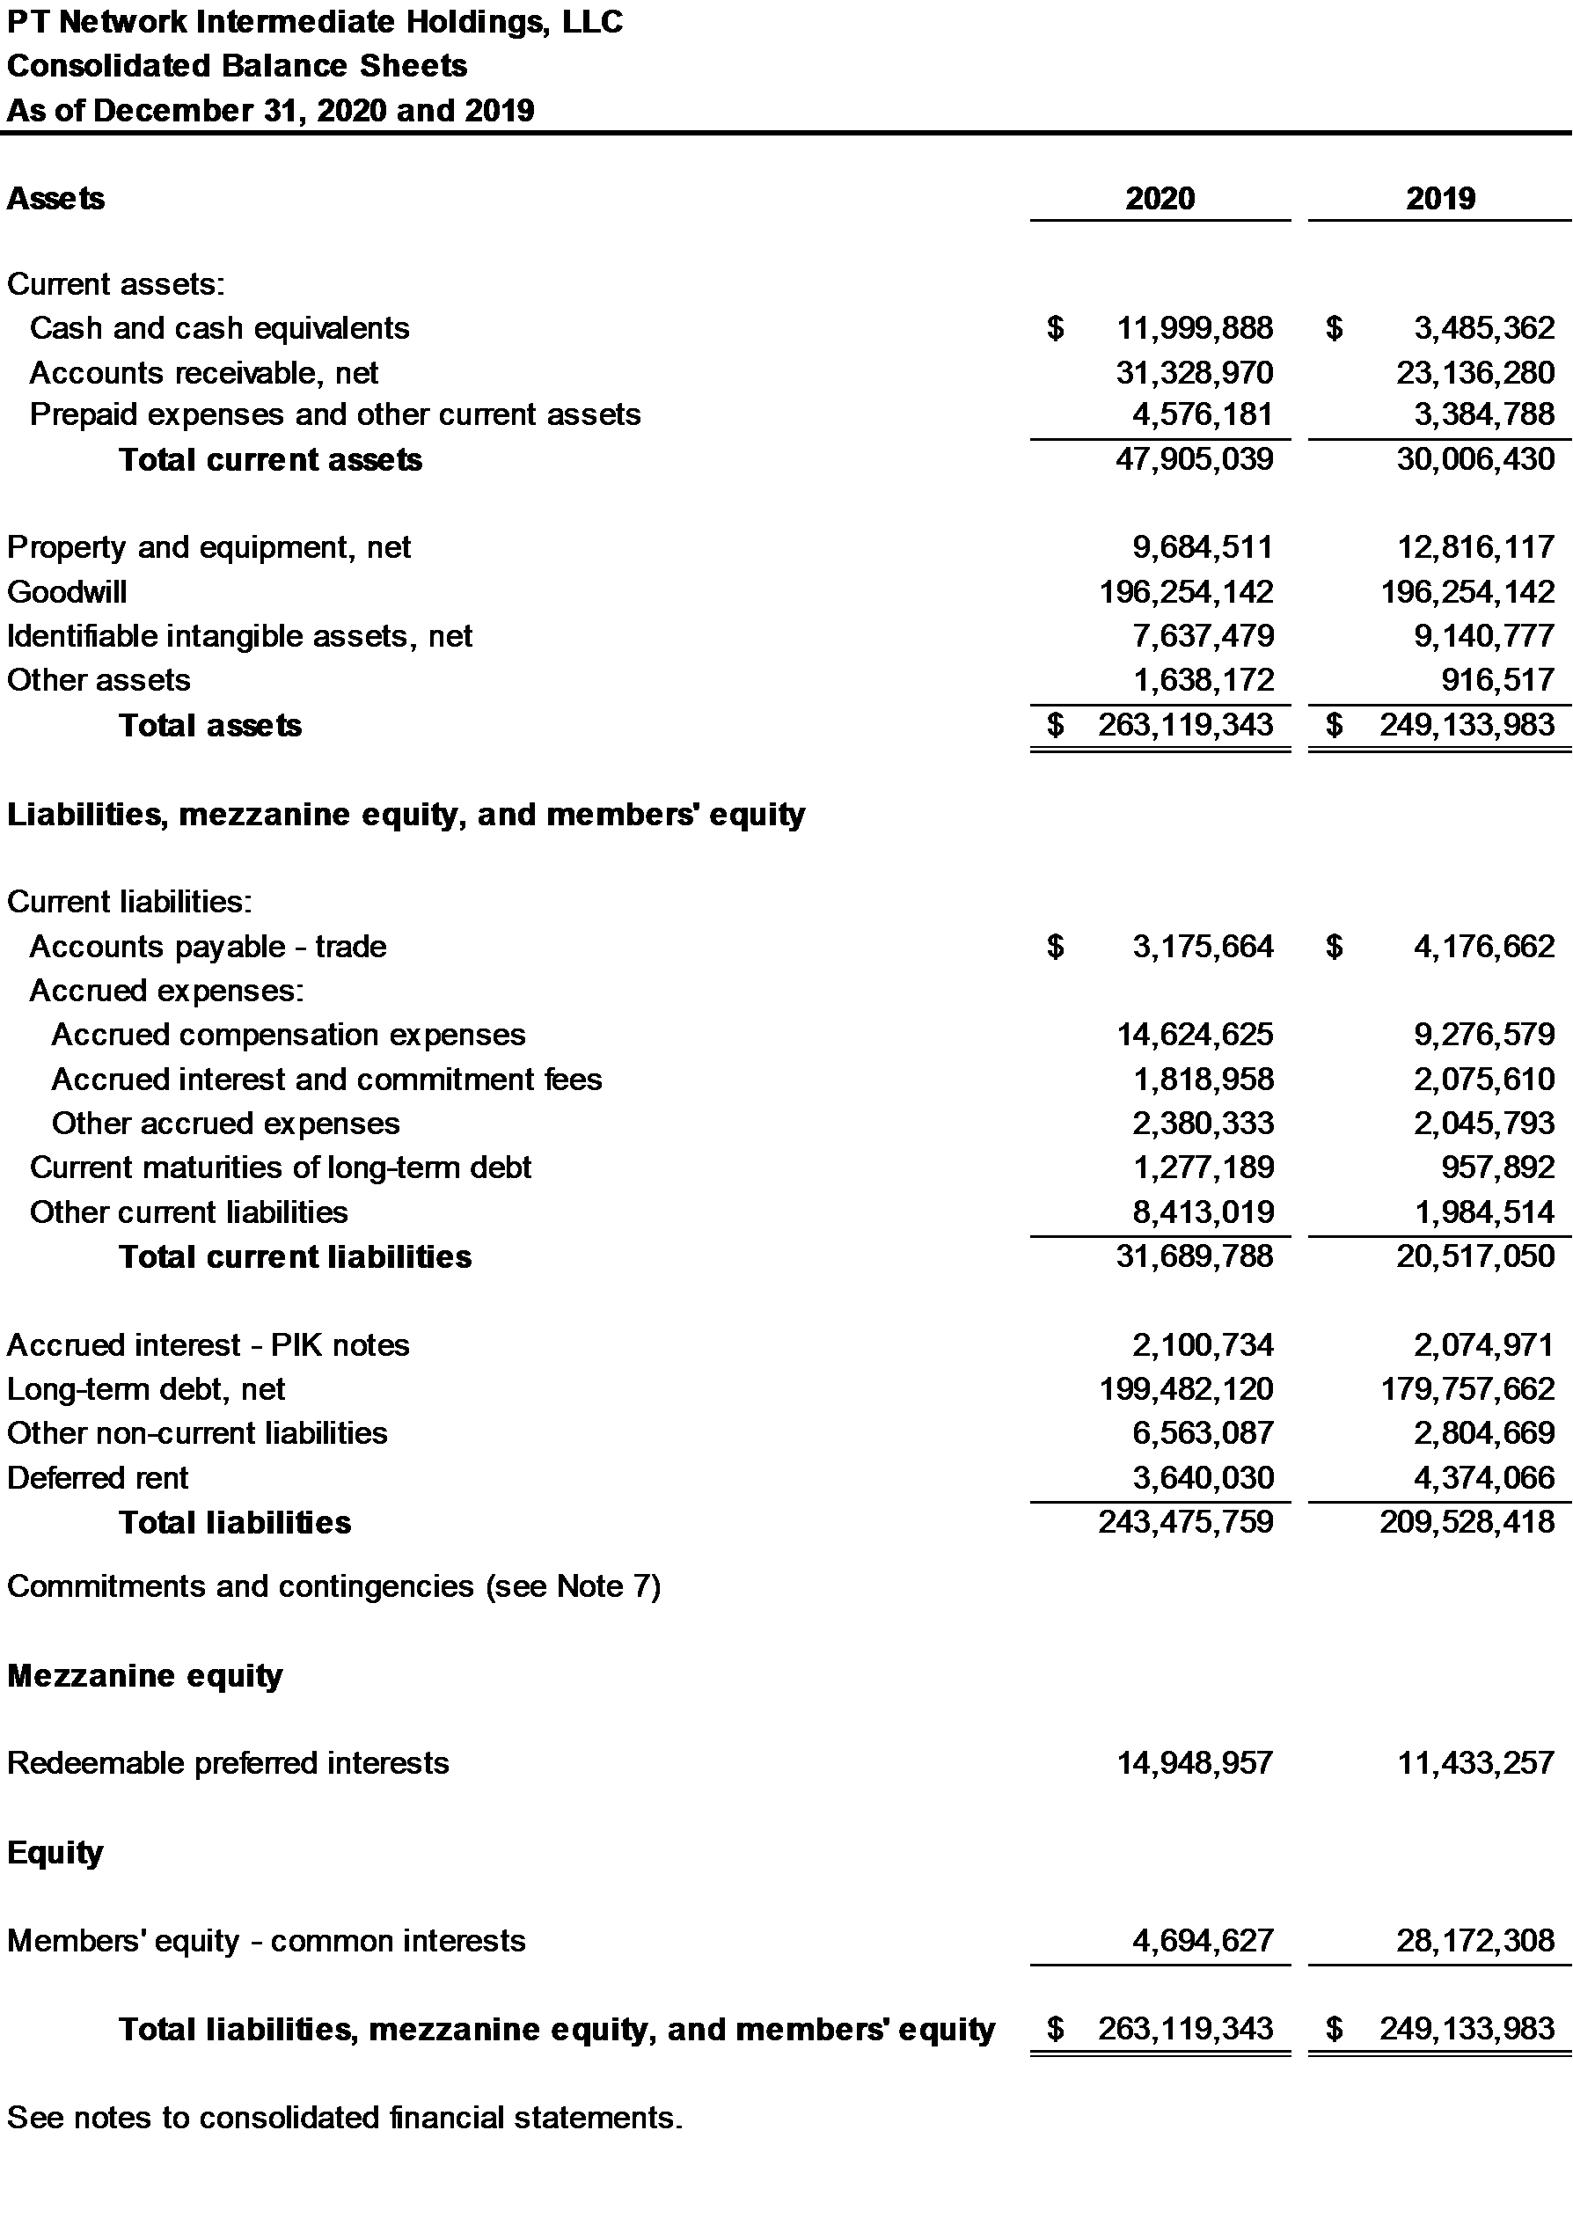
2

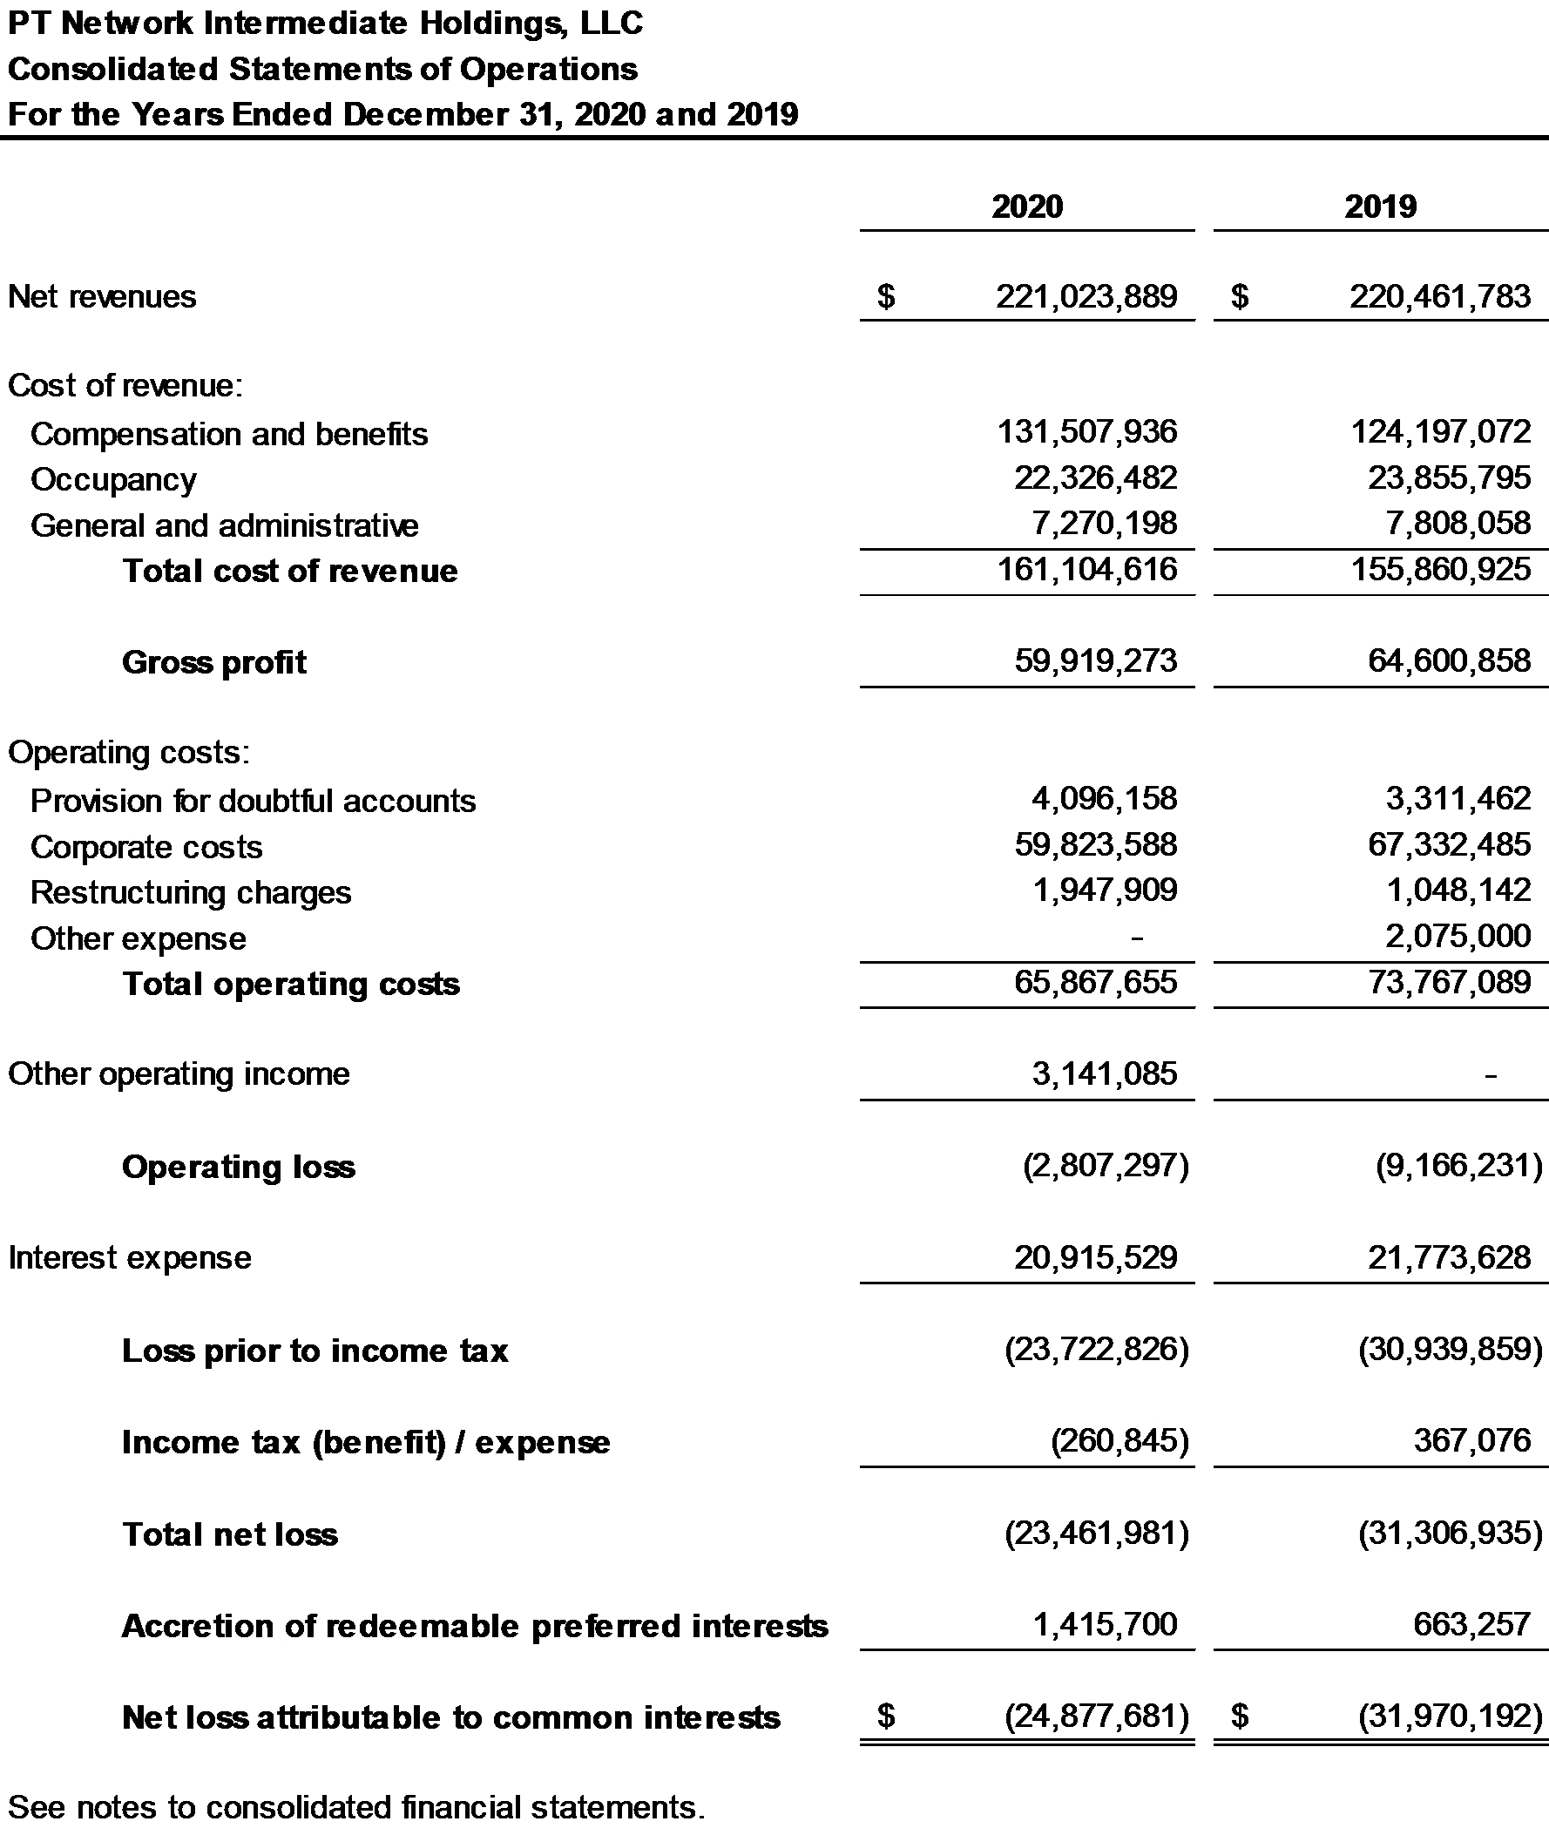
3

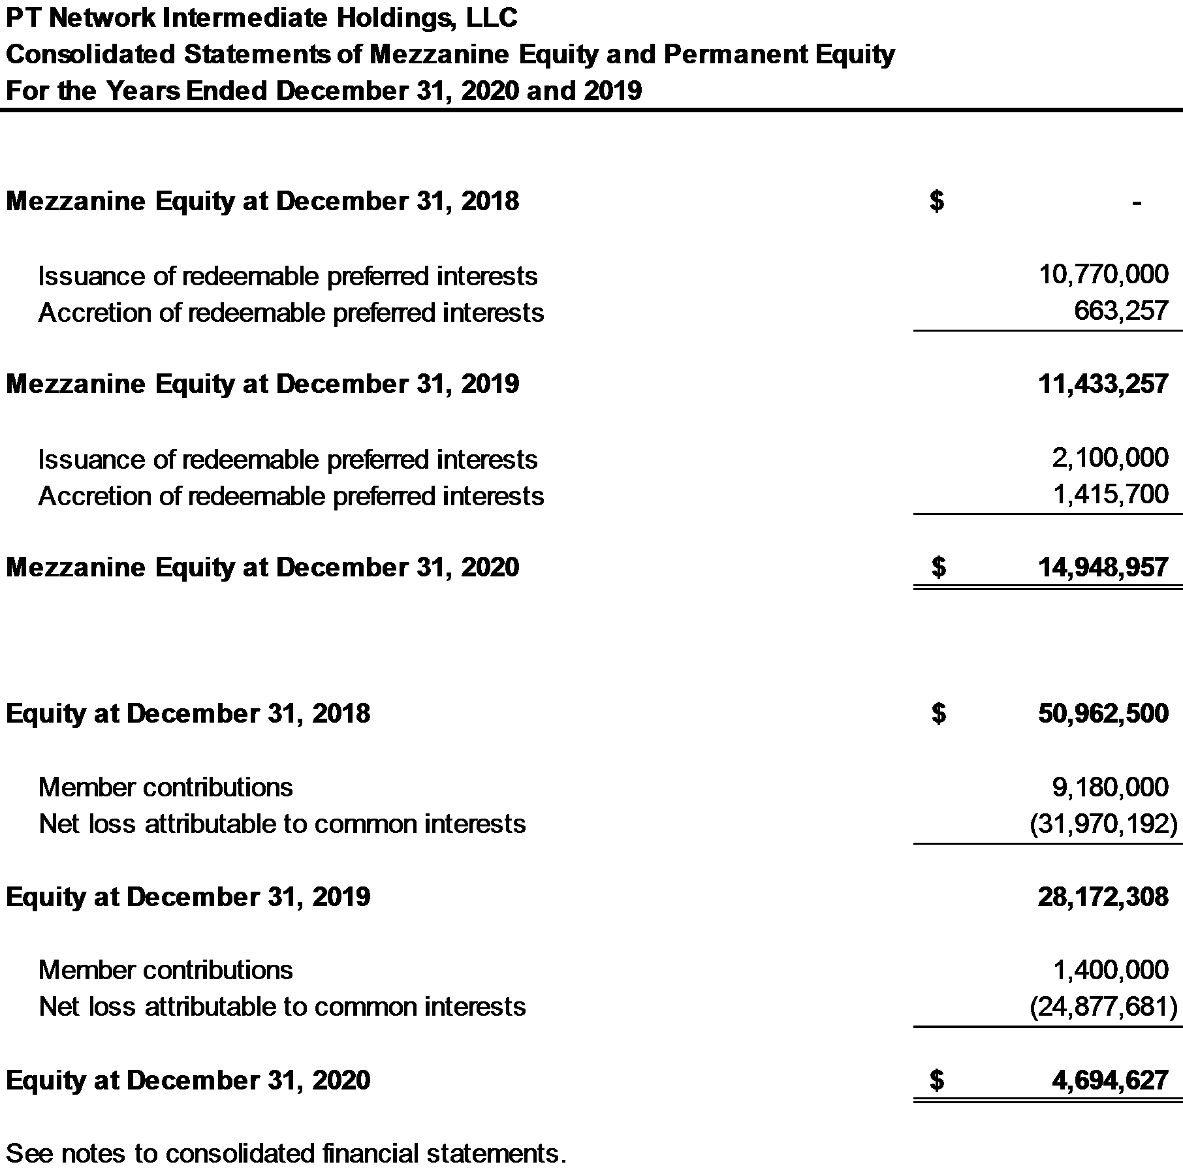

4

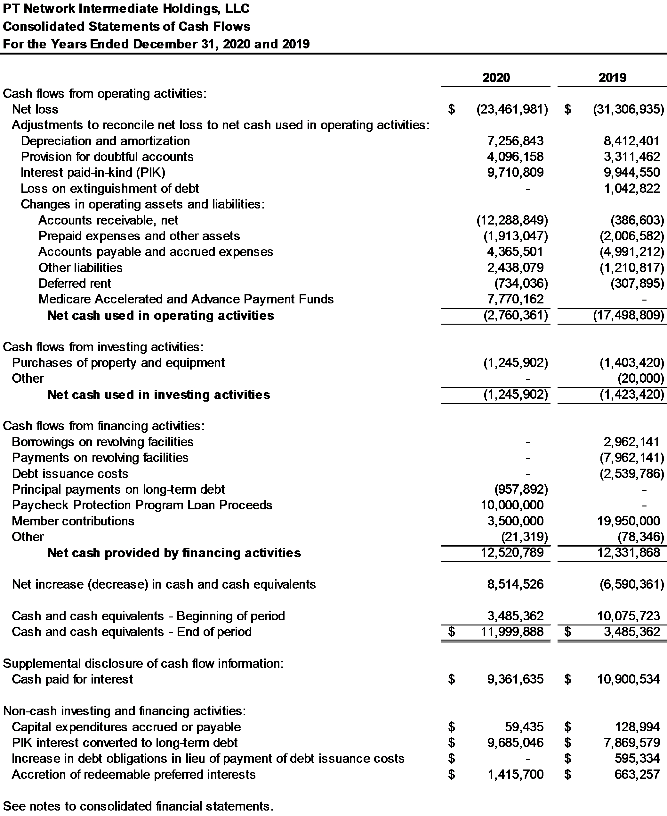
5

Note 1. Nature of Business and Significant Accounting Policies

Nature of Business

PT Network Intermediate Holdings, LLC (PTNIH), is a limited liability company formed in the State of Delaware on September 16, 2013. PTNIH wholly owns PT Network, LLC (PTN). PT Network, LLC, d/b/a Pivot Physical Therapy, operates outpatient physical therapy and occupational health clinics that provide physical therapy, sports medicine and athletic training, aquatic therapy, work injury, and sports performance and wellness services. Services are provided at locations throughout Maryland, Virginia, West Virginia, Washington, D.C., Pennsylvania, Delaware, and North Carolina. Additionally, Pivot Physical Therapy provides on-site physical therapy, occupational therapy, and athletic training to job sites across the country.

PTNIH operates directly through its subsidiaries, PT Network, LLC, Bayside Physical Therapy, LLC, Cambridge Physical Therapy and SportsCare, LLC, Glen Burnie Physical Therapy & Sports Care, LLC, Maryland SportsCare & Rehab, L.L.C., Maryland Sports Care & Rehabilitation of Salisbury, LLC, Professional SportsCare & Rehab, LLC, Professional SportsCare & Rehab of West Virginia, LLC, Professional SportsCare, LLC, Professional Sportscare & Rehab Associates, LLC, Southern Delaware SportsCare and Rehabilitation, LLC, PTN Transportation, LLC, ActivCare Physical Therapy, LLC, Pivot Occupational Health Holdings LLC, Pivot Athletic Training, LLC, Allegheny &
Chesapeake Physical Therapists Incorporated, Omega Medical Center LLC, Tidewater Physical Therapy, LLC, PhysioHealth, LLC, Dynamic Therapy Services of Pennsylvania, LLC, Dynamic Therapy Services, LLC, Pivot Physical Therapy of Pennsylvania, LLC, PTCG, LLC, Pivot Health Professionals, P.C., and Onsite Innovations, LLC (collectively, the Company).

The 26 consolidated entities include a holding company, 24 physical therapy, athletic training, and occupational health companies and a transportation company. The operating entities earn revenue directly from patient care through their clinic and Onsite Innovations, LLC locations. The clinics primarily generate business from physician referrals. The principal sources of payment for the clinics’ services are commercial health insurance, Medicare, Medicaid, workers’ compensation insurance and proceeds from personal injury cases. Services provided at Onsite Innovations, LLC locations are contract based and the contracted party is the single source of payment.

Significant Accounting Policies

A summary of the Company’s significant accounting policies follows:

Basis of Accounting
The accompanying consolidated financial statements have been prepared using the accrual basis of accounting, whereby revenue is recognized when services are rendered and expenses are recognized when incurred, in accordance with accounting principles generally accepted in the United States (GAAP).

Principles of Consolidation
The consolidated financial statements include the accounts and operations of the Company. All intercompany balances, transactions and amounts have been eliminated in consolidation.

Cash and Cash Equivalents
The Company maintains its cash and cash equivalents at various financial institutions. The Company considers all highly liquid investments with maturity of three months or less when purchased to be cash equivalents. The combined account balances at several institutions typically exceed Federal Deposit Insurance Corporation (FDIC) insurance coverage and, as a result, there is a concentration of credit risk related to amounts on deposit in excess of FDIC insurance coverage. The Company has not experienced any losses in such accounts and management believes it is not exposed to any significant credit risk on cash and cash equivalents.

Revenue Recognition

Physical Therapy Revenues
Revenues are recognized in the period in which services are rendered. Physical therapy revenues, which are
6

included in net revenues in the consolidated statements of operations, consists of revenues for physical therapy and occupational therapy clinics that provide pre-and post-operative care and treatment for orthopedic related disorders, sports-related injuries, preventative care, rehabilitation of injured workers and neurological-related injuries. Physical therapy revenues (patient revenues less estimated contractual adjustments), are recognized at the estimated net realizable amounts from third-party payers, patients and others in exchange for services rendered when obligations under the terms of the contract are satisfied. There is an implied contract between the Company and the patient upon each patient visit. Generally, this occurs as the Company provides physical and occupational therapy services, as each service provided is distinct and future services rendered are not dependent on previously rendered services. The Company has agreements with third-party payers that provide for payments to the Company at amounts different from its established rates. See below for further discussion on variable consideration and allowance for doubtful accounts estimates.

Industrial injury prevention services revenues
Revenues from the industrial injury prevention business, which are also included in net revenues in the consolidated statements of operations, are derived from onsite services provided to clients’ employees including injury prevention, rehabilitation, ergonomic assessments and performance optimization. Revenue from the Company’s industrial injury prevention business is recognized when obligations under the terms of the contract are satisfied. Revenues are recognized at an amount equal to the consideration the Company expects to receive in exchange for providing injury prevention services to its clients. The revenue is determined and recognized based on the contractual terms with the third party under the series guidance of ASC 606. Variable fees, which can include per-hour or per-event charges, are recognized in the period that the underlying services are performed based on the variable consideration exception applicable for services that comprise a series.

Other revenues
The Company recognizes revenue for services provided to schools and industrial worksites, for physical or occupational therapy services, and athletic trainers and gym membership fees, which are also included in net revenues in the consolidated statements of operations. Contract terms and rates are agreed to in advance between the Company and third parties. Services are typically performed over the contract period and revenue is recorded as the services are rendered. If the services are paid in advance, revenue is recorded as a contract liability over the period of the agreement and recognized over time as the services are performed, generally under the series guidance.

The Company had disaggregated revenues for the years ended December 31, 2020 and 2019 as follows:

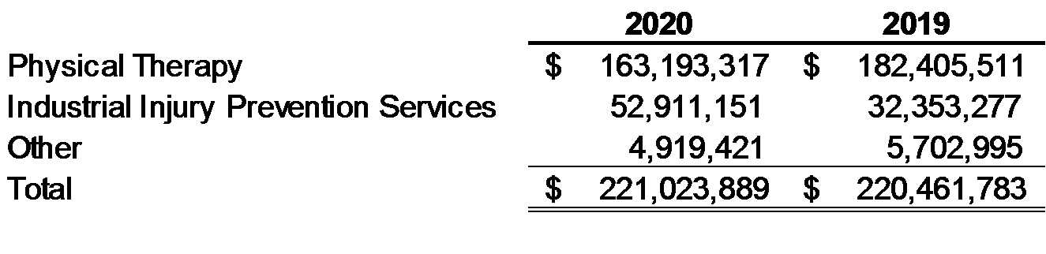
The Company recorded a contract liability of $242,048 and $979,045 at December 31, 2019 and 2018, respectively, for services that were billed to certain industrial injury prevention clients but services had not yet been rendered. Approximately $242,048 and $781,131 of this liability was subsequently earned and recognized as part of operating revenues during 2020 and 2019, respectively. As of December 31, 2020, the contract liability balance was $322,610 and is expected to be recognized over the next year.

As discussed in Note 14, in 2020, the Company received advanced payments totaling $7,770,162 under the Medicare Accelerated and Advance Payments Program. The advance represents a contract liability for services to be performed in 2021 and 2022. The advance will be recognized as revenue and the contract liability offset as the related services are performed over the next 12 to 18 months.

Revenue recognized for the years ended December 31, 2020 and 2019 from performance obligations partially satisfied in prior periods was not material and there were no material contract assets as of December 31, 2020 and 2019. The Company applied the practical expedients related to the series guidance and shorter-term (original contract term of one year or less) to not disclose the aggregate transaction price allocated to unsatisfied performance obligations.

The Company does not capitalize any costs to obtain or fulfill a contract.
7

Accounts Receivable, net
Substantially all of the Company’s accounts receivable are related to providing healthcare services to patients whose costs are primarily paid by federal and state governmental authorities, managed care health plans, commercial insurance companies, and workers’ compensation and employer programs. The Company reports accounts receivable at an amount equal to the consideration the Company expects to receive in exchange for providing healthcare services to its patients, which is estimated using contractual provisions associated with specific payers, historical reimbursement rates, and an analysis of past experience to estimate potential adjustments.

The Company also has certain receivables that are related to providing healthcare services to patients whose costs are primarily paid by local governments and other third parties. The Company reports these receivables at an amount equal to the consideration the Company expects to receive in exchange for providing healthcare services to its patients.

Allowance for Doubtful Accounts
The Company writes off amounts that have been deemed to be uncollectible. The Company writes off uncollectible invoices when appropriate collection efforts have been exhausted. The allowance for doubtful accounts is included in accounts receivable, net on the consolidated balance sheets.

Security Deposits
The Company has recorded $892,228 and $916,517 of refundable security deposits as of December 31, 2020 and 2019, respectively, for various physical therapy and occupational health clinics in other assets in the consolidated balance sheet.

Long-Lived Assets

Property and equipment, net
Property and equipment, net is stated at cost less accumulated depreciation. Depreciation is recorded using the straight-line method over the estimated useful lives of the related assets. Leasehold improvements are amortized using the straight-line method over the shorter of the estimated useful lives of the improvements or the remaining lease term.

The general range of useful lives is as follows:

Computer equipment and software | 3 years
Furniture and office equipment | 7 years
Medical equipment | 7 years
Leasehold improvements | 1-10 years

Finite-lived Intangible Assets
Intangible assets that have finite useful lives are amortized over their useful lives and reported at cost less accumulated amortization and impairment losses, if applicable. The Company's finite-lived intangible assets consist of customer relationships and trade name assets associated with the Company’s historical acquisitions.

Impairment of Long-Lived Assets
Long-lived assets are not required to be tested for impairment annually. However, long-lived assets are tested for impairment whenever circumstances indicate that the carrying amount of the asset may not be recoverable, such as when the disposal of such assets before the end of its previously estimated useful life is likely or there is an adverse change in the market involving the business employing the related assets. The impairment test first requires an assessment of the recoverability of the asset by comparing the net future cash flows of the asset to the carrying value of the asset. The net cash flows of the asset are estimated on an undiscounted, pre-tax basis, and should be based on future cash inflows expected from use of the asset over its remaining useful life, less expected future cash outflows necessary for maintenance, and cash flows associated with the eventual disposition of the asset. If the carrying value of the asset exceeds the net future cash flows of the asset, the asset would not be deemed to be recoverable. An impairment of the asset would then be recognized in an amount equal to the excess of the asset’s carrying value over its estimated fair value, calculated based on the discounted cash flows of the asset. Significant judgments used for long-lived asset impairment assessments include determining whether events of circumstances indicate that the carrying value of the asset may not be recoverable, identifying asset groupings, identifying the
8

primary assets within each asset grouping, and estimating projected cash flows attributable to the asset grouping. The valuation of long-lived assets at estimated fair value, when required, is performed using Level 2 or Level 3 fair value inputs. There were no impairment charges related to long-lived assets in 2020 or 2019.

Goodwill
The Company records goodwill for the excess purchase price over the fair value of the identifiable net assets acquired in business combinations. The fair value of goodwill is evaluated for impairment annually, or earlier upon the occurrence of substantive unfavorable changes in economic conditions, industry trends, costs, or cash flows. The impairment test requires judgment, including the identification of reporting units, the assignment of assets, liabilities and goodwill to reporting units, and the determination of fair value of each reporting unit if a quantitative test is performed. If management believes that as a result of our qualitative assessment it is more likely than not that the fair value of a reporting unit is greater than its carrying amount, a quantitative impairment test is not required. The Company has identified a total of three reporting units, of which two reporting units have been allocated goodwill.

An impairment loss generally would be recognized when the carrying value of a reporting unit exceeds the estimated fair value of equity of the reporting unit. The estimated fair value of a reporting unit is determined by employing income and market approaches. Included in the income and market approaches are assumptions regarding projected revenue, profitability, and capital requirements for each reporting unit. The projected cash flows of each reporting unit are discounted back to the present value to estimate the fair value of each reporting unit as of the impairment testing date under the income approach. Under the market approach, a market multiple is applied to historical and / or projected financial information to estimate the fair value of each reporting unit as of the impairment testing date. The financial projections for each reporting unit are based on management’s knowledge of the industry, management’s understanding of each reporting unit’s recent transactions, and management’s expectations for each reporting unit’s operations. If the financial projections for a reporting unit fail to materialize, the resulting decline in estimated fair values could result in an impairment charge to the goodwill associated with the respective reporting unit. The valuation of goodwill at estimated fair value, when required, is performed using Level 2 or Level 3 fair value inputs.

The Company assessed goodwill for impairment for the two reporting units with goodwill and did not identify any evidence of impairment with respect to goodwill for either reporting unit as of the assessment date.

Fair Value of Financial Instruments
The carrying amounts of financial instruments, including cash, accounts receivable, net, accounts payable, accrued expenses, and our line-of-credit approximate fair value due to the short maturity of these instruments. The carrying amount of long-term debt approximates fair value because the interest rates fluctuate with market interest rates. The fair value of debt estimates are based on Level 2 inputs.

Fair Value Measurements
The Company follows the Financial Accounting Standards Board (FASB) authoritative guidance for fair value measurements, which defines fair value as the estimated price at which an asset can be sold or a liability settled in an orderly transaction to a third party under current market conditions, and establishes a framework for measuring fair value in accordance with GAAP.

Debt Issuance Costs
Costs associated with acquiring debt are capitalized as debt issuance costs. Debt issuance costs related to a recognized debt liability are presented in the consolidated balance sheets as a direct deduction from the carrying amount of that debt liability, consistent with debt discounts. These costs are amortized over the term of the related loans using the straight-line method, which is not materially different than the effective interest method, and are included in interest expense in the consolidated statements of operations.

Deferred Rent
Rent payments on operating leases are recognized as an expense on a straight-line basis over the related lease term, which includes renewal options that are reasonably assured of exercise. Generally, renewal options are not considered reasonably assured of exercise. Deferred rent is based on cumulative rent expense that is in excess of amounts paid to date. The liability as of December 31, 2020 and 2019 was $2,035,019 and $2,228,670, respectively, and is reported as part of deferred rent in the consolidated balance sheets.

When the Company receives a tenant improvement allowance, it records a liability which is then amortized as a
9

reduction of rent expense over the related lease term. The liability for tenant improvement allowances, net of amortization, as of December 31, 2020 and 2019 was $1,605,011 and $2,145,396, respectively, and is reported as part of deferred rent in the consolidated balance sheets.

Corporate Costs
Corporate costs consist primarily of salaries and benefits of corporate office personnel, rent, insurance costs, depreciation and amortization, travel, legal, compliance, professional, marketing and recruiting fees.

Income Taxes
The Company was formed as a limited liability company under the Delaware Liability Company Act and provisions of the Internal Revenue Code. One subsidiary of the Company is a C Corporation for which a provision for income taxes has been included in the financial statements. These consolidated financial statements contain no provision for income taxes or benefits for PTNIH and its subsidiaries, other than for the subsidiary described above, as taxable income or loss is reported by the members on their individual income tax returns. The Company’s Operating Agreement provides for the division of LLC profits and losses to the members and the perpetual existence of the entity.

Management has evaluated the Company’s tax positions and concluded that the Company has taken no uncertain tax positions that require adjustment to or disclosure in the financial statements.

Use of Estimates
The preparation of financial statements in conformity with GAAP requires management to make estimates and assumptions that affect the reported amounts of assets and liabilities, including disclosure of contingencies, at the date of the financial statements and the reported amounts of revenues and expenses during the reporting period. Significant estimates and assumptions are used for, but not limited to: amounts realizable for services performed, estimated useful lives of assets, the valuation of goodwill and intangible assets, amounts payable for self-insured losses, and the computation of income taxes. Future events and their effects cannot be predicted with certainty; accordingly, the Company’s accounting estimates require the exercise of judgment. The accounting estimates used in the preparation of the financial statements will change as new events occur, as more experience is acquired, as additional information is obtained, and as the Company’s operating environment changes. The Company’s management evaluates and updates assumptions and estimates on an ongoing basis. Actual results could differ from those estimates.

Reclassifications
The Company made certain reclassifications of prior year amounts to conform to the current year presentation. Such reclassifications had no impact on previously reported net loss.

Recently Adopted Accounting Guidance
In May 2014, March 2016, April 2016, and December 2016, the FASB issued Accounting Standards Update (ASU) 2014-09, Revenue from Contracts with Customers, ASU 2016-08, Revenue from Contracts with Customers, Principal versus Agent Considerations, ASU 2016-10, Revenue from Contracts with Customers, Identifying Performance Obligations and Licensing, ASU 2016-12, Revenue from Contracts with Customers, Narrow Scope Improvements and Practical Expedients, and ASU 2016-20, Technical Corrections and Improvements to Topic 606, Revenue from Contracts with Customer (collectively “New Revenue Standard”), respectively, which supersede most of the existing revenue recognition requirements. The core principle of the new guidance is that an entity should recognize revenue to depict the transfer of promised goods or services to customers in an amount that reflects the consideration to which the entity expects to be entitled in exchange for those goods or services. New disclosures about the nature, amount, timing and uncertainty of revenue and cash flows arising from contracts with customers are also required. The New Revenue Standard is effective for the Company for annual periods beginning after December 15, 2018 (as amended in August 2015 by ASU 2015-14, Deferral of the Effective Date).

The Company implemented the New Revenue Standard beginning January 1, 2019 using the modified retrospective transition method. The adoption of the New Revenue Standard did not result in any material changes to the Company’s financial statements other than the requirement to include incremental quantitative and qualitative disclosures such as certain disaggregation of revenue disclosures.

The Company completed the adoption of ASU 2016-13, Financial Instruments – Credit Losses on January 1, 2020. The financial instruments subject to ASU 2016-13 are the Company’s accounts receivable derived from contracts with customers. A significant portion of the Company’s accounts receivable are from highly-solvent, creditworthy
10

payers including governmental programs such as Medicare and Medicaid, and highly regulated commercial insurers. The Company’s estimate of expected credit losses as of January 1, 2020, using its expected credit loss evaluation process, resulted in no adjustments to the allowance for credit losses and no cumulative-effect adjustment to retained earnings on the adoption date of the standard.

In January 2017, the FASB issued ASU 2017-04, Simplifying the Test for Goodwill Impairment (Topic 350), which eliminates the requirement to calculate the implied fair value of goodwill to measure a goodwill impairment change. The Company completed the adoption of this standard effective January 1, 2020 and there was no impact to goodwill from the Company’s adoption of this change.

In August 2018, the FASB issued ASU 2018-15, Customer’s Accounting for Implementation Costs Incurred in a Cloud Computing Arrangement That is a Service Contract. This amendment aligns the requirements for capitalizing implementation costs incurred in a hosting arrangement that is a service contract with the requirements for capitalizing implementation costs incurred to develop or obtain internal-use software (and hosting arrangements that include an internal use software license). This generally means that an intangible asset is recognized for the software license and, to the extent that the payments attributable to the software license are made over time, a liability also is recognized. If a cloud computing arrangement does not include a software license, the entity should account for the arrangement as a service contract. This generally means that the fees associated with the hosting element of the arrangement are expensed as incurred. The amendment is effective for annual and interim periods beginning after December 15, 2019, with early adoption permitted. The Company implemented the new standard on January 1, 2020 and capitalized certain implementation costs that were incurred in a cloud computing arrangement that is a service contract related to system conversions. The total amount of costs that were capitalized as of December 31, 2020 was $742,815. The Company assigned useful lives of 3 – 5 years to these costs based on the term of the underlying service contract. Costs are amortized to general and administrative costs on the consolidated statements of operations. These costs are presented as components of prepaid expenses and other current assets and other assets on the consolidated balance sheets as of December 31, 2020.

Recently Issued Accounting Guidance
In February 2016, the FASB issued amended accounting guidance (ASU 2016-02, Leases) which replaced most existing lease accounting guidance under GAAP. Among other changes, the amended guidance requires that a right-to-use asset, which is an asset that represents the lessee’s right to use, and a lease liability, which is a lessee’s obligation to make lease payments arising for an operating lease measured on a discounted basis, be recognized on the balance sheet by lessees. The amended guidance is effective for the Company starting in the year ended December 31, 2021. Entities can use a modified retrospective approach for leases that exist or are entered into after the beginning of the earliest comparative period in the financial statements or recognize the cumulative effect of applying the new standard as an adjustment to the opening balance of equity.

The Company has operating leases for each of its clinic and certain corporate locations, as well as equipment. As a result, the Company will recognize right of use assets and lease liabilities on the consolidated balance sheet upon adoption of the new leasing standard. Operating lease expense will continue to be recognized as occupancy costs on a straight-line basis over the respective lease terms in the consolidated statement of operations. The Company implemented the new standard beginning January 1, 2021, and elected certain practical expedients, including the expedient that permits the Company to retain its existing lease assessment and classification. The Company also elected the transition method in ASU 2018-11, Leases (Topic 842):Targeted Improvements which allows the Company to recognize a cumulative effect adjustment of the standard adoption to the opening balance of equity at the adoption date. The Company continues to evaluate the impact that the pronouncement will have on the Company's financial statements, including footnote disclosures.

In March 2020, the FASB issued ASU 2020-04, Reference Rate Reform (Topic 848): Facilitation of the Effects of Reference Rate Reform on Financial Reporting. This ASU provides temporary optional expedients and exceptions to the guidance on contract modifications and hedge accounting to ease the financial reporting burdens of the expected market transition from the London Interbank Offered Rate (“LIBOR”) and other interbank offered rates to alternative reference rates. The new guidance was effective upon issuance, and the Company is allowed to elect to apply the amendments prospectively through December 31, 2022. Borrowings under the Amended Credit Agreement bear interest based on LIBOR or an alternate base rate. Provisions within the agreement currently provide the Company with the ability to replace LIBOR with a different reference rate in the event LIBOR ceases to exist. The impact of the adoption was immaterial.

11

Note 2. Goodwill and Intangible Assets, net

Goodwill
The carrying amount of goodwill as of December 31, 2020 and 2019 was $196,254,142. There were no additions, disposals, or goodwill impairments that occurred for the years ended December 31, 2020 and 2019.

Intangible Assets, net
The balance and activity of finite-lived intangible assets is shown in the tables below:

 | Useful Life ranges |  | Intangible Assets, net, balance as of December 31, 2018 | Amortization Expense |  | Intangible Assets, net, balance as of December 31, 2019
Trade names, net of accumulated amortization of $3,690,772 and $3,889,800 as of December 31, 2018 and 2019, respectively | 1 - 7 years | $ | 1,062,519 | $ | 199,028 |  | $ 863,491
Customer relationships, net of accumulated amortization of $2,156,874 and $3,461,144 as of December 31, 2018 and 2019, respectively | 9 years | $ | 9,581,556 | $ | 1,304,270 |  | $ 8,277,286

 | Useful Life ranges |  | Intangible Assets, net, balance as of December 31, 2019 | Amortization Expense |  | Intangible Assets, net, balance as of December 31, 2020
Trade names, net of accumulated amortization of $3,889,800 and $4,088,828 as of December 31, 2019 and 2020, respectively | 1 - 7 years | $ | 863,491 | $ | 199,028 |  | $ 664,463
Customer relationships, net of accumulated amortization of $3,461,144 and $4,765,414 as of December 31, 2019 and 2020, respectively | 9 years | $ | 8,277,286 | $ | 1,304,270 |  | $ 6,973,016

Amortization of intangible assets, net, is recognized on a straight-line basis over the estimated useful lives of intangible assets. No impairments of finite-lived intangible assets were recorded for the years ended December 31, 2020 and 2019. Estimated amortization expense of the Company’s finite-lived intangible assets for each of the five succeeding years and thereafter is as follows:

12

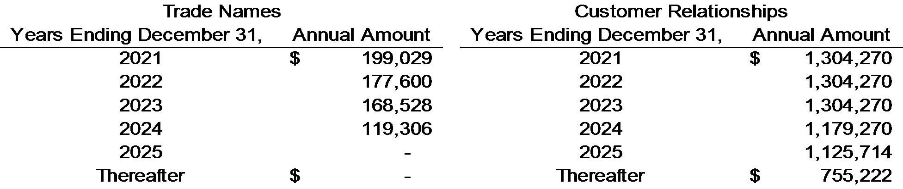

Note 3. Property and Equipment, net

Property and equipment consists of the following at December 31, 2020 and 2019:

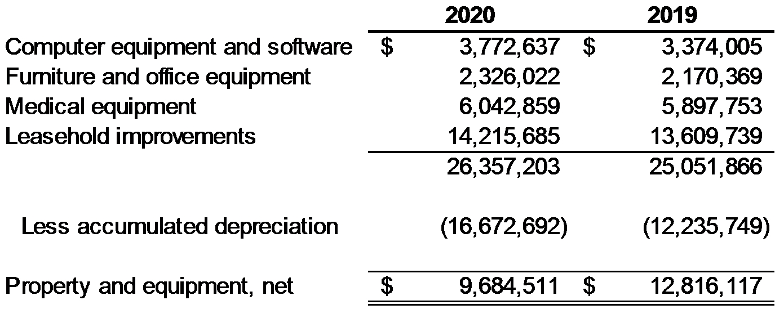
Depreciation expense was $4,436,943 and $5,372,027 for the years ended December 31, 2020 and 2019, respectively. There were no impairments recorded for the years ended December 31, 2020 and 2019.

Note 4. Net Revenues and Accounts Receivable, net

Medicare/Medicaid and Blue Cross entities represent approximately 37% and 25% of third-party payer net patient service revenue, respectively, for the years ended December 31, 2020 and 2019. The remaining 38% represents various other commercial payers and patients.

Medicare Reimbursement

The Medicare program reimburses outpatient rehabilitation providers based on the Medicare Physician Fee Schedule (‘‘MPFS’’). For services provided in 2019, a 0.25% increase was applied to the fee schedule payment rates before applying the mandatory budget neutrality adjustment. For services provided in 2020 through 2025, a 0.0% percent update will be applied each year to the fee schedule payment rates, before applying the mandatory budget neutrality adjustment. However, in the 2020 MPFS Final Rule, CMS proposed an increase to the code values for office/outpatient evaluation and management (E/M) codes and cuts to other codes to maintain budget neutrality of the MPFS. This change in code valuations was to become effective January 1, 2021. Under the 2021 MPFS Final Rule, reimbursement for the codes applicable to physical/occupational therapy services were to be reduced by approximately 9% in the aggregate. The 9% reduction in payment was addressed by the Consolidated Appropriations Act, 2021 (“Act”) signed into law on December 27, 2020. Based on various provisions in the Act, the Company now estimates that the Medicare rate reduction for the full year of 2021 will be approximately 3.5% in aggregate.

CMS adopted a multiple procedure payment reduction (“MPPR”) for therapy services in the final update to the MPFS for calendar year 2011. The MPPR applied to all outpatient therapy services paid under Medicare Part B — occupational therapy, physical therapy and speech-language pathology. Under the policy, the Medicare program pays 100% of the practice expense component of the Relative Value Unit (“RVU”) for the therapy procedure with the highest practice expense RVU, then reduces the payment for the practice expense component for the second and subsequent therapy procedures or units of service furnished during the same day for the same patient, regardless of whether those therapy services are furnished in separate sessions. Since 2013, the practice expense component for
13

the second and subsequent therapy service furnished during the same day for the same patient was reduced by 50%. In addition, the MCTRA directed CMS to implement a claims-based data collection program to gather additional data on patient function during the course of therapy in order to better understand patient conditions and outcomes. All practice settings that provide outpatient therapy services are required to include this data on the claim form. Since 2013, therapists have been required to report new codes and modifiers on the claim form that reflect a patient’s functional limitations and goals at initial evaluation, periodically throughout care, and at discharge. Reporting of these functional limitation codes and modifiers are required on the claim for payment.

Medicare claims for outpatient therapy services furnished by therapy assistants on or after January 1, 2020 must include a modifier indicating the service was furnished by a therapy assistant. Outpatient therapy services furnished on or after January 1, 2022 in whole or part by a therapy assistant will be paid at an amount equal to 85% of the payment amount otherwise applicable for the service.

Statutes, regulations, and payment rules governing the delivery of therapy services to Medicare beneficiaries are complex and subject to interpretation. Management believes that the Company is in compliance, in all material respects, with all applicable laws and regulations and are not aware of any pending or threatened investigations involving allegations of potential wrongdoing that would have a material effect on the our financial statements as of December 31, 2020. Compliance with such laws and regulations can be subject to future government review and interpretation, as well as significant regulatory action including fines, penalties, and exclusion from the Medicare program.

Accounts receivable, net consist of the following at December 31, 2020 and 2019:

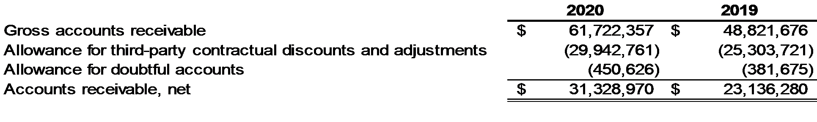

Below is a rollforward of the allowance for doubtful accounts for the years ended December 31, 2020 and 2019:

Medicare/Medicaid and commercial insurance providers represent approximately 18% and 15%, and 60% and 65% respectively, of gross accounts receivable at December 31, 2020 and 2019. The remainder is due from patients. Accounts receivable are carried based on total patient charges. The contractual allowances include estimates for third-party contractual and other adjustments. Management determines the allowance for doubtful accounts by using historical experience applied to an aging of accounts. Accounts receivable are written off when deemed uncollectible.

Contractual allowances result from the differences between the rates charged for services performed and expected reimbursements by both insurance companies and government sponsored healthcare programs for such services. Medicare regulations and the various third party payers and managed care contracts are often complex and may include multiple reimbursement mechanisms payable for the services provided in our clinics. The Company estimates contractual allowances based on its interpretation of the applicable regulations, payer contracts, and the historical collection experience of the clinic and apply an appropriate contractual allowance reserve percentage to the gross accounts receivable balances for each clinic. Based on management’s historical experience, calculating the contractual allowance reserve percentage at the clinic level is sufficient to allow the Company to provide the necessary detail and accuracy with its collectability estimates. However, the services authorized and provided and related reimbursement are subject to interpretation that could result in payments that differ from the Company’s estimates. Payer terms are periodically revised necessitating continual review and assessment of the estimates made by management. The Company’s billing systems may not capture the exact change in contractual allowance
14

reserve estimate from period to period. Therefore, in order to assess the accuracy of revenues and hence contractual allowance reserves, management compares cash collections to corresponding net revenues measured both in the aggregate and on a clinic-by-clinic basis.

Note 5. Long-Term Debt, net

Prior to the year ended December 31, 2019, the Company’s operating subsidiary, PTN, previously entered into an amended and restated credit agreement for commitments of $130,000,000 term loan, $10,000,000 revolving line-of-credit and $50,000,000 delayed draw term loan (First Lien Facilities). There was no outstanding balance on the First Lien Facilities delayed draw term loan at December 31, 2018. The outstanding balances on the First Lien Facilities initial term loan and revolving line-of-credit were $127,718,900 and $5,000,000, respectively, at December 31, 2018. In addition to the First Lien Facilities, PTN entered into a credit agreement with a different lender for commitments of $49,000,000 term loan, and $11,000,000 delayed draw term loan (Second Lien Facilities). The outstanding balances on the Second Lien Facilities initial term loan and delayed draw term loan were $49,000,000 and $1,000,000, respectively, at December 31, 2018.

All loans under the credit agreements were collateralized by all of PTN’s assets and PTNIH’s member equity interests.

All facilities under the First Lien Credit Facilities were to mature on November 30, 2021. All facilities under the Second Lien Facilities were to mature on April 12, 2023. The credit agreements were subject to certain financial and non-financial covenants.

In January 2019, PTN was unable to meet its obligation for scheduled interest payments and loan commitment fees in accordance with the terms of the First Lien Facilities and Second lien Facilities, resulting in default of the credit agreements. In response to this default, PTN’s lenders executed forbearance agreements and amended credit agreements with its First Lien Agent, the Second Lien Agent, each First Lien Lender and each Second Lien Lender.

In April 2019, the First Lien Agent, the Second Lien Agent, each First Lien Lender and each Second Lien Lender entered into a Restructuring Support Agreement (RSA) with respect to a proposed restructuring of the Loan Parties, which provided for consensual restructuring of the Company’s debt and equity structure (Restructuring). This agreement was amended and restated in June 2019.

The forbearance agreements were amended and extended up to the closing date, and terminated on June 28, 2019, upon execution of the restructured credit agreements.

At Restructuring closing, the Second Lien Lenders contributed cash of $15,000,000 on a pro-rata basis to PTNIH in exchange for $6,000,000 of voting Class A common units and $9,000,000 of non-voting preferred units. Preferred units have a preferred return of LIBOR (floor of 1%) plus 10% compounded annually, on unreturned preferred unit invested capital, and preferred distribution rights. The funds were then contributed by PTNIH to PTN and used for the following purposes: (i) to pay-off the First Lien revolving line-of-credit and accrued interest; (ii) to pay forbearance fees due on the First Lien credit agreement; (iii) to pay accrued interest on the First Lien term loan and revolving line-of-credit, fees and expenses; and (iv) to pay legal fees. The remaining funds were available for general business purposes.

The RSA and PTNIH’s amended and restated LLC agreement provide for the Second Lien Lenders to contribute up to an additional $10,000,000 on a delayed draw basis as needed by the Company. This additional funding, if needed, will be exchanged for up to $4,000,000 of voting Class A common units and $6,000,000 of non-voting preferred units. Refer to Note 11 for additional information on contributions made under this commitment for years ended 2020 and 2019.

In addition, the RSA and a separate Carveout, Intercreditor and Subordination Agreement and Release dated as of June 28, 2019 (the Sale Carveout Agreement), provide for Sale Carveout Rights and Transaction Bonus Rights (as each term is defined in the Sale Carveout Agreement) for certain current and former employees, in the event of a future sale or change in control transaction.

The restructured First Lien credit agreement and Second Lien credit agreement require the Company to maintain certain financial and non-financial covenants, as defined in the credit agreements. The Company was in compliance with all covenants as of December 31, 2020 and 2019.
15

PTNIH assumed PTN’s obligation as the borrower under the restructured Second Lien credit agreement.
The restructured credit agreements include the following terms:

Restructured Terms | Restructured First Lien  Credit Agreement | Restructured Second Lien  Credit Agreement
Borrower | PT Network, LLC | PT Network Intermediate Holdings, LLC
Outstanding balance of term loans | $127,718,900 | $54,221,183
Revolving loan commitment | $10,000,000 | -
Interest rates:
Index rate loans - cash | Index rate plus 4.5% | Index rate plus 9%
LIBOR loans - cash | LIBOR (floor 1%) plus 5.5% | LIBOR (floor 1%) plus 10%
PIK – subject to terms of credit  agreement | 2%
Maturity date | November 30, 2023 | November 30, 2024
Loan amortization - quarterly | 0% through March 31, 2020 | Due at maturity
 | 0.25% through March 31, 2022
 | 0.50% thereafter

Additionally, the Company incurred costs from lenders and third parties from the restructuring transaction. Certain forbearance and restructuring fees that are due upon the maturity of these credit agreements.

The outstanding balances on the First Lien term loan at December 31, 2020 and 2019 were $130,165,547 and $128,492,925, respectively. The outstanding balances on the Second Lien term loan at December 31, 2020 and 2019 were $64,745,420 and $57,690,888, respectively. The outstanding balances on the Company’s Paycheck Protection Program (PPP) loan at December 31, 2020 and 2019 were $10,000,000 and $0. The Company included the PPP loan in debt maturing in 2022 in the table below. Refer to Note 14 for additional information regarding the Company’s PPP loan. In accordance with the restructured credit agreements, and the Company’s PPP loan note, aggregate future maturities required on long-term debt are as follows:

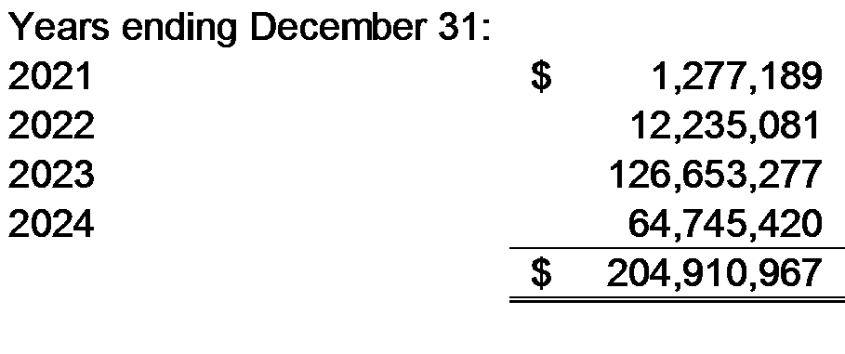
PTN’s revolving line-of-credit from the First Lien lenders had a balance of $5,000,000 at January 1, 2019. In January 2019, PTN drew $2,962,141 on this facility to service the interest on the First Lien term loan. The total amount borrowed on the revolving line-of-credit was $7,962,141, which was paid off as part of the restructuring. There was no balance on the revolving line-of-credit at December 31, 2020 and 2019. The interest rate on the revolver was 10.00%.

Debt issuance costs, which are classified as a reduction to the carrying amount of the debt above, consist of the following at December 31, 2020 and 2019:

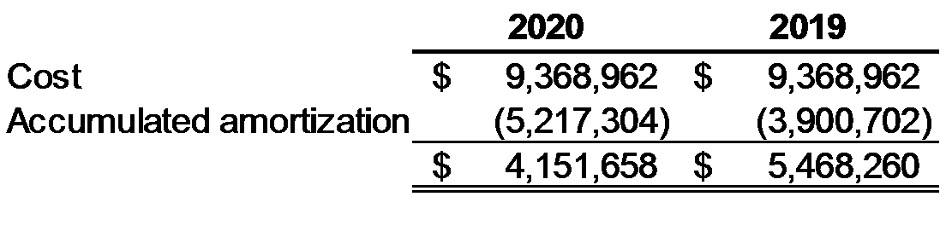
Amortization of debt issuance costs was $1,316,602 and $1,537,075 for the years ended December 31, 2020 and 2019, and is included in interest expense on the consolidated statements of operations. Amortization for the next four years is as follows:
16

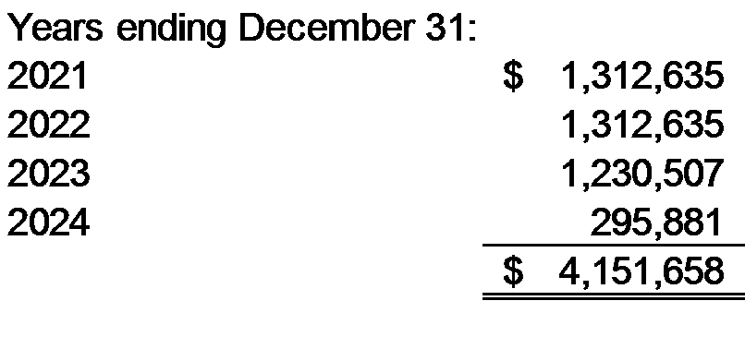
Interest expense of $19,549,483 and $19,162,775 and commitment fee expense of $49,444 and $30,956 for the years ended December 31, 2020 and 2019 are included in interest expense on the consolidated statements of operations. Accrued interest and commitment fees on the First and Second Lien Credit Agreements was $1,818,958 and $2,075,610 at December 31, 2020 and 2019, respectively. Accrued interest on the First and Second Lien Credit agreements that will be paid-in-kind was $2,100,734 and $2,074,971 at December 31, 2020 and 2019, respectively. Both accrued interest and accrued interest – PIK notes are disclosed on the face of the consolidated balance sheet.

The Company recorded a loss on extinguishment of debt of $1,042,822 during 2019 in conjunction with the restructuring transaction. This expense is part of interest expense on the consolidated statements of operations.

Refer to Note 14 for additional information on the Company’s PPP borrowings.

Note 6. Employee Benefit Plans

The operating company sponsors the Pivot Physical Therapy 401(k) Plan for the benefit of substantially all employees of PTN. Under the plan, employees can contribute a portion of their compensation on a pre- or post- tax basis. The Company has the option to make matching contributions to the plan. The Company’s matching contribution expense was $1,106,916 and $978,790 for the years ended December 31, 2020 and 2019, and amounts unpaid are included in accrued compensation expenses on the consolidated balance sheet.

Note 7. Commitments and Contingencies

Operating Leases
The Company has operating leases for equipment and for each of its operating and corporate locations, which expire at various dates through October 2030. The Company’s future minimum rental commitments with original or remaining terms in excess of one year are as follows:

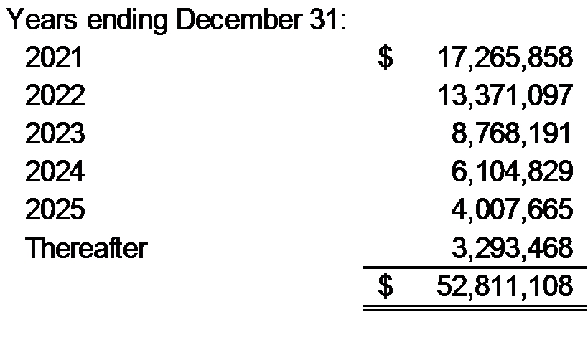
The minimum lease payments above do not include common area and maintenance (CAM) charges, which are also required contractual obligations under the operating leases. They also include the minimum lease terms and not optional renewal periods. The CAM charges are not fixed and can fluctuate from year to year. Rent expense, including CAM charges, was $19,297,674 and $20,345,784 for the years ended December 31, 2020 and 2019, respectively, and is included as a component of occupancy expense or corporate office costs on the consolidated statements of operations, depending on the nature and use of the underlying asset.

Self-Insurance
The Company has a self-insurance medical and dental plan for its employees. Losses are limited through the use of stop-loss policies from reinsurers. Specific losses for claims are limited to $150,000 annually per covered employee. The Company’s aggregate annual loss limitation is based on a formula that considers, among other things, the total number of employees. The Company paid claims of $8,323,272 and $7,159,591 during the years ended December 31, 2020 and 2019, respectively. The Company accrued an estimate for claims payable totaling $692,491 and
17

$729,588 at December 31, 2020 and 2019, respectively.

Note 8. Related Party Transactions

Lease Agreements
The Company leases office space for certain of its operating locations and one of its corporate locations from real estate holding companies owned by employees or officers of the Company. Rent expense for these facilities was approximately $2,359,359 and $2,401,271 for the years ended December 31, 2020 and 2019, respectively, and is included as a component of occupancy costs or corporate costs, depending on the use of the underlying asset, on the consolidated statements of operations.

Note 9. Certain Significant Risks and Uncertainties

Government Regulation
The Company and others in the health care business are subject to certain inherent risks, including the following.

Substantial dependence on revenue derived from reimbursement by the federal Medicare and state
Medicaid programs, which have been drastically cut in recent years and which entail exposure to various healthcare fraud statutes; government regulations, government budgetary constraints, and proposed legislative and regulatory changes; and lawsuits alleging malpractice and related claims. Such inherent risks require the use of certain management estimates in the preparation of the Company’s financial statements and it is reasonably possible that a change in such estimates may occur in the near term.

The Company’s operations are subject to a variety of federal, state, and local legal and regulatory risks,
including without limitation, the federal Anti-Kickback statute and the federal Ethics in Patient Referral Act (so-called Stark Law), many of which apply to virtually all companies engaged in the health care services industry. The Anti-Kickback statute prohibits, among other things, the offer, payment, solicitation or receipt of any form of remuneration in return for the referral of Medicare and Medicaid patients. The Stark Law prohibits, with limited exceptions, financial relationships between ancillary service providers and referring physicians.

The Medicaid and Medicare programs are highly regulated. Compliance with laws and regulations governing the Medicare and Medicaid programs is subject to government review and interpretation, as well as significant regulatory action, including fines, penalties and possible exclusion from the Medicare and Medicaid programs. The failure of the Company to comply with applicable reimbursement regulations could adversely affect the Company’s business. It is not possible to quantify fully the effect of potential legislative or regulatory changes, the administration of such legislation or any other governmental initiatives on the Company’s business. Accordingly, there can be no assurance that the impact of these changes or any future health care legislation will not adversely affect the Company’s business. There can be no assurance that payments under governmental and private third-party payer programs will be timely, will remain at levels comparable to present levels or will, in the future, be sufficient to cover the costs allocable to patients eligible for reimbursement pursuant to such programs.

The Company’s financial condition and results of operations may be materially and adversely affected by the reimbursement process, which in the healthcare industry is complex and can involve lengthy delays. In addition, under the Medicare program, if the federal government makes a formal demand for reimbursement, even related to contested items, payment must be made for those items before the provider is given an opportunity to appeal and resolve the case.

Malpractice Insurance
The Company has malpractice insurance policies covering all therapists providing services for the Company. The insurance coverage is $1,000,000 per incident and $3,000,000 aggregate per Named Insured entity per policy year subject to a $10,000,000 policy aggregate. The Company also purchases $10,000,000 in excess liability coverage. The Company believes this is adequate coverage to protect against any outstanding claims and litigation.

Litigation
The Company is involved in claims and legal actions arising in the ordinary course of business. In the opinion of management, the ultimate disposition of these matters will not have a material adverse effect on the Company’s financial position, results of activities or liquidity. See Note 12 for further discussion of certain settlement agreements reached in 2019.

18

COVID-19
The Company is aware of certain risks regarding the spread of COVID-19, a disease caused by a novel strain of coronavirus. On March 11, 2020 the World Health Organization declared COVID-19 a pandemic, and on March 13, 2020 a national emergency was declared in the U.S. State and local governments, including regions in which the Company operates, have imposed measures to curtail certain aspects of public life including stay-at-home orders and bans on elective surgeries. The containment measures taken by state and local governments negatively impacted the physical therapy business. The industrial injury prevention business was less impacted by the pandemic.

The Company expects that its business could continue to be adversely affected by risks, including the public perception of risks, related to the COVID-19 outbreak and efforts taken to contain it. These risks, and the public perception of the risks, caused, and can be expected to continue to cause, patients to avoid public places, including the Company’s clinics and operations. Furthermore, the overall economic impact of the pandemic could also adversely affect our patients' financial condition, resulting in reduced spending for the healthcare services the Company provides. Risks related to the COVID-19 outbreak have led to the closures of certain clinics and could lead to the complete or partial closure of additional clinics and operations.

In response, management developed a range of forecasts assuming various scenarios, and has developed specific plans given known circumstances through December 2020 and estimates over a range of time horizons. Management’s plans included reductions in variable costs in response to reductions in demand, including compensation and benefits, general and administrative, and certain corporate expenses. A thorough assessment was completed across the organization to identify both fixed and variable cost reduction opportunities, including negotiating rent deferments and abatements for the Company’s numerous leases. The Company also applied for and received funding from various sources established by the CARES Act. Refer to Note 14 for additional information on CARES Act funding received by the Company in 2020. In addition, a substantial portion of the Company’s outstanding borrowings are due in 2023 and 2024, further alleviating financing needs for a period of not less than 12 months from the financial statements issuance date.

Based on information currently available to it and known trends, management’s view is that it is probable that its overall plan and related cost reduction activities will appropriately alleviate the risk of material adverse impact to the Company from the COVID-19 outbreak, and that the Company will be able to continue to meet its obligations as they become due for at least the next 12 months.

Note 10. Income Taxes

New Tax Legislation
The United States government approved and signed into law on December 22, 2017, the Tax Cuts and Jobs Act reform legislation. This legislation makes significant changes in U.S. tax law including a reduction in the corporate tax rates, changes to net operating loss carryforwards and carrybacks, and a repeal of the corporate alternative minimum tax. The legislation reduced the U.S. corporate tax rate from the current graduated system, with a top rate of 35%, to a flat rate of 21% starting in 2018.

Deferred income taxes are provided on the liability method whereby deferred tax assets are recognized for deductible temporary differences and operating loss and tax credit carryforwards, and deferred tax liabilities are recognized for taxable temporary differences. Temporary differences are the differences between the reported amounts of assets and liabilities and their tax basis. Deferred tax assets are reduced by a valuation allowance when, in the opinion of management, it is more likely than not that some or all of the deferred tax assets will not be realized. Deferred tax assets and liabilities are adjusted for the effects of changes in tax laws and rates on the date of enactment.

The components of the provision for income taxes for the years ended December 31, 2020 and 2019 are as follows:

19

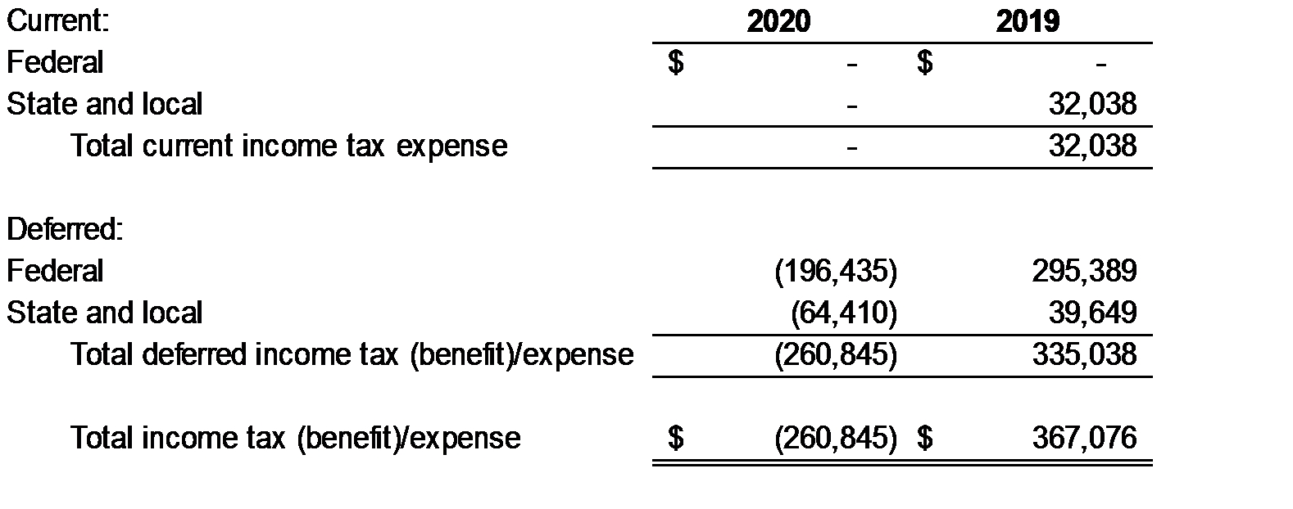
Income tax expense is included on the consolidated statements of operations.

The Company has recorded a valuation allowance for the years ended December 31, 2020 and 2019 of $514,969 and $429,415, respectively, as management does not expect to realize the full benefit of interest deductions in future years. The net deferred tax liability is part of other non-current liabilities on the consolidated balances sheet.

The expense for income taxes differs from the amount computed by applying the statutory federal income tax rate to loss before provision for income taxes. For the years ended December 31, 2020 and 2019, the Company had a benefit for income taxes of $260,845 and an expense of $367,076, respectively. The significant difference between actual tax expense and the amount computed by applying the statutory federal income tax rate to the loss before provision for income taxes is due to the fact that substantially all of the Company's loss before income taxes is not subject to federal or state income taxes due to its tax status as a partnership.

Temporary differences between the financial reporting carrying amounts and the tax basis of assets and liabilities give rise to deferred taxes. The components of the deferred income tax assets and liabilities for the years ended December 31, 2020 and 2019 are as follows:

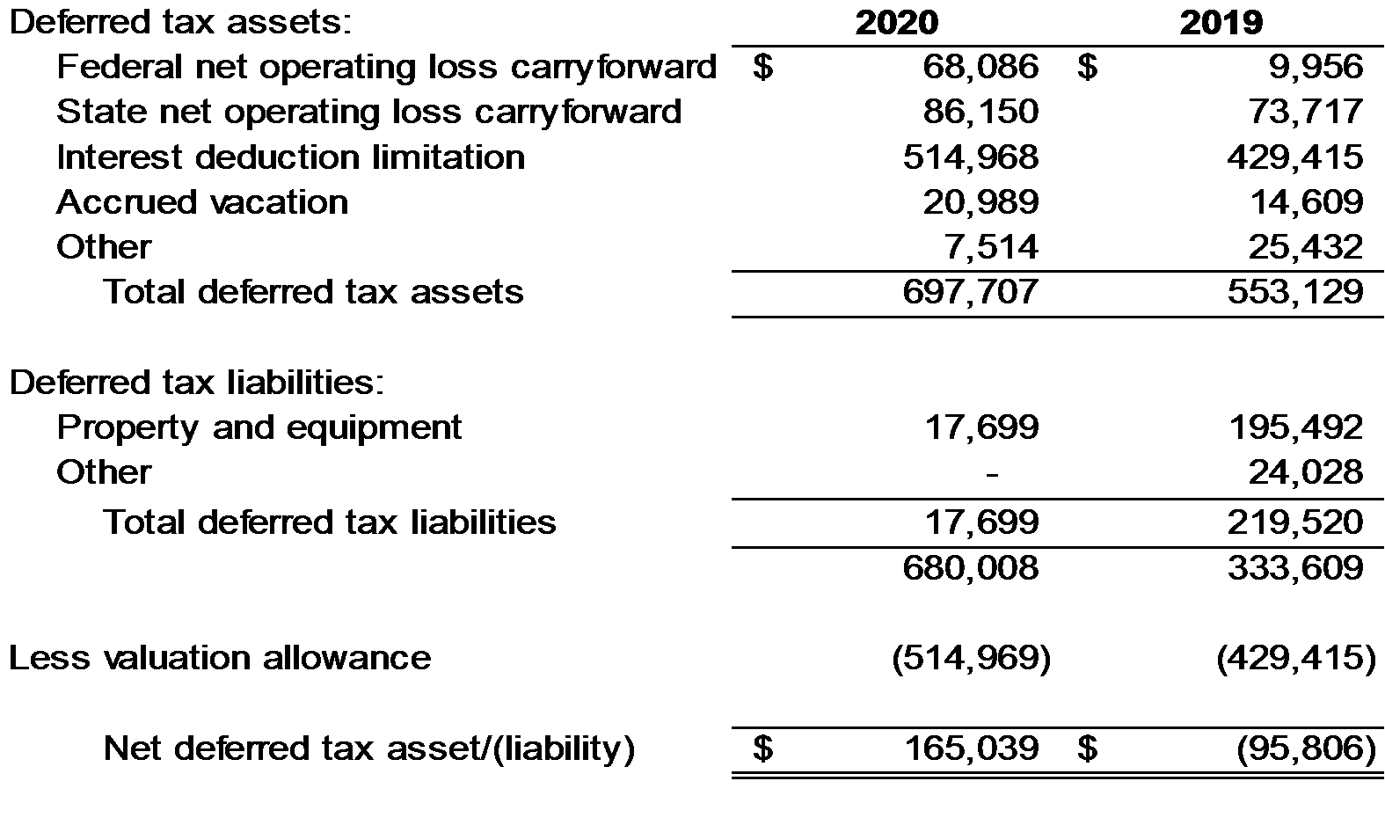
General
The Company is subject to income taxes in the U.S. federal and Pennsylvania tax jurisdictions. Tax regulations within each jurisdiction are subject to the interpretations of the related tax laws and regulations and require significant judgement to apply.

In assessing the realizability of deferred tax assets, the Company considers whether it is more likely than not that some portion, or all of the deferred tax assets, will not be realizable. The ultimate realization of deferred tax assets is dependent upon the generation of future taxable income during the periods in which those temporary differences
20

become deductible. As noted above, the Company has recorded a valuation allowance of $514,969 and $429,415 for the years ended December 31, 2020 and 2019, respectively, against the deferred tax asset arising from interest expense disallowed pursuant to IRC section 163(j). Other than this amount, the Company believes that it is more likely than not that the net deferred tax assets as shown above will be realized when future taxable income is generated through the reversal of existing taxable temporary differences and income that is expected to be generated by businesses that have a history of generating taxable income.

ASC Topic 740 prescribes a minimum recognition threshold and measurement attribute methodology for the financial statement recognition and measurement of tax positions taken or expected to be taken in a tax return. The Company did not have unrecognized tax benefits for the years ended December 31, 2020 and 2019 and does not anticipate this to change significantly over the next 12 months. The Company will recognize interest and penalties accrued on any unrecognized tax benefits as a component of income tax expense.

The Company is subject to audit for all open years in which the statute of limitations is open. With few exceptions, the Company is no longer subject to U.S. federal, state and local tax examinations for the years before 2017. The Company is not currently under examination by any taxing authorities.

Note 11. Members’ Equity

Equity prior to the Restructuring of Credit Agreements and Members’ Equity

The Company had preferred units and common units authorized, issued and outstanding as of December 31, 2018, and for the portion of the fiscal year 2019 prior to the restructuring of credit agreements and members equity that occurred on June 28, 2019. See Note 5 for additional details regarding the restructuring.

Equity after the Restructuring of Credit Agreements and Members’ Equity

Subsequent to the restructuring of credit agreements and members’ equity that occurred on June 28, 2019, the Company has seven classes of membership interests, Class A, Class B, Class C, Class D-1, Class D-2, Class E and Preferred Interests.

Upon any liquidation, dissolution, or change in control, the Company shall distribute from its assets the amounts in the order of priority set forth below but, in each case, only to the extent that all amounts then required to be paid ranking prior thereto have been paid in full.

Order of Liquidation | Interest Class | Liquidation Preference Amount
1 | Preferred Interests | Preferred Return (as subsequently defined)
2 | Preferred Interests | Preferred Invested Capital
3 | Class A Common Interests | Class A Common Invested Capital
4 | All Classes of Common Interests | Assets distributed ratably to each class with the exception of the following:  ●Class C common units’ share of allocations is increased, and Class A common units’ share of allocations is correspondingly decreased, upon certain cumulative distribution thresholds  ●Class D-1 interests that are subject to a 50% reduction in distributions in excess of a specified enterprise value  ●Class D-2 common units are allocated 5% of such distributions in excess of a specified enterprise value

Common Interests

Class A common interests are held by the Second Lien Lenders and are the only interests with voting rights. Additionally, Class A common interests have preference in liquidation and distribution compared to other classes of common interests, up to the amount of Class A invested capital. As of December 31, 2020 and 2019, Class A
21

invested capital totaled $8,580,000 and $7,180,000, respectively. All classes of common interests are junior to First and Second Lien Debt, as well as Preferred Interests with regards to all distributions, including distributions from liquidation, dissolution or change in control.

In the event of change in control, common interests are entitled to distributions of such change in control proceeds in accordance with the distribution preferences. In the event of a successful initial public offering, all common interest holders have the right to require the Company to convert their common interests into the common stock issued in connection with the initial public offering. An initial public offering is not contemplated at this time.

Pursuant to the RSA executed on June 28, 2019, the preferred interest holders and the common interest holders have modified the LLC agreement of the Company in order to provide certain restrictions on the transfer of members’ interests, to grant first refusal and co-sale rights to the Company and to certain of the preferred interest holders, and to provide for obligations to participate in certain sales of capital stock of the Company.

In December 2019, the Company’s Board approved a Long-Term Management Incentive Plan which allows for the issuance of Class E interests to certain members of management. Interest units under this plan were issued throughout 2020.

Redeemable Preferred Interests

The redeemable preferred interests are held by the Second Lien Lenders and were recorded at the amount of cash received at the date the interests were issued. Each interest has a liquidation preference equal to the applicable original issue price, plus the Preferred Return of LIBOR (floor of 1.00%) plus 10.00% compounded annually.

Second Lien Lenders have a controlling interest in the Company through their Class A interests, therefore the preferred interests are redeemable at the option of the holders as the Second Lien Lenders have the power to direct the Company to make the distributions to redeem the preferred interests. Furthermore, in connection with a successful initial public offering, the redeemable preferred interest holders have the right to either exchange their preferred interests for the common stock issued in connection with the initial public offering, or redeem the preferred interests, for cash, at the value equal to the aforementioned liquidation preference. If the holders elect to convert to newly issued common stock, redeemable preferred interests would be converted into common stock at an amount equal to the preferred interest liquidation preference divided by the price at which the shares of common stock are sold to the public in an initial public offering.

As the preferred interests are redeemable, and the redemption is not solely in control of the Company, the Company has separately presented redeemable preferred stock from permanent equity and reports these interests on the consolidated balance sheets in a mezzanine equity section. In the Company’s financial statements, the value of the preferred interests is increased each period by the amount of preferred return. Furthermore, the liquidation preference is reflected as accretion of redeemable preferred interests in the consolidated statements of operations and is accounted for as an increase to net loss attributable to common interest holders. The accretion amount for the years ended December 31, 2020 and 2019 was $1,415,700 and $663,257, respectively.

In connection with their ownership of the Class A common interests and redeemable preferred interests, the Second Lien Holders are obligated to make additional cash contributions up to $10,000,000 in the event that the Company’s operating cash levels are below a certain threshold for a number of consecutive days. Such cash contributions are allocated 40% to Class A common interests and 60% redeemable preferred interest capital accounts. During the years ended December 31, 2020 and 2019, Second Lien Lenders have contributed $3,500,000 and $2,950,000 of additional capital, respectively.

Note 12. Other Liabilities

In June 2019, the Company entered into confidential settlement and release agreements with related parties. The first settlement agreement provides for payments totaling $4,000,000. The second settlement agreement provides for payments totaling $2,000,000. These settlements have been recognized as other expense on the consolidated statements of operations, and as other current or other non-current liabilities on the consolidated balance sheets at December 31, 2019. The company made payments of $1,630,952 and $3,833,333 for the years ended December 31, 2020 and 2019, respectively.

In December 2019, the Company entered into a confidential settlement and release agreement with a third party.
22

The agreement provides for payments totaling $2,075,000.This settlement has been recognized as other expense on the consolidated statements of operations, and as other current or other non-current liabilities on the consolidated balance sheets as of December 31, 2019. This liability has been satisfied as of December 31, 2020.

Note 13. Restructuring Costs

Restructuring costs include charges associated with exit or disposal activities that meet the definition of restructuring under FASB ASC Topic 420, Exit or Disposal Cost Obligations. Restructuring costs incurred under these plans include (i) one-time termination benefits related to employee separations, and (ii) contract termination costs, including the costs for closing outpatient physical therapy operating locations. Restructuring liabilities are recorded in accrued expenses and other non-current liabilities on the consolidated balance sheets.

The following table shows the activity in accrued restructuring and related charges for the years ended December 31, 2020 and 2019:

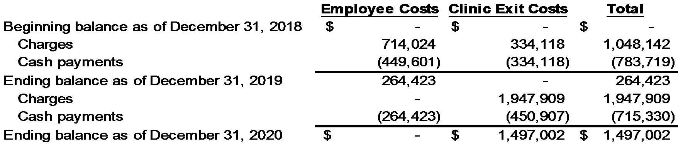

Note 14. CARES Act

Provider Relief Funds
On March 27, 2020, the Coronavirus Aid, Relief, and Economic Security Act (“CARES Act”) was enacted. The CARES Act provided additional waivers, reimbursement, grants and other funds to assist health care providers during the COVID-19 pandemic, including appropriations for the Public Health and Social Services Emergency Fund, also referred to as the Provider Relief Fund, to be used for preventing, preparing, and responding to COVID-19, and for reimbursing “eligible health care providers for health care related expenses or lost revenues that are attributable to coronavirus.” These health care related expenses could include costs associated with constructing temporary structures or emergency operation centers, retrofitting facilities, purchasing medical supplies and equipment including personal protective equipment and testing supplies, and increasing workforce and trainings. The Company is able to use payments received under the Provider Relief Fund through June 30, 2021.

On December 27, 2020, the Coronavirus Response and Relief Supplemental Appropriations Act of 2021 (“CRRSA Act”) was signed into law. The CRRSA Act legislated certain provisions and reporting requirements associated with the payments received under the Provider Relief Fund, including provisions surrounding how an entity should calculate lost revenues and a provision specifying that a parent organization may allocate all or a portion of the General and Targeted Distributions it has received among its other subsidiaries. As discussed above, the payments received under the Provider Relief Fund are to be used for health care related expenses and lost revenues attributable to the COVID-19 pandemic. These amounts, which are to be calculated in accordance with the terms and conditions set forth by the Department of Health and Human Services (“HHS”), must be determined for each of the Company’s subsidiaries by taxpayer identification number. Further, the payments are to be applied first against health care related expenses and then applied to lost revenue attributable to the COVID-19 pandemic.

On January 15, 2021, HHS released an updated post-payment notice of reporting requirements which incorporates the provisions of the CRRSA Act. HHS continues to release updated guidance and new or modified responses to Frequently Asked Questions regarding the Provider Relief Fund payments. The Company believes that any changes made to the terms and conditions from those contained in the CRRSA Act are a change to, rather than clarification of, the terms and conditions which existed as of December 31, 2020. Further, the Company believes that the terms and conditions surrounding the Provider Relief Fund payments are subject to additional changes given the series of post-payment notices of reporting requirements and other guidance issued by HHS during the year ended December 31, 2020, which, in some instances, significantly altered the terms and conditions surrounding the Provider Relief Fund payments.

23

The Company’s consolidated subsidiaries received $3,141,085 of payments under the Provider Relief Fund as of December 31, 2020. Under the Company’s accounting policy, payments are recognized on the books and records of the Company’s subsidiaries as income when it is reasonably assured that it has complied with the terms and conditions of the funds. The Company evaluated its compliance with the terms and conditions set forth within the CRRSA Act and by HHS as of December 31, 2020, and recognized $3,141,085 as other operating income on the consolidated statements of operations.

Medicare Accelerated and Advance Payments Program
In accordance with the CARES Act, CMS temporarily expanded its current Accelerated and Advance Payment Program for Medicare providers. Under this program, qualified healthcare providers could receive advanced or accelerated payments from CMS. The Company’s consolidated subsidiaries received $7,770,162 of advanced payments under this program. These payments were received in April 2020.

On October 1, 2020, a short-term government funding bill was signed into law. This bill, among other things, extended the repayment terms for providers who received advanced payments under the Medicare Accelerated and Advance Payment Program. The bill modified the terms of repayment so that a provider can request no recoupment for one year after the advanced payment was issued, followed by a 25.0% recoupment of Medicare payments during the next 11 months, and 50.0% recoupment of Medicare payments during the last six months. Any amounts that remain unpaid after 29 months would be subject to a 4.0% interest rate.

Due to the mechanism in which the advanced payments are repaid, there is uncertainty surrounding when the Company will repay the advances it received under this program. Accordingly, amounts received under the Accelerated and Advance Payment Program are reflected in other current liabilities in the consolidated balance sheets as of December 31, 2020 until all performance obligations have been met as the payments were made on behalf of patients before services were provided.

Paycheck Protection Program
On April 21, 2020, the Company received loan proceeds in the amount of $10,000,000 under the Paycheck Protection Program (“PPP”) and has elected to account for the funds received in accordance with ASC Topic 470, Debt. The PPP, established as part of the CARES Act, enables the Small Business Administration (SBA) to guarantee low-interest rate loans to certain entities. The PPP loans may be partially or fully forgiven if employees are retained and funds are used for eligible expenses including payroll costs, costs to continue group healthcare benefits, mortgage payments, rent, utilities, and interest on other debt obligations. The Company believes it used these funds on eligible expenses during the covered period and applied for full forgiveness with the SBA. As of the date of these financial statements, the Company has not received a decision on its forgiveness application from the SBA.

The loan, which was in the form of a note dated April 18, 2020, matures on April 18, 2022 and bears interest at a rate of 1.00%. Payments are deferred during the deferral period, which began on the loan origination date and extends until a forgiveness decision is rendered by the SBA. The Company has elected to classify the outstanding balance of the loan as long-term debt on the consolidated balance sheets as of December 31, 2020 given it expects to receive forgiveness within the next operating cycle and as such, the balance does not represent an expected use of current resources. Any unforgiven portion of the PPP loan would be payable under the terms of the note.

Employer Payroll Tax Deferral
In April 2020, the Company began deferring payment on its share of payroll taxes owed, as allowed by the CARES Act through December 31, 2020. The Company is able to defer half of its share of payroll taxes owed until December 31, 2021, with the remaining half due on December 31, 2022. As of December 31, 2020, the Company deferred $5,166,294 of payroll taxes. These amounts are reflected in accrued compensation expenses and other non-current liabilities on the consolidated balance sheets as of December 31, 2020.

Note 15. Subsequent Events

The Company evaluated subsequent events through March 22, 2021, the date which the consolidated financial statements were issued.

On March 1, 2021, the Company entered into the Third Amendment to the Amended and Restated Credit Agreement. There was no change to the Company’s borrowings under this Third Amendment.

24

On March 1, 2021, the Company acquired all of the capital stock of Physical Therapy Enterprises, Inc., a Virginia Corporation, which operates a single physical therapy clinic based in Norfolk, VA for $2,200,000 of cash consideration and $800,000 of contingent consideration. Of the $2,200,000 cash consideration, $836,000 was paid at closing and the remainder is payable through June 2023 as defined in the purchase agreement. The Company has not completed the accounting for this transaction as of the date of these financial statements.

On March 1, 2021, the Company acquired certain assets of two physical therapy companies based in Rockville, MD and Hagerstown, MD for $135,882 paid in cash on the closing date. The Company has not completed the accounting for this transaction as of the date of these financial statements.

25

Schedule I: Condensed Parent Company Financial Statements

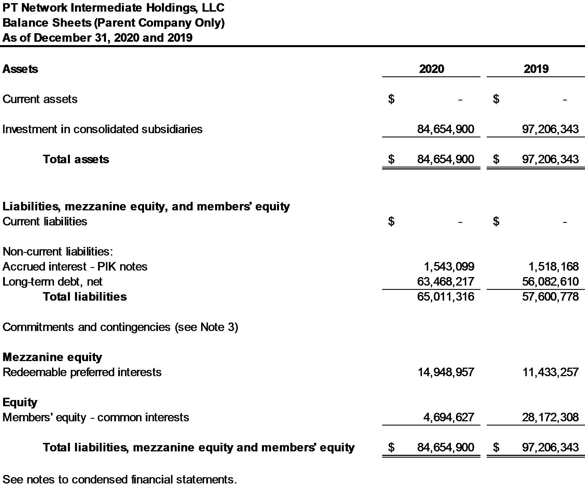

26

Schedule I: Condensed Parent Company Financial Statements (continued)

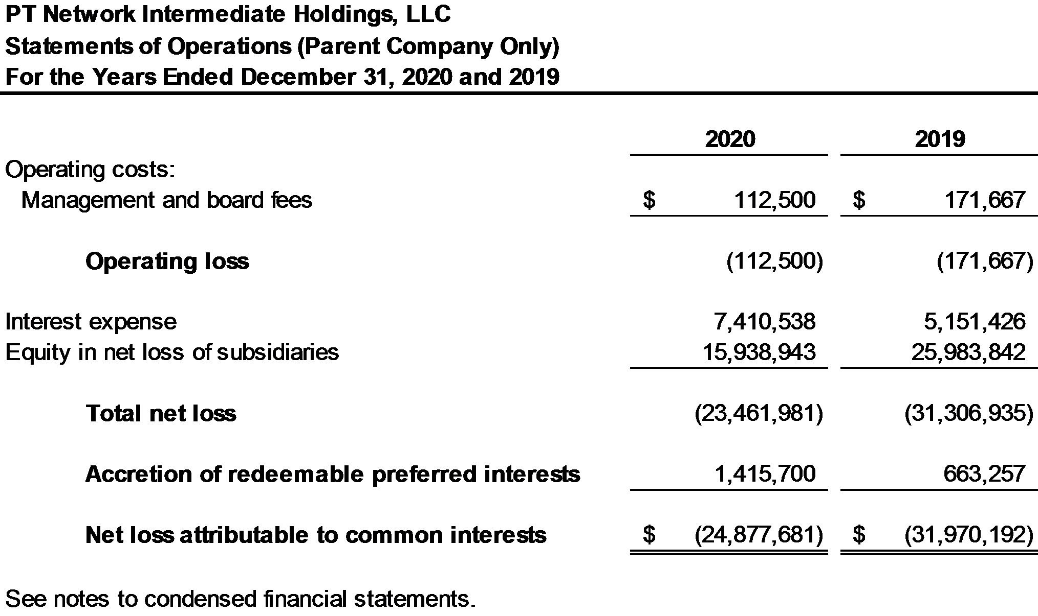

27

Schedule I: Condensed Parent Company Financial Statements (continued)

PT Network Intermediate Holdings, LLC
Statements of Cash Flows (Parent Company Only)
For the Years Ended December 31, 2020 and 2019

PT Network Intermediate Holdings, LLC (PTNIH) does not maintain a bank account as all cash transactions are at the PT Network, LLC (PTN) level or other consolidated subsidiaries. There was no cash activity for the years ended December 31, 2020 and 2019 at the PTNIH level.

PTNIH had the following non-cash investing and financing activity for the years ended December 31, 2020 and 2019:

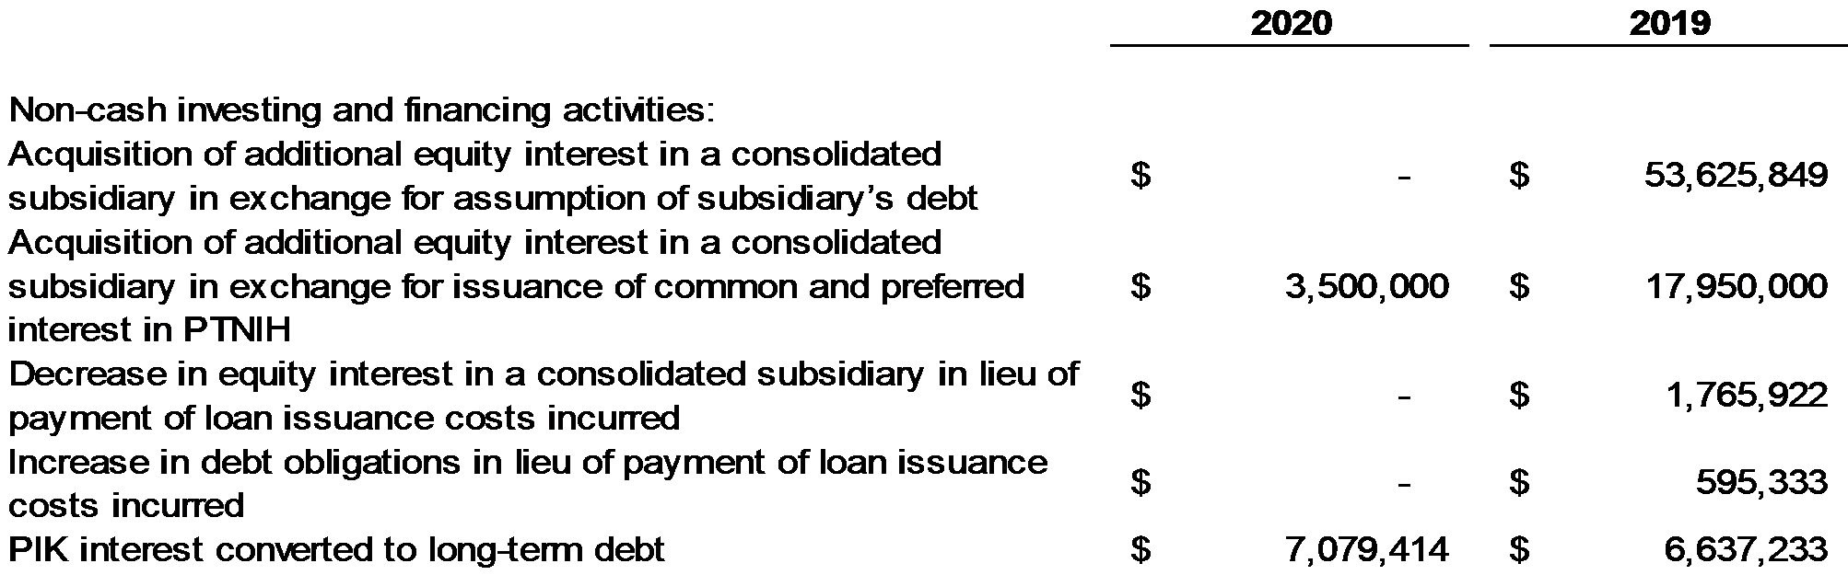

See notes to condensed financial statements.

28

Note 1. Basis of Presentation

PTNIH is a holding company and conducts substantially all of its business operations through its subsidiaries. These condensed Parent Company financial statements and related notes have been prepared in accordance with Rule 12-04, Schedule I of Regulation S-X, as the restricted net assets of the subsidiaries of PTNIH exceed 25% of the consolidated net assets of PTNIH as stipulated by Rule 5-04, Section I from Regulation S-X. The ability of the operating subsidiaries to pay dividends is restricted due to the terms of the subsidiaries’ credit agreement as defined in Note 5 to the consolidated financial statements. The total amount of such restricted net assets totaled $84,654,900 and $97,206,343 at December 31, 2020 and 2019, respectively. Any information, other than listed herein, is omitted as the information is either not applicable or has been furnished in the consolidated financial statements or notes thereto. These statements should be read in conjunction with the consolidated financial statements and the notes to the consolidated financial statements.

Note 2. Long-Term Debt

In April 2019, the Second Lien Agent and each Second Lien Lender entered into a Restructuring Support Agreement (RSA) with respect to a proposed restructuring of the Loan Parties, which provided for consensual restructuring of the Company’s debt and equity structure (Restructuring). This agreement was amended and restated in June 2019. PTNIH assumed the Company’s obligation as the borrower under the restructured Second Lien credit agreement.
In accordance with the Restructured Second Lien Credit Agreement, future maturities required on long-term debt are as follows:

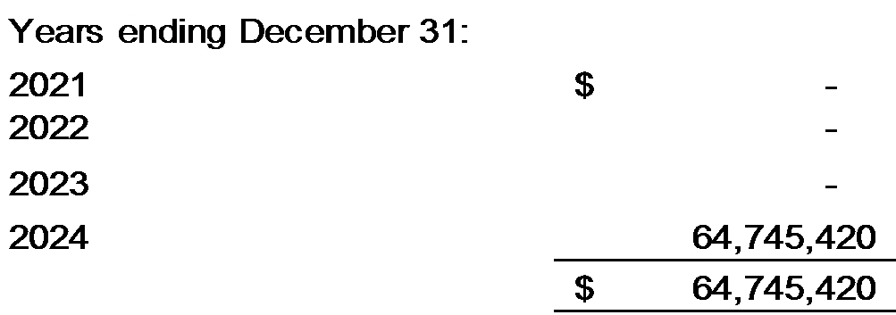

Debt issuance costs, which are classified as a reduction to the carrying amount of the debt above, consist of the following at December 31, 2020 and 2019:

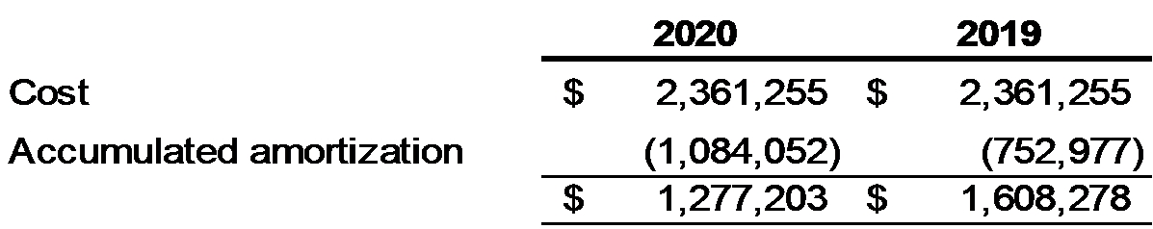

Amortization of debt issuance costs was $331,075 and $352,238 for the years ended December 31, 2020 and 2019, and is included in interest expense on the condensed statements of operations. Amortization for the next four years is as follows:

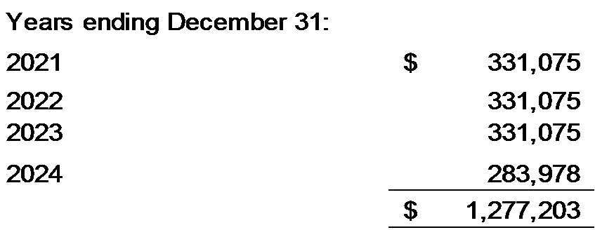

Interest expense of $7,079,463 and $3,599,322 for the years ended December 31, 2020 and 2019 are included in interest expense on the condensed statements of operations. Accrued interest on the Second Lien Credit agreement that will be paid-in-kind was $1,543,099 and $1,518,168 at December 31, 2020 and 2019, respectively. Accrued
29

interest – PIK notes is disclosed on the face of the condensed balance sheet.

See Note 5 of the consolidated financial statements for additional information regarding the long-term obligations of PTNIH and its consolidated subsidiaries.

Note 3. Guarantees

All loans under the Restructured First Lien Credit Agreement discussed in Note 5 of the consolidated financial statements are collateralized by substantially all of the assets of PTNIH, PTN, and its subsidiaries, including the equity interests held by such entities. All loans under the Restructured Second Lien Credit Agreement discussed in Note 5 of the consolidated financial statements are collateralized by PTNIH’s limited liability company membership interest in PTN.

See Note 5 of the Consolidated Financial Statements in this Report for information regarding the guarantees provided by PTNIH.

30

EXHIBIT 99.7

PT Network Intermediate Holdings, LLC
Unaudited Consolidated Financial Report
December 31, 2018

Contents
Unaudited Financial Statements of PT Network Intermediate Holdings, LLC
Unaudited Consolidated Balance Sheet as of December 31, 2018 |  | 1
Unaudited Consolidated Statement of Operations for the Year Ended December 31, 2018 |  | 2
Unaudited Consolidated Statement of Members’ Equity for the Year Ended December 31, 2018 |  | 3
Unaudited Consolidated Statement of Cash Flows for the Year Ended December 31, 2018 |  | 4
Unaudited Notes to Consolidated Financial Statements |  | 5-18
Unaudited Schedule I: Condensed Parent Company Financial Statements |  | 19-21
Unaudited Notes to Schedule I: Condensed Parent Company Financial Statements |  | 22

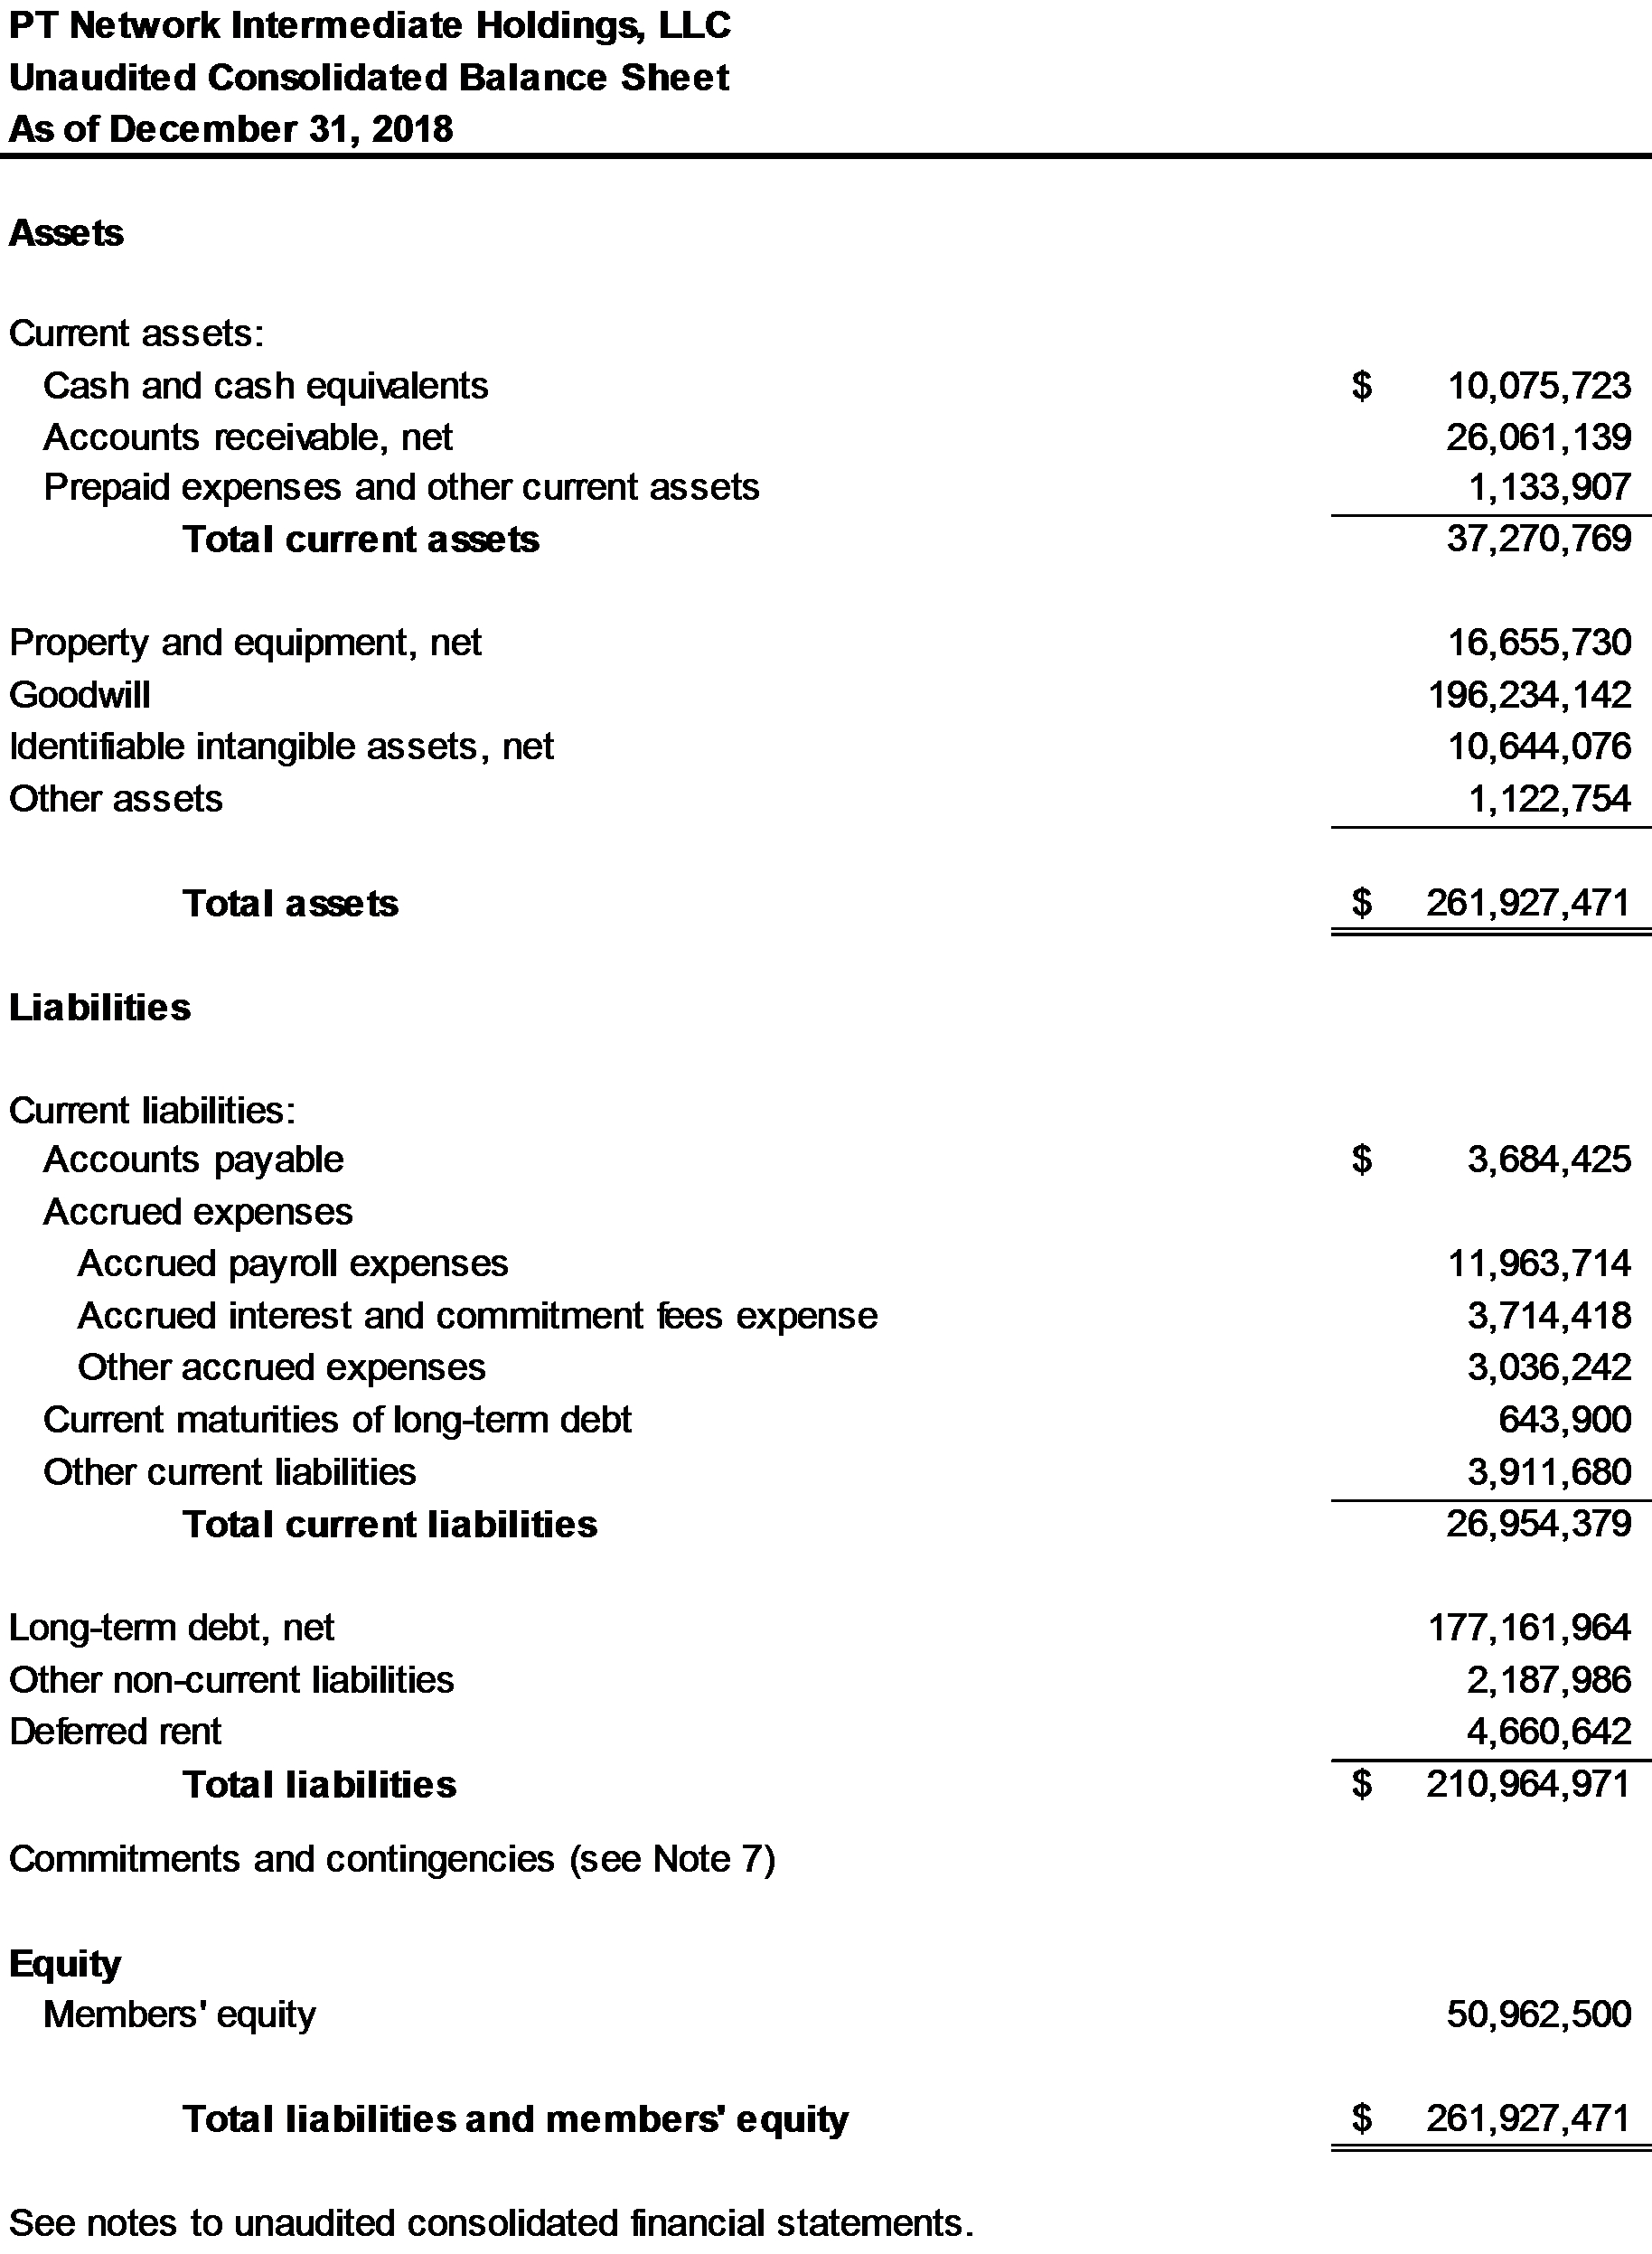
1

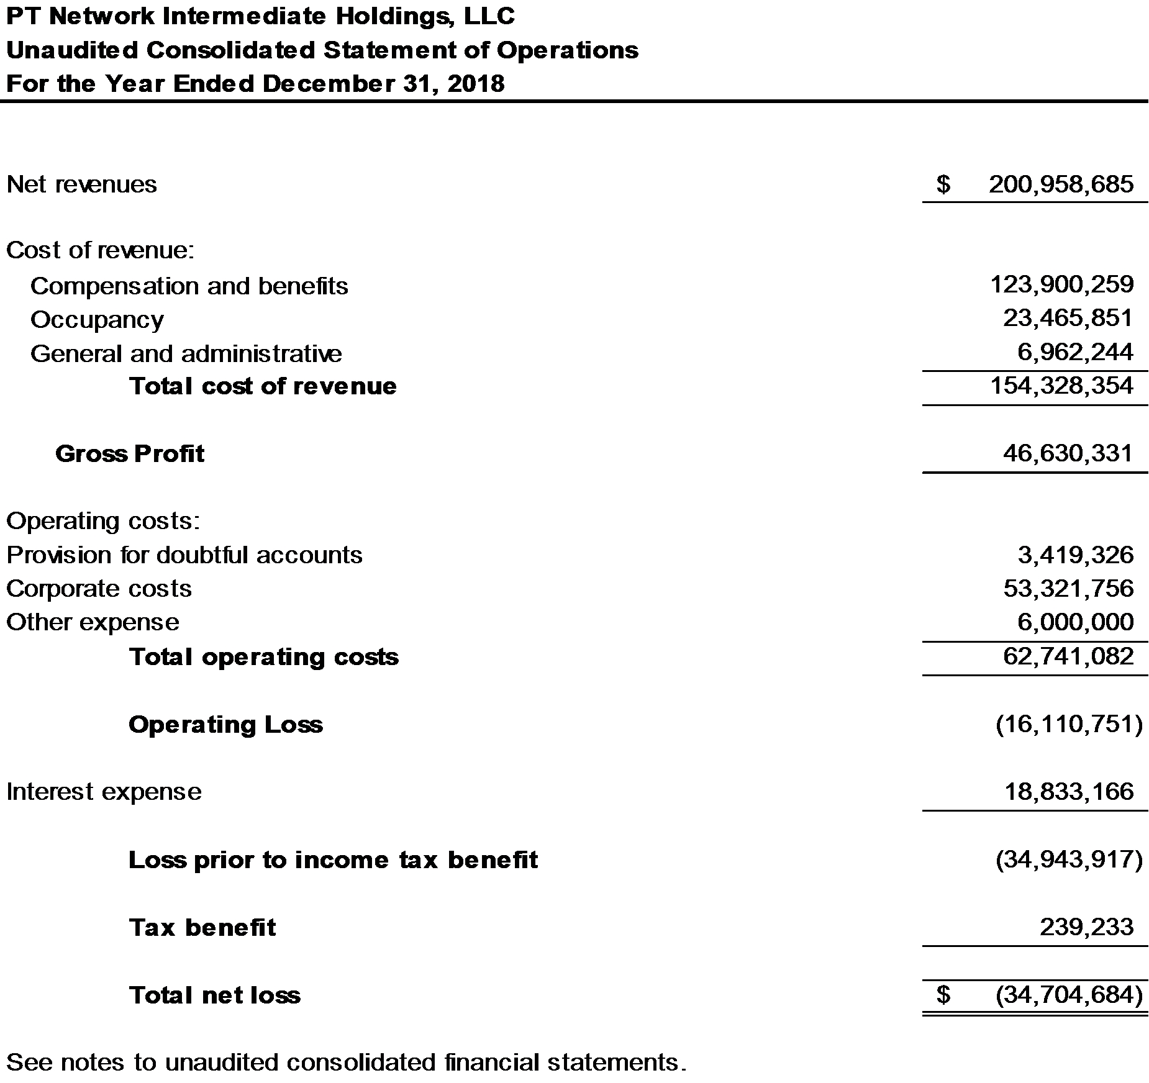

2

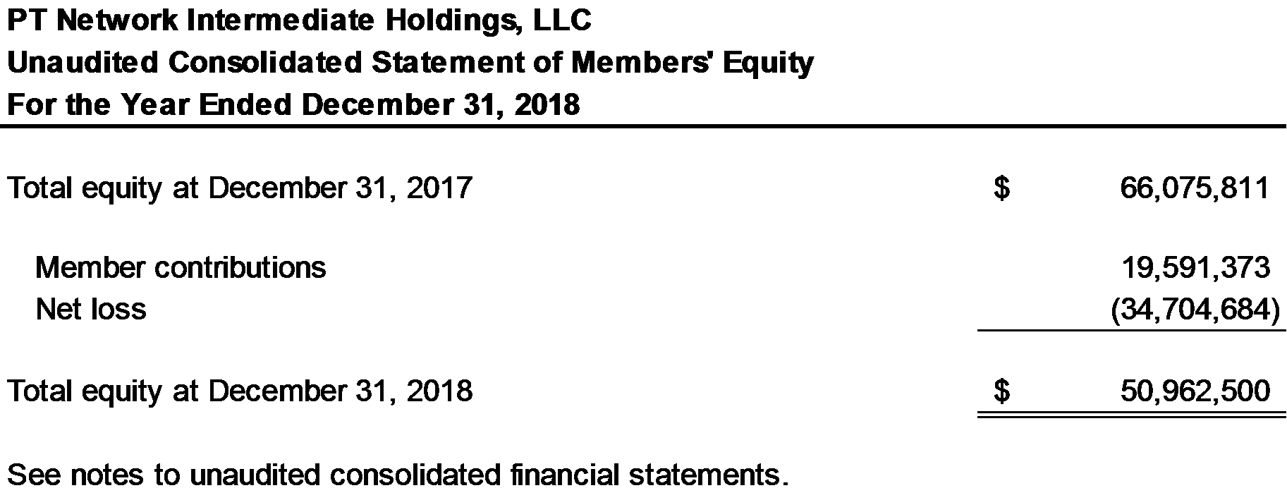

3

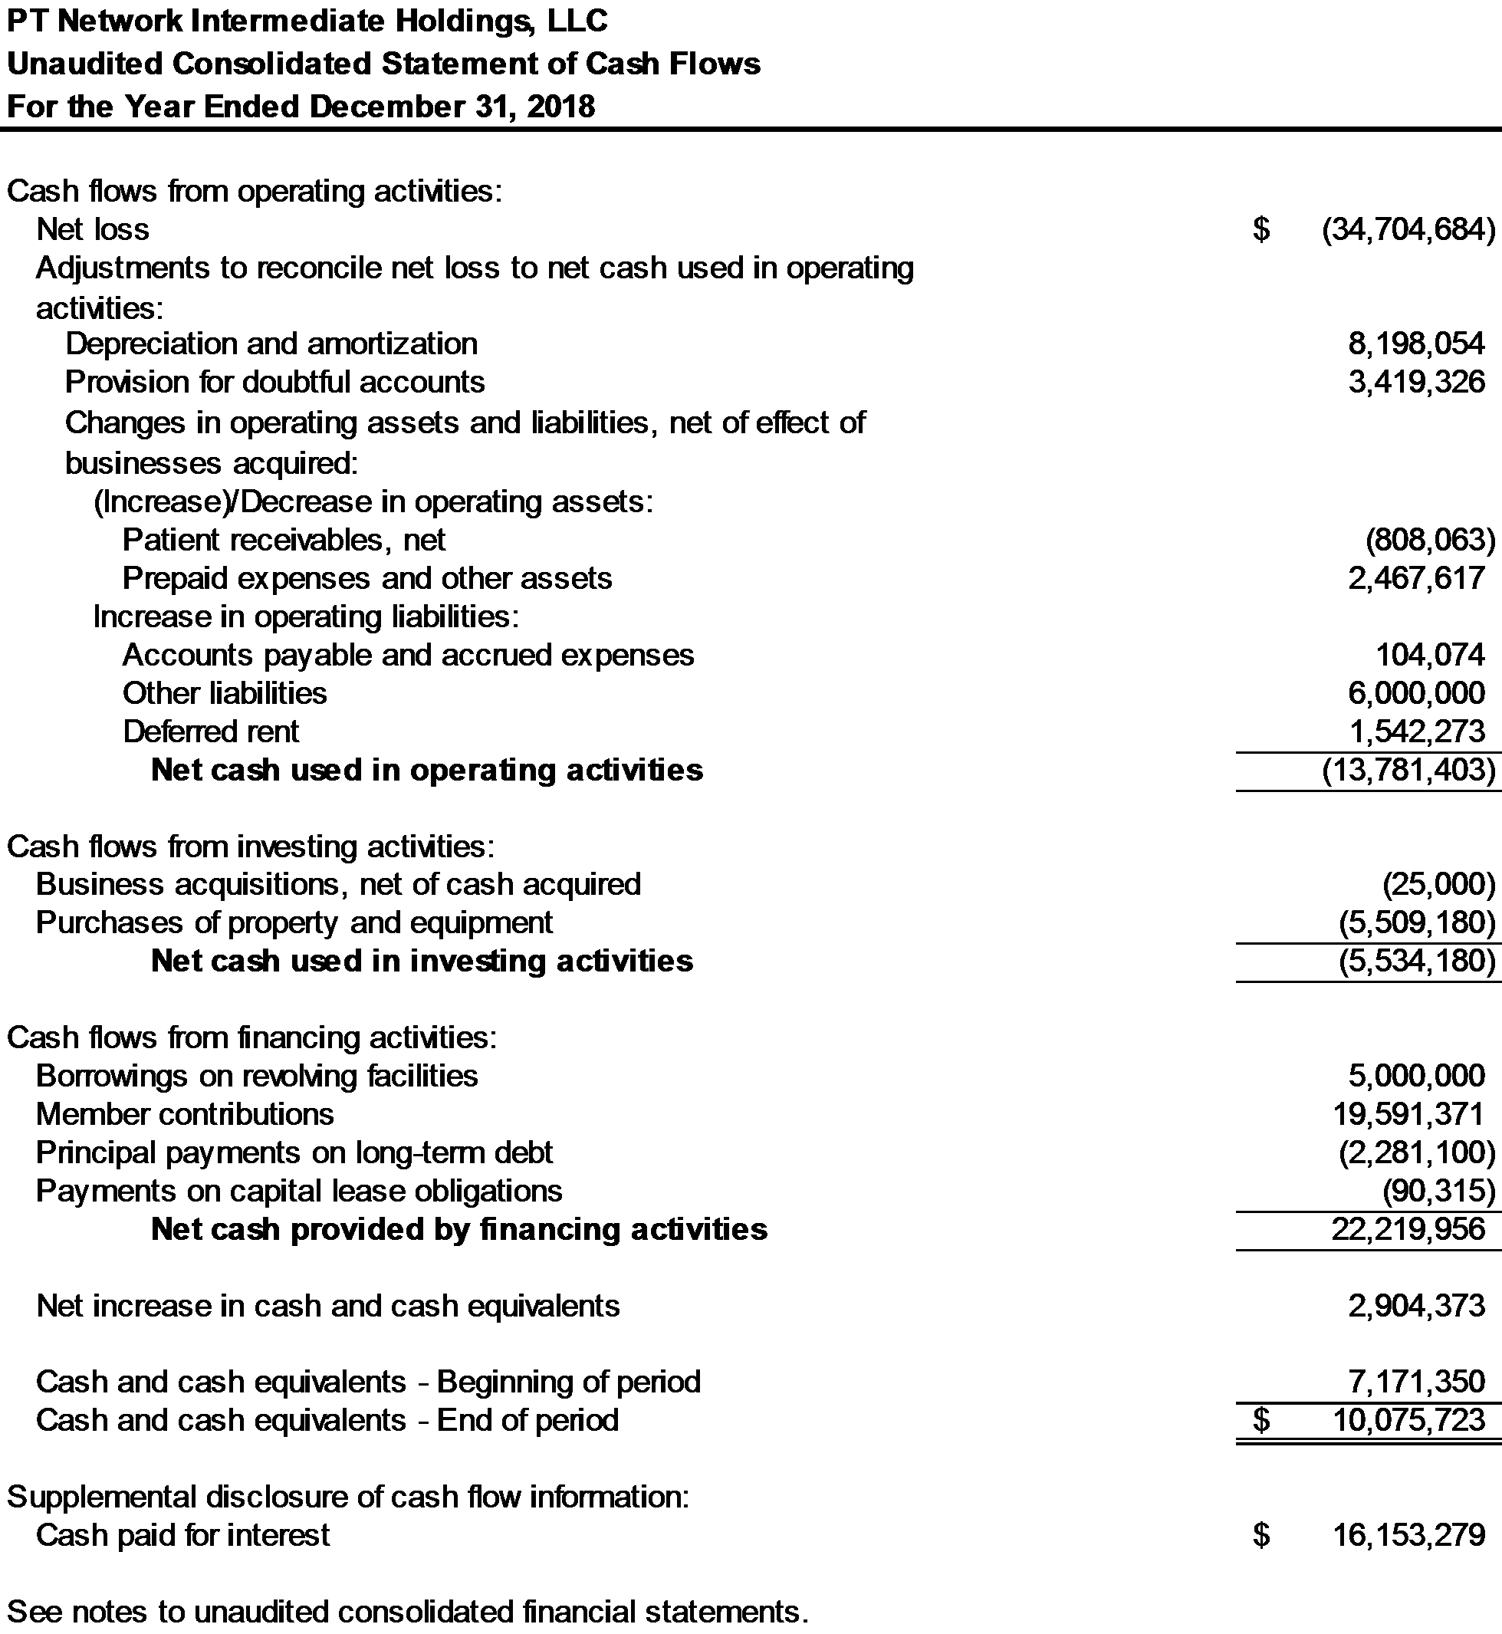

4

Note 1. Nature of Business and Significant Accounting Policies

Nature of Business
PT Network Intermediate Holdings, LLC (PTNIH), is a limited liability company formed in the State of Delaware on September 16, 2013. PTNIH wholly owns PT Network, LLC (PTN). PT Network, LLC, d/b/a Pivot Physical Therapy, operates outpatient physical therapy and occupational health clinics that provide physical therapy, sports medicine and athletic training, aquatic therapy, work injury, and sports performance and wellness services. Services are provided at locations throughout Maryland, Virginia, West Virginia, Washington, D.C., Pennsylvania, Delaware, and North Carolina. Additionally, Pivot Physical Therapy provides on-site physical therapy, occupational therapy, and athletic training to job sites across the country.

PTNIH operates directly through its subsidiaries, PT Network, LLC, Bayside Physical Therapy, LLC, Cambridge Physical Therapy and SportsCare, LLC, Glen Burnie Physical Therapy & Sports Care, LLC, Maryland SportsCare & Rehab, L.L.C., Maryland Sports Care & Rehabilitation of Salisbury, LLC, Professional SportsCare & Rehab, LLC, Professional SportsCare & Rehab of West Virginia, LLC, Professional SportsCare, LLC, Professional Sportscare & Rehab Associates, LLC, Southern Delaware SportsCare and Rehabilitation, LLC, PTN Transportation, LLC, ActivCare Physical Therapy, LLC, Pivot Occupational Health Holdings LLC, Pivot Athletic Training, LLC, Allegheny &
Chesapeake Physical Therapists Incorporated, Omega Medical Center LLC, Tidewater Physical Therapy, LLC, PhysioHealth, LLC, Dynamic Therapy Services of Pennsylvania, LLC, Dynamic Therapy Services, LLC, Pivot Physical Therapy of Pennsylvania, LLC, PTCG, LLC, Pivot Health Professionals, P.C., and Onsite Innovations, LLC (collectively, the Company).

The 26 consolidated entities include a holding company, 24 physical therapy, athletic training, and occupational health companies and a transportation company. The operating entities earn revenue directly from patient care through their clinic and Onsite Innovations, LLC locations. The clinics primarily generate business from physician referrals. The principal sources of payment for the clinics’ services are commercial health insurance, Medicare, Medicaid, workers’ compensation insurance and proceeds from personal injury cases. Services provided at Onsite Innovations, LLC locations are contract based and the contracted party is the single source of payment.

Significant Accounting Policies
A summary of the Company’s significant accounting policies follows:

Basis of Accounting
The accompanying consolidated financial statements have been prepared using the accrual basis of accounting, whereby revenue is recognized when services are rendered and expenses are recognized when incurred, in accordance with accounting principles generally accepted in the United States (GAAP).

Principles of Consolidation
The consolidated financial statements include the accounts and operations of the Company. All intercompany balances, transactions and amounts have been eliminated in consolidation.

Cash and Cash Equivalents
The Company maintains its cash and cash equivalents at various financial institutions. The Company considers all highly liquid investments with maturity of three months or less when purchased to be cash equivalents. The combined account balances at several institutions typically exceed Federal Deposit Insurance Corporation (FDIC) insurance coverage and, as a result, there is a concentration of credit risk related to amounts on deposit in excess of FDIC insurance coverage. The Company has not experienced any losses in such accounts and management believes it is not exposed to any significant credit risk on cash and cash equivalents.

Revenue Recognition

Physical Therapy Revenues
Revenues are recognized in the period in which services are rendered. Physical therapy revenues consists of revenues for physical therapy and occupational therapy clinics that provide pre-and post-operative care and treatment for orthopedic related disorders, sports-related injuries, preventative care, rehabilitation of injured workers
5

and neurological-related injuries. Physical therapy revenues (patient revenues less estimated contractual adjustments), which are presented on the consolidated statement of operations, are recognized at the estimated net realizable amounts from third-party payers, patients and others in exchange for services rendered when obligations under the terms of the contract are satisfied. There is an implied contract between the Company and the patient upon each patient visit. Generally, this occurs as the Company provides physical and occupational therapy services, as each service provided is distinct and future services rendered are not dependent on previously rendered services. The Company has agreements with third-party payers that provide for payments to the Company at amounts different from its established rates. See below for further discussion on variable consideration and allowance for doubtful accounts estimates.

Industrial injury prevention services revenues
Revenue from the industrial injury prevention business, which are also included in net revenues in the consolidated statement of operations, are derived from onsite services we provide to clients’ employees including injury prevention, rehabilitation, ergonomic assessments and performance optimization. Revenue from the Company’s industrial injury prevention business is recognized when the services under the terms of the contract are performed. Revenues are recognized at an amount equal to the consideration the Company expects to receive in exchange for providing injury prevention services to its clients. The revenue is determined and recognized based on the contractual terms with the third party.

Other revenues
The Company recognizes revenue for services provided to schools and industrial worksites, for physical or occupational therapy services, and athletic trainers and gym membership fees, which are also included in net revenues in the consolidated statement of operations. Contract terms and rates are agreed to in advance between the Company and third parties. Services are typically performed over the contract period and revenue is recorded as the services are rendered.

The Company had disaggregated revenues for the year ended December 31, 2018 as follows:

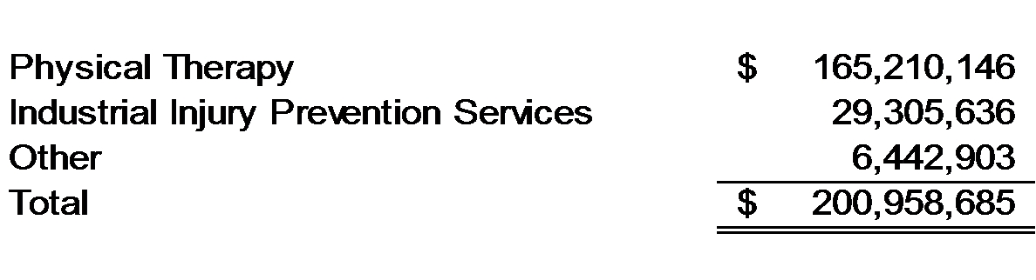
Accounts Receivable, net
Substantially all of the Company’s accounts receivable are related to providing healthcare services to patients whose costs are primarily paid by federal and state governmental authorities, managed care health plans, commercial insurance companies, and workers’ compensation and employer programs. The Company reports accounts receivable at an amount equal to the consideration the Company expects to receive in exchange for providing healthcare services to its patients, which is estimated using contractual provisions associated with specific payers, historical reimbursement rates, and an analysis of past experience to estimate potential adjustments.

The Company also has certain receivables that are related to providing healthcare services to patients whose costs are primarily paid local governments and other third parties. The Company reports these receivables at an amount equal to the consideration the Company expects to receive in exchange for providing healthcare services to its patients.

Allowance for Doubtful Accounts
The Company writes-off amounts that have been deemed to be uncollectible. The Company writes off uncollectible invoices when appropriate collection efforts have been exhausted. The allowance for doubtful accounts is included in accounts receivable, net on the consolidated balance sheet.

Security Deposits
The Company has recorded $921,583 of refundable security deposits as of December 31, 2018 for various physical therapy and occupational health clinics in other assets in the consolidated balance sheet.

6

Long-Lived Assets

Property and equipment, net
Property and equipment, net is stated at cost less accumulated depreciation. Depreciation is recorded using the straight-line method over the estimated useful lives of the related assets. Leasehold improvements are amortized using the straight-line method over the shorter of the estimated useful lives of the improvements or the remaining lease term.

The general range of useful lives is as follows:

Computer equipment and software | 3 years
Furniture and office equipment | 7 years
Medical equipment | 7 years
Leasehold improvements | 1-10 years
Finite-lived Intangible Assets
Intangible assets that have finite useful lives are amortized over their useful lives and reported at cost less accumulated amortization and impairment losses, if applicable. The Company's finite-lived intangible assets consist of customer relationships and trade name assets associated with the Company’s historical acquisitions.

Impairment of Long-Lived Assets
Long-lived assets are not required to be tested for impairment annually. However, long-lived assets are evaluated for impairment whenever circumstances indicate that the carrying amount of the asset may not be recoverable, such as when the disposal of such assets before the end of its previously estimated useful life is likely or there is an adverse change in the market involving the business employing the related assets. The impairment test first requires an assessment of the recoverability of the asset by comparing the net future cash flows of the asset to the carrying value of the asset. The net cash flows of the asset are estimated on an undiscounted, pre-tax basis, and should be based on future cash inflows expected from use of the asset over its remaining useful life, less expected future cash outflows necessary for maintenance, and cash flows associated with the eventual disposition of the asset. If the carrying value of the asset exceeds the net future cash flows of the asset, the asset would not be deemed to be recoverable. An impairment of the asset would then be recognized in an amount equal to the excess of the asset’s carrying value over its estimated fair value, calculated based on the discounted cash flows of the asset. Significant judgments used for long-lived asset impairment assessments include determining whether events of circumstances indicate that the carrying value of the asset may not be recoverable, identifying asset groupings, identifying the primary assets within each asset grouping, and estimating projected cash flows attributable to the asset grouping. The valuation of long-lived assets at estimated fair value, when required, is performed using Level 2 or Level 3 fair value inputs.

Goodwill
The Company records goodwill for the excess purchase price over the fair value of the identifiable net assets acquired in business combinations. The fair value of goodwill is evaluated for impairment annually, or earlier upon the occurrence of substantive unfavorable changes in economic conditions, industry trends, costs, or cash flows. The impairment test requires judgment, including the identification of reporting units, the assignment of assets, liabilities and goodwill to reporting units, and the determination of fair value of each reporting unit if a quantitative test is performed. If management believes that as a result of our qualitative assessment it is more likely than not that the fair value of a reporting unit is greater than its carrying amount, a quantitative impairment test is not required. As of December 31, 2018, the Company has identified a total of three reporting units, of which two reporting units have been allocated goodwill.

An impairment loss generally would be recognized when the carrying value of a reporting unit exceeds the estimated fair value of equity of the reporting unit. The estimated fair value of a reporting unit is determined by employing income and market approaches. Included in the income and market approaches are assumptions regarding projected revenue, profitability, and capital requirements for each reporting unit. The projected cash flows of each reporting unit are discounted back to the present value to estimate the fair value of each reporting unit as of the impairment testing date under the income approach. Under the market approach, a market multiple is applied to historical and / or projected financial information to estimate the fair value of each reporting unit as of the impairment testing date. The financial projections for each reporting unit are based on management’s knowledge of the industry, management’s understanding of each reporting unit’s recent transactions, and management’s expectations for each
7

reporting unit’s operations. If the financial projections for a reporting unit fail to materialize, the resulting decline in our estimated fair values could result in an impairment charge to the goodwill associated with the respective reporting unit. The valuation of goodwill at estimated fair value, when required, is performed using Level 2 or Level 3 fair value inputs.

The Company assessed goodwill for impairment for the two reporting units with goodwill and did not identify any evidence of impairment with respect to goodwill for either reporting unit as of the assessment date.

Fair Value of Financial Instruments
The carrying amounts of financial instruments, including cash, accounts receivable, net, accounts payable, accrued expenses, and our line-of-credit approximate fair value due to the short maturity of these instruments. The carrying amount of long-term debt approximates fair value because the interest rates fluctuate with market interest rates. The fair value of debt estimates are based on Level 2 inputs.

Fair Value Measurements
The Company follows the Financial Accounting Standards Board (FASB) authoritative guidance for fair value measurements, which defines fair value as the estimated price at which an asset can be sold or a liability settled in an orderly transaction to a third party under current market conditions, and establishes a framework for measuring fair value in accordance with GAAP.

Debt Issuance Costs
Costs associated with acquiring debt are capitalized as debt issuance costs. Debt issuance costs related to a recognized debt liability are presented in the consolidated balance sheet as a direct deduction from the carrying amount of that debt liability, consistent with debt discounts. These costs are amortized over the term of the related loans using the straight-line method, which is not materially different than the effective interest method, and are included in interest expense in the consolidated statement of operations.

Deferred Rent
Rent payments on operating leases are recognized as an expense on a straight-line basis over the related lease term, which includes renewal options that are reasonably assured of exercise. Generally, renewal options are not considered reasonably assured of exercise. Deferred rent is based on rent expense that is in excess of amounts paid to date. The liability as of December 31, 2018 was $2,271,548, and is reported as part of deferred rent in the consolidated balance sheet.

When the Company receives a tenant improvement allowance, it records a liability, which is then amortized as a reduction of rent expense over the life of the lease. The liability for tenant improvement allowances, net of amortization, as of December 31, 2018 was $2,489,094, and is reported as part of deferred rent and other liabilities in the consolidated balance sheet.

Corporate Costs
Corporate costs consist primarily of salaries and benefits of corporate office personnel, rent, insurance costs, depreciation and amortization, travel, legal, compliance, professional, marketing and recruiting fees.

Income Taxes
The Company was formed as a limited liability company under the Delaware Liability Company Act and provisions of the Internal Revenue Code. One subsidiary of the Company is a C Corporation for which a provision for income taxes has been included in the financial statements. These consolidated financial statements contain no provision for income taxes or benefits for PTNIH and its subsidiaries, other than for the subsidiary described above, as taxable income or loss is reported by the members on their individual income tax returns. The Company’s Operating Agreement provides for the division of LLC profits and losses to the members and the perpetual existence of the entity.

Management has evaluated the Company’s tax positions and concluded that the Company has taken no uncertain tax positions that require adjustment to or disclosure in the financial statements.

Use of Estimates
The preparation of financial statements in conformity with GAAP requires management to make estimates and assumptions that affect the reported amounts of assets and liabilities, including disclosure of contingencies, at the date of the financial statements and the reported amounts of revenues and expenses during the reporting period.
8

Significant estimates and assumptions are used for, but not limited to: amounts realizable for services performed, estimated useful lives of assets, the valuation of goodwill and intangible assets, amounts payable for self-insured losses, and the computation of income taxes. Future events and their effects cannot be predicted with certainty; accordingly, the Company’s accounting estimates require the exercise of judgment. The accounting estimates used in the preparation of the financial statements will change as new events occur, as more experience is acquired, as additional information is obtained, and as the Company’s operating environment changes. The Company’s management evaluates and updates assumptions and estimates on an ongoing basis. Actual results could differ from those estimates.

Recently Issued Accounting Guidance
In May 2014, March 2016, April 2016, and December 2016, the FASB issued Accounting Standards Update (ASU) 2014-09, Revenue from Contracts with Customers, ASU 2016-08, Revenue from Contracts with Customers, Principal versus Agent Considerations, ASU 2016-10, Revenue from Contracts with Customers, Identifying Performance Obligations and Licensing, ASU 2016-12, Revenue from Contracts with Customers, Narrow Scope Improvements and Practical Expedients, and ASU 2016-20, Technical Corrections and Improvements to Topic 606, Revenue from Contracts with Customer (collectively “New Revenue Standard”), respectively, which supersede most of the existing revenue recognition requirements. The core principle of the new guidance is that an entity should recognize revenue to depict the transfer of promised goods or services to customers in an amount that reflects the consideration to which the entity expects to be entitled in exchange for those goods or services. New disclosures about the nature, amount, timing and uncertainty of revenue and cash flows arising from contracts with customers are also required. The New Revenue Standard is effective for the Company for annual periods beginning after December 15, 2018 (as amended in August 2015 by ASU 2015-14, Deferral of the Effective Date).

The Company will implement the New Revenue Standard beginning January 1, 2019 using the modified retrospective transition method. The Company does not believe that the adoption of the New Revenue Standard will result in any material changes to the Company’s financial statements other than the requirement to include incremental financial statement footnote disclosures.

In February 2016, the FASB issued amended accounting guidance (ASU 2016-02, Leases) which replaced most existing lease accounting guidance under GAAP. Among other changes, the amended guidance requires that a right-to-use asset, which is an asset that represents the lessee’s right to use, and a lease liability, which is a lessee’s obligation to make lease payments arising for an operating lease measured on a discounted basis, be recognized on the balance sheet by lessees. The amended guidance is effective for the Company starting in the year ending December 31, 2021. Entities can use a modified retrospective approach for leases that exist or are entered into after the beginning of the earliest comparative period in the financial statements or recognize the cumulative effect of applying the new standard as an adjustment to the opening balance of equity.

The Company has operating leases for each of its clinic and certain corporate locations, as well as equipment. As a result, the Company will recognize right of use assets and lease liabilities on the consolidated balance sheet upon adoption of the new leasing standard. Operating lease expense will continue to be recognized as occupancy costs on a straight-line basis over the respective lease terms in the consolidated statement of operations. The Company will implement the new standard beginning January 1, 2021, and expects to elect certain of the practical expedients permitted, including the expedient that permits the Company to retain its existing lease assessment and classification. The Company also expects to elect the transition method in ASU 2018-11, which allows the Company to recognize a cumulative effect adjustment of the standard adoption to the opening balance of equity at the adoption date. The Company continues to evaluate the impact that the pronouncement will have on the Company's financial statements, including footnote disclosures.

In January 2017, the FASB issued ASU 2017-04, Simplifying the Test for Goodwill Impairment (Topic 350), which eliminates the requirement to calculate the implied fair value of goodwill to measure a goodwill impairment change. The Company will implement the new standard in the year ending December 31, 2020. The Company continues to evaluate the impact that the pronouncement will have on its financial statements.

In June 2016, the FASB issued ASU 2016-13, Financial Instruments – Credit Losses, which added a new impairment model, known as the current expected credit loss (CECL) model, that is based on expected losses rather than incurred losses. Under the new guidance, an entity recognizes as an allowance its estimate of expected credit losses. The CECL model applies to most debt instruments, including trade receivables. The CECL model does not have a minimum threshold for recognition of impairment losses and entities will need to measure expected credit losses on assets that have a low risk of loss. The Company will implement the new standard in the year ending
9

December 31, 2020. Management is currently evaluating the potential impact of these changes on the financial statements.

In August 2018, the FASB issued ASU 2018-15, Customer’s Accounting for Implementation Costs Incurred in a Cloud Computing Arrangement That is a Service Contract. This amendment aligns the requirements for capitalizing implementation costs incurred in a hosting arrangement that is a service contract with the requirements for capitalizing implementation costs incurred to develop or obtain internal-use software (and hosting arrangements that include an internal use software license). This generally means that an intangible asset is recognized for the software license and, to the extent that the payments attributable to the software license are made over time, a liability also is recognized. If a cloud computing arrangement does not include a software license, the entity should account for the arrangement as a service contract. This generally means that the fees associated with the hosting element of the arrangement are expensed as incurred. The amendment is effective for annual and interim periods beginning after December 15, 2019, with early adoption permitted. The company will implement the new standard in the year ending December 31, 2020. The Company continues to evaluate the impact that the pronouncement will have on its financial statements.

Note 2. Goodwill and Intangible Assets, net

Goodwill
The carrying amount of goodwill as of December 31, 2018 was $196,254,146. There were no additions, disposals, or goodwill impairments that occurred for the year ended December 31, 2018.

Intangible assets, net
The balance and activity of finite-lived intangible assets is shown in the table below:
 | Useful Life ranges |  | Intangible Assets, net, balance as of December 31, 2017 | Amortization Expense |  | Intangible Assets, net, balance as of December 31, 2018
Trade names, net of accumulated amortization of $3,238,961 and $3,690,772 as of December 31, 2017 and 2018, respectively | 1 - 7 years | $ | 1,514,330 | $ | 451,811 |  | 1,062,519
Customer relationships, net of accumulated amortization of $852,604 and $2,156,874 as of December 31, 2017 and 2018, respectively | 9 years | $ | 10,885,826 | $ | 1,304,270 |  | 9,581,556

Amortization of intangible assets, net, is recognized on a straight-line basis over the estimated useful lives of intangible assets. No impairments of finite-lived intangible assets were recorded for the year ended December 31, 2018. Estimated amortization expense of the Company’s finite-lived intangible assets for each of the five succeeding years and thereafter is as follows:

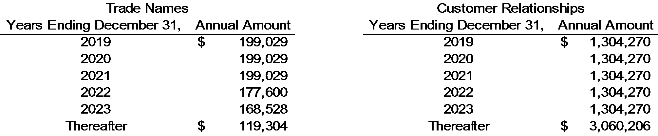

10

Note 3. Property and Equipment, net

Property and equipment consists of the following at December 31, 2018:

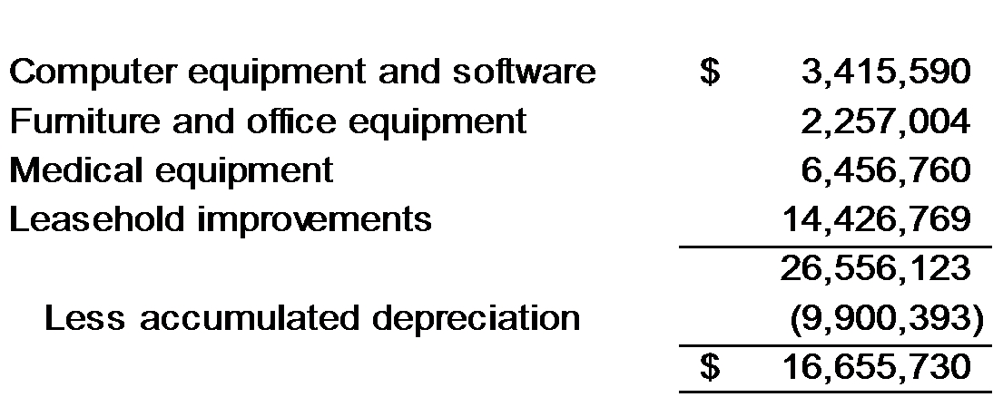

Depreciation expense was $5,191,139 for the year ended December 31, 2018. There were no impairments recorded for the year ended December 31, 2018.

Note 4. Net Revenues and Accounts Receivable, net

Medicare/Medicaid and Blue Cross entities represent approximately 27% and 25% of third-party payer net patient service revenue for the year ended December 31, 2018. The remaining 48% represents various other commercial payers and patients, respectively.

Medicare Reimbursement

The Medicare program reimburses outpatient rehabilitation providers based on the Medicare Physician Fee Schedule (“MPFS”). For services provided in 2018, a 0.5% increase has been applied to the fee schedule payment rates; for services provided in 2019, a 0.25% increase will be applied to the fee schedule payment rates before applying the mandatory budget neutrality adjustment. For services provided in 2020 through 2025, a 0.0% percent update will be applied each year to the fee schedule payment rates, before applying the mandatory budget neutrality adjustment. Beginning in 2021, payments to individual therapists (Physical/Occupational Therapist in Private Practice) paid under the fee schedule may be subject to adjustment based on performance in the Merit Based Incentive Payment System (“MIPS”), which measures performance based on certain quality metrics, resource use, and meaningful use of electronic health records. Under the MIPS requirements, a provider’s performance is assessed according to established performance standards each year and then is used to determine an adjustment factor that is applied to the professional’s payment for the corresponding payment year. The provider’s MIPS performance in 2019 will determine the payment adjustment in 2021. Each year from 2019 through 2024, professionals who receive a significant share of their revenues through an alternate payment model (“APM”), (such as accountable care organizations or bundled payment arrangements) that involves risk of financial losses and a quality measurement component will receive a 5% bonus in the corresponding payment year. The bonus payment for APM participation is intended to encourage participation and testing of new APMs and to promote the alignment of incentives across payers. The specifics of the MIPS and APM adjustments will be subject to future notice and comment rule-making.

CMS adopted a multiple procedure payment reduction (MPPR) for therapy services in the final update to the MPFS for calendar year 2011. The MPPR applied to all outpatient therapy services paid under Medicare Part B — occupational therapy, physical therapy and speech-language pathology. Under the policy, the Medicare program pays 100% of the practice expense component of the Relative Value Unit (RVU) for the therapy procedure with the highest practice expense RVU, then reduces the payment for the practice expense component for the second and subsequent therapy procedures or units of service furnished during the same day for the same patient, regardless of whether those therapy services are furnished in separate sessions. Since 2013, the practice expense component for the second and subsequent therapy service furnished during the same day for the same patient was reduced by 50%.

Medicare claims for outpatient therapy services furnished by therapy assistants on or after January 1, 2020 must include a modifier indicating the service was furnished by a therapy assistant. Outpatient therapy services furnished on or after January 1, 2022 in whole or part by a therapy assistant will be paid at an amount equal to 85% of the
11

payment amount otherwise applicable for the service.

Statutes, regulations, and payment rules governing the delivery of therapy services to Medicare beneficiaries are complex and subject to interpretation. The Company believes that it is in compliance, in all material respects, with all applicable laws and regulations and is not aware of any pending or threatened investigations involving allegations of potential wrongdoing that would have a material effect on the Company’s financial statements as of December 31, 2018. Compliance with such laws and regulations can be subject to future government review and interpretation, as well as significant regulatory action including fines, penalties, and exclusion from the Medicare program.

Accounts receivable, net consist of the following at December 31, 2018:

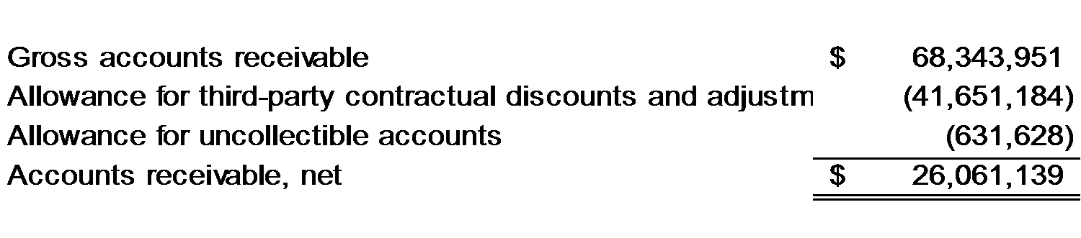
Below is a rollforward of the allowance for uncollectible accounts for the year ended December 31, 2018:

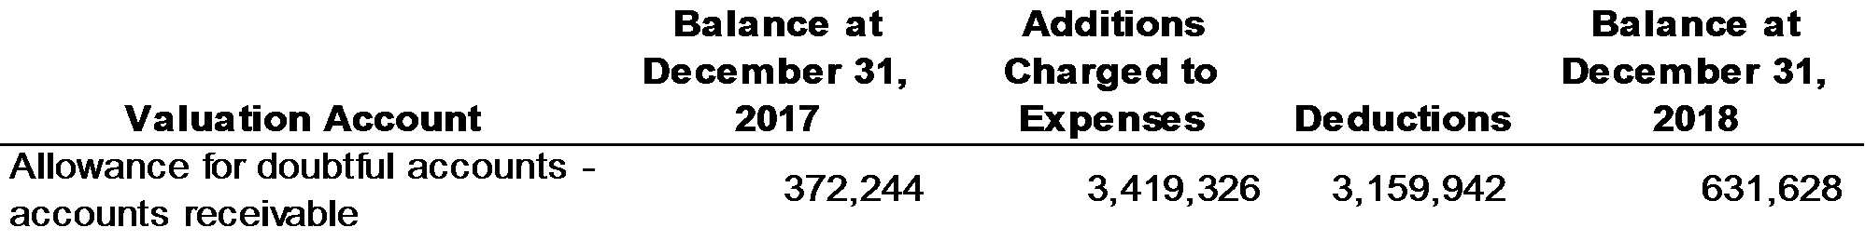

Medicare/Medicaid and commercial insurance providers represent approximately 21% and 66% of gross accounts receivable at December 31, 2018. The remainder is due from patients. Accounts receivable are carried based on total patient charges. The contractual allowances include estimates for third-party contractual and other adjustments. Management determines the allowance for uncollectible accounts by using historical experience applied to an aging of accounts. Accounts receivable are written off when deemed uncollectible.

Contractual allowances result from the differences between the rates charged for services performed and expected reimbursements by both insurance companies and government sponsored healthcare programs for such services. Medicare regulations and the various third party payers and managed care contracts are often complex and may include multiple reimbursement mechanisms payable for the services provided in our clinics. The Company estimates contractual allowances based on its interpretation of the applicable regulations, payer contracts, and the historical collection experience of the clinic and apply an appropriate contractual allowance reserve percentage to the gross accounts receivable balances for each clinic. Based on management’s historical experience, calculating the contractual allowance reserve percentage at the clinic level is sufficient to allow the Company to provide the necessary detail and accuracy with its collectability estimates. However, the services authorized and provided and related reimbursement are subject to interpretation that could result in payments that differ from the Company’s estimates. Payer terms are periodically revised necessitating continual review and assessment of the estimates made by management. The Company’s billing systems may not capture the exact change in contractual allowance reserve estimate from period to period. Therefore, in order to assess the accuracy of revenues and hence contractual allowance reserves, management compares cash collections to corresponding net revenues measured both in the aggregate and on a clinic-by-clinic basis.

Note 5. Long-Term Debt, net

PTN’s credit agreement provides for a revolving line-of-credit, initial term loan, and delayed draw term loan with commitments of $10,000,000, $130,000,000, and $50,000,000, respectively. This credit agreement was amended and restated effective October 12, 2017. The commitments for the amended revolving line-of-credit, term loan, and delayed draw term loan (collectively, the First Lien Credit Agreement) remain unchanged.

On October 12, 2017, PTN entered into a credit agreement with a different lender, which provides for an initial term
12

loan and delayed draw term loan with commitments of $49,000,000 and $11,000,000, respectively, (collectively, the Second Lien Credit Agreement). The Second Lien Credit Agreement is subordinated to the First Lien Credit Agreement.

The term loans and delayed draw loans under the First and Second Lien Credit Agreements can be designated as Index Rate loans at the index rate plus applicable index margin, as defined in the applicable agreements. Interest accrues on LIBOR loans at LIBOR plus an applicable LIBOR margin, as defined in the applicable agreements. The interest rates on the First Lien Credit Agreement initial term loan and revolving line of credit were 7.93% and 10.00%, respectively, at December 31, 2018. There was no interest rate election for the delayed draw term loan under the First Lien Credit Agreement. The interest rates on the Second Lien Credit Agreement initial term loan and delayed draw term loan were 12.43% and 12.34%, respectively at December 31, 2018.

The First Lien Credit Agreement requires quarterly calendar principal repayments in installments of $325,000 beginning in December 2017 through September 2021, with the balance due on the maturity date. The Second Lien Credit Agreement requires repayment of all outstanding borrowings on the maturity date.

All loans under the credit agreements are collateralized by all of PTN’s assets and the Company’s member equity interest. All facilities under the First Lien Credit Facilities mature on November 30, 2021. All facilities under the Second Lien Facilities mature on April 12, 2023.

The credit agreements are subject to certain financial and non-financial covenants. PTN was in breach of certain financial covenants during 2018, resulting in a required prepayment of the 2019 principal of $656,100 on the First Lien Credit Agreement. This prepayment occurred in August 2018.

In January 2019, PTN entered into forbearance agreements with its lenders. See Note 13 for further disclosure of a restructuring that occurred in June 2019.

Beginning with the year ended December 31, 2018, the initial term loans under the First and Second Lien Credit Agreements also require mandatory prepayment within ten days of the issuance of annual December 31 audited financial statements, in an amount equal to 50% of excess cash flow for such year, as defined in the applicable agreements, based upon PTN’s leverage ratio financial covenant.

There was no outstanding balance on the First Lien Credit Agreement delayed draw term loan at December 31, 2018. The outstanding balances on the First Lien Credit Agreement initial term loan and revolving line-of-credit were $127,718,900 and $5,000,000, respectively, at December 31, 2018.

The outstanding balances on the Second Lien Credit Agreement initial term loan and delayed draw term were $49,000,000 and $1,000,000, respectively, at December 31, 2018.

Aggregate future maturities required on long-term debt, at December 31, 2018, are as follows (see Note 13 for future maturities required under restructured credit agreements):

Years ending December 31:
2019 |  | $ 643,900
2020 |  | 1,300,000
2021 |  | 130,775,000
2022 |  | -
2023 |  | -
Thereafter |  | 50,000,000
 |  | 182,718,900
Less unamortized debt issuance costs |  | (4,913,036)
Total long-term debt, including current maturities |  | 177,805,864
Less current maturities |  | (643,900)
Total long-term debt |  | $ 177,161,964

Debt issuance costs, which are classified as a reduction to the carrying amount of the debt above, consist of the following at December 31, 2018:

13

Cost |  | $ 6,839,696
Accumulated amortization |  | (1,926,660)
 |  | $ 4,913,036

Amortization of debt issuance costs was $1,550,925 for the year ended December 31, 2018, and is included in interest expense on the consolidated statement of operations. Amortization for the next five years and thereafter is as follows:

Years ending December 31:
2019 |  | $ 1,539,267
2020 |  | 1,527,609
2021 |  | 1,417,785
2022 |  | 331,646
2023 |  | 96,729
 |  | $ 4,913,036

Interest expense was $16,592,893 for the year ended December 31, 2018 and is included in interest expense on the consolidated statement of operations. Accrued interest and commitment fees on the First and Second Lien Credit Agreements were $3,714,418 at December 31, 2018.

Note 6. Employee Benefit Plans

The operating company (PTN) sponsors the Pivot Physical Therapy 401(k) Plan for the benefit of substantially all employees of PTN. Under the plan, employees can contribute a portion of their compensation on a pre- or post- tax basis. The Company has the option to make matching contributions to the plan. The Company’s matching contribution expense was $957,213 for the year ended December 31, 2018, and is included in accrued compensation expenses on the consolidated balance sheet.

Note 7. Commitments and Contingencies

Operating Leases
The Company has operating leases for equipment and for each of its operating and corporate locations, which expire at various dates through January 2029. The Company’s future minimum rental commitments with original or remaining terms in excess of one year are as follows:
Years ending December 31:
2019 |  | $ 17,450,415
2020 |  | 14,232,332
2021 |  | 10,768,667
2022 |  | 7,104,450
2023 |  | 3,711,154
Thereafter |  | 6,528,264
 |  | $ 59,795,282

The minimum lease payments above do not include common area and maintenance (CAM) charges, which are also required contractual obligations under the operating leases. They also include the minimum lease terms and not optional renewal periods. The CAM charges are not fixed and can fluctuate from year to year. Rent expense, including CAM charges, was $20,223,056 for the year ended December 31, 2018, and is included as a component of occupancy expense or corporate costs, depending on the nature and use of the underlying asset, on the consolidated statement of operations.

Self-Insurance
The Company has a self-insurance medical and dental plan for its employees. Losses are limited through the use of stop-loss policies from reinsurers. Specific losses for claims are limited to $100,000 annually per covered employee. The Company’s aggregate annual loss limitation is based on a formula that considers, among other things, the total number of employees. The Company paid claims of $6,949,397 during the year ended December 31, 2018. The
14

Company accrued an estimate for claims payable of $414,764 at December 31, 2018.

Note 8. Related Party Transactions

The Company’s operating subsidiary has advisory services agreements with CI Capital Partners II, L.P. (CI), the Company’s former private equity sponsor, and InTandem Capital Partners, LLC, an entity related to CI. Total advisory fees and related expenses were $303,171 for the year ended December 31, 2018, and are included in corporate costs in the consolidated statement of operations. These fees are subordinated to PTN’s debt service obligation disclosed in Note 5. Total accrued fees were $170,296 for the year ended December 31, 2018, and are included in accounts payable and other accrued expenses on the consolidated balance sheet. These advisory agreements were terminated in conjunction with the restructuring event disclosed in Note 13.

Lease Agreements
The Company leases office space for certain of its operating locations and one of its corporate locations from real estate holding companies owned by employees or officers of the Company. Rent expense for these facilities was approximately $2,492,561 for the year ended December 31, 2018, and is included as a component of occupancy costs or corporate costs on the consolidated statement of operations, depending on the underlying use of the asset.

Note 9. Certain Significant Risks and Uncertainties

Government Regulation
The Company and others in the health care business are subject to certain inherent risks, including the following.

Substantial dependence on revenue derived from reimbursement by the federal Medicare and state
Medicaid programs, which have been drastically cut in recent years and which entail exposure to various healthcare fraud statues; government regulations, government budgetary constraints, and proposed legislative and regulatory changes; and lawsuits alleging malpractice and related claims. Such inherent risks require the use of certain management estimates in the preparation of the Company’s financial statements and it is reasonably possible that a change in such estimates may occur in the near term.

The Company’s operations are subject to a variety of federal, state, and local legal and regulatory risks,
including without limitation, the federal Anti-Kickback statute and the federal Ethics in Patient Referral Act (so-called Stark Law), many of which apply to virtually all companies engaged in the health care services industry. The Anti-Kickback statute prohibits, among other things, the offer, payment, solicitation or receipt of any form of remuneration in return for the referral of Medicare and Medicaid patients. The Stark Law prohibits, with limited exceptions, financial relationships between ancillary service providers and referring physicians.

The Medicaid and Medicare programs are highly regulated. Compliance with laws and regulations governing the Medicare and Medicaid programs is subject to government review and interpretation, as well as significant regulatory action, including fines, penalties and possible exclusion from the Medicare and Medicaid programs. The failure of the Company to comply with applicable reimbursement regulations could adversely affect the Company’s business. It is not possible to quantify fully the effect of potential legislative or regulatory changes, the administration of such legislation or any other governmental initiatives on the Company’s business. Accordingly, there can be no assurance that the impact of these changes or any future health care legislation will not adversely affect the Company’s business. There can be no assurance that payments under governmental and private third-party payer programs will be timely, will remain at levels comparable to present levels or will, in the future, be sufficient to cover the costs allocable to patients eligible for reimbursement pursuant to such programs.

The Company’s financial condition and results of operations may be materially and adversely affected by the reimbursement process, which in the healthcare industry is complex and can involve lengthy delays. In addition, under the Medicare program, if the federal government makes a formal demand for reimbursement, even related to contested items, payment must be made for those items before the provider is given an opportunity to appeal and resolve the case.

Malpractice Insurance
The Company has malpractice insurance policies covering all therapists providing services for the Company. The insurance coverage is $1,000,000 per incident and $3,000,000 aggregate per Named Insured entity per policy year subject to a $10,000,000 policy aggregate. The Company also purchases $10,000,000 in excess liability coverage. The Company believes this is adequate coverage to protect against any outstanding claims and litigation.
15

Litigation
The Company is involved in claims and legal actions arising in the ordinary course of business. In the opinion of management, the ultimate disposition of these matters will not have a material adverse effect on the Company’s financial position, results of activities or liquidity. See Note 13 for further discussion of certain settlement agreements reached in 2019.

Note 10. Income Taxes

New Tax Legislation
The United States government approved and signed into law on December 22, 2017, the Tax Cuts and Jobs Act reform legislation. This legislation makes significant changes in U.S. tax law including a reduction in the corporate tax rates, changes to net operating loss carryforwards and carrybacks, and a repeal of the corporate alternative minimum tax. The legislation reduced the U.S. corporate tax rate from the current graduated system, with a top rate of 35%, to a flat rate of 21% starting in 2018.

Deferred income taxes are provided on the liability method whereby deferred tax assets are recognized for deductible temporary differences and operating loss and tax credit carryforwards, and deferred tax liabilities are recognized for taxable temporary differences. Temporary differences are the differences between the reported amounts of assets and liabilities and their tax basis. Deferred tax assets are reduced by a valuation allowance when, in the opinion of management, it is more likely than not that some or all of the deferred tax assets will not be realized. Deferred tax assets and liabilities are adjusted for the effects of changes in tax laws and rates on the date of enactment.

The income tax benefit is composed of the following at December 31, 2018 and is included on the consolidated statement of operations.:

Deferred:
Federal | $ 157,791
State and local | 81,442
Income benefit | $ 239,233

The company has recorded a valuation allowance of $218,332 at December 31, 2018, as management does not expect to realize the full benefit of interest deductions in future years.

The significant temporary differences that give rise to deferred tax assets and liabilities are as follows:

Deferred tax assets:
Federal net operating loss carryforward | $ 253,281
State net operating loss carryforward | 93,800
Interest deduction limitation | 218,332
Accrued Vacation | 25,045
Other | 13,494
Total deferred tax assets | $ 603,952

Deferred tax liabilities:
Property and equipment | $ 122,359
Other | 24,028
Total deferred tax liabilities | 146,387
 | 457,565
Less valuation allowance | (218,332)
Net deferred tax asset | $ 239,233

Note 11. Members’ Equity

The Company had common units authorized, issued and outstanding for the year ended December 31, 2018.

During 2018, the Company received $19,591,373 of contributions in exchange for common units in the Company.
16

Note 12. Other Liabilities

The Company is obligated under capital leases for vehicles which expire at various dates through 2020.

Future minimum payments required under the leases together with their present value as of December 31, 2018, are as follows:

Years ending December 31:
2019 |  | $ 85,232
2020 |  | 22,122
Total minimum lease payments |  | 107,354
Less amount representing interest |  | (7,689)
Present value of minimum lease payments |  | 99,665
Less current portion |  | 78,346
Long-term portion |  | $ 21,319

Note 13. Subsequent Events

In January 2019, PTN was unable to meet its obligation for scheduled interest payments and loan commitment fees in accordance with the terms of the First Lien Facilities and Second lien Facilities, resulting in default of the credit agreements. In response to this default, PTN’s lenders executed forbearance agreements and amended credit agreements with its First Lien Agent, the Second Lien Agent, each First Lien Lender and each Second Lien Lender.

In April 2019, the First Lien Agent, the Second Lien Agent, each First Lien Lender and each Second Lien Lender entered into a Restructuring Support Agreement (RSA) with respect to a proposed restructuring of the Loan Parties, which provided for consensual restructuring of the Company’s debt and equity structure (Restructuring). This agreement was amended and restated in June 2019.

At Restructuring closing, the Second Lien Lenders contributed cash of $15,000,000 on a pro-rata basis to the Company in exchange for $6,000,000 of voting Class A common units and $9,000,000 of non-voting preferred units. Preferred units have a preferred return of LIBOR (floor of 1%) plus 10% compounded annually, on unreturned preferred unit invested capital, and preferred distribution rights. The funds were then contributed by the Company to PTN and used for the following purposes: (i) to pay-off the First Lien revolving line of credit and accrued interest; (ii) to pay forbearance fees due on the First Lien credit agreement; (iii) to pay accrued interest on the First Lien term loan and revolving line of credit, fees and expenses; and (iv) to pay legal fees. The remaining funds were available for general business purposes.

The RSA and the Company’s amended and restated LLC agreement provide for the Second Lien Lenders to contribute an additional $10,000,000 on a delayed draw basis as needed by the Company. This additional funding, if needed, will be exchanged for $4,000,000 of voting Class A common units and $6,000,000 of non-voting preferred units.

In addition, the RSA and the Company’s amended and restated LLC agreement provide for Sale Carveout Rights and Transaction Bonus Rights, as defined in a separate Carveout, Intercreditor and Subordination Agreement and Release, for certain current and former employees, in the event of a future sale or change in control transaction.
The forbearance agreements were amended and extended up to the closing date, and terminated on June 28, 2019, upon execution of the restructured credit agreements. The restructured First Lien credit agreement and Second Lien credit agreement require the Company to maintain certain financial and non-financial covenants, as defined in the credit agreements.

The Company assumed PTN’s obligation as the borrower under the restructured Second Lien credit agreement.

The restructured credit agreements include the following terms:

17

Restructured Terms | Restructured First Lien  Credit Agreement | Restructured Second Lien  Credit Agreement
Borrower | PT Network, LLC | PT Network Intermediate Holdings, LLC
Outstanding balance of term loans | $127,718,900 | $54,221,183
Revolving loan commitment | $10,000,000 | -
Interest rates:
Index rate loans - cash | Index rate plus 4.5% | Index rate plus 9%
LIBOR loans - cash | LIBOR (floor 1%) plus 5.5% | LIBOR (floor 1%) plus 10%
PIK – subject to terms of credit  agreement | 2%
Maturity date | November 30, 2023 | November 30, 2024
Loan amortization - quarterly | 0% through March 31, 2020 | Due at maturity
 | 0.25% through March 31, 2022
 | 0.50% thereafter
Additionally, there are certain forbearance and restructuring fees that are due upon the maturity of these credit agreements. In accordance with the restructured credit agreements, aggregate future maturities required on long-term debt are as follows:

Years ending December 31:
2020 | $ 957,892
2021 | 1,277,189
2022 | 2,235,081
2023 | 124,022,763
2024 | 57,690,888
 | $ 186,183,813

In June 2019, the Company entered into confidential settlement and release agreements with related parties. The first settlement agreement provides for payments totaling $4,000,000. The second settlement agreement provides for payments totaling $2,000,000. These settlements have been recognized as other expense on the consolidated statement of operations, and as other current and other non-current liabilities on the consolidated balance sheet at December 31, 2018.

18

Schedule I: Unaudited Condensed Parent Company Financial Statements

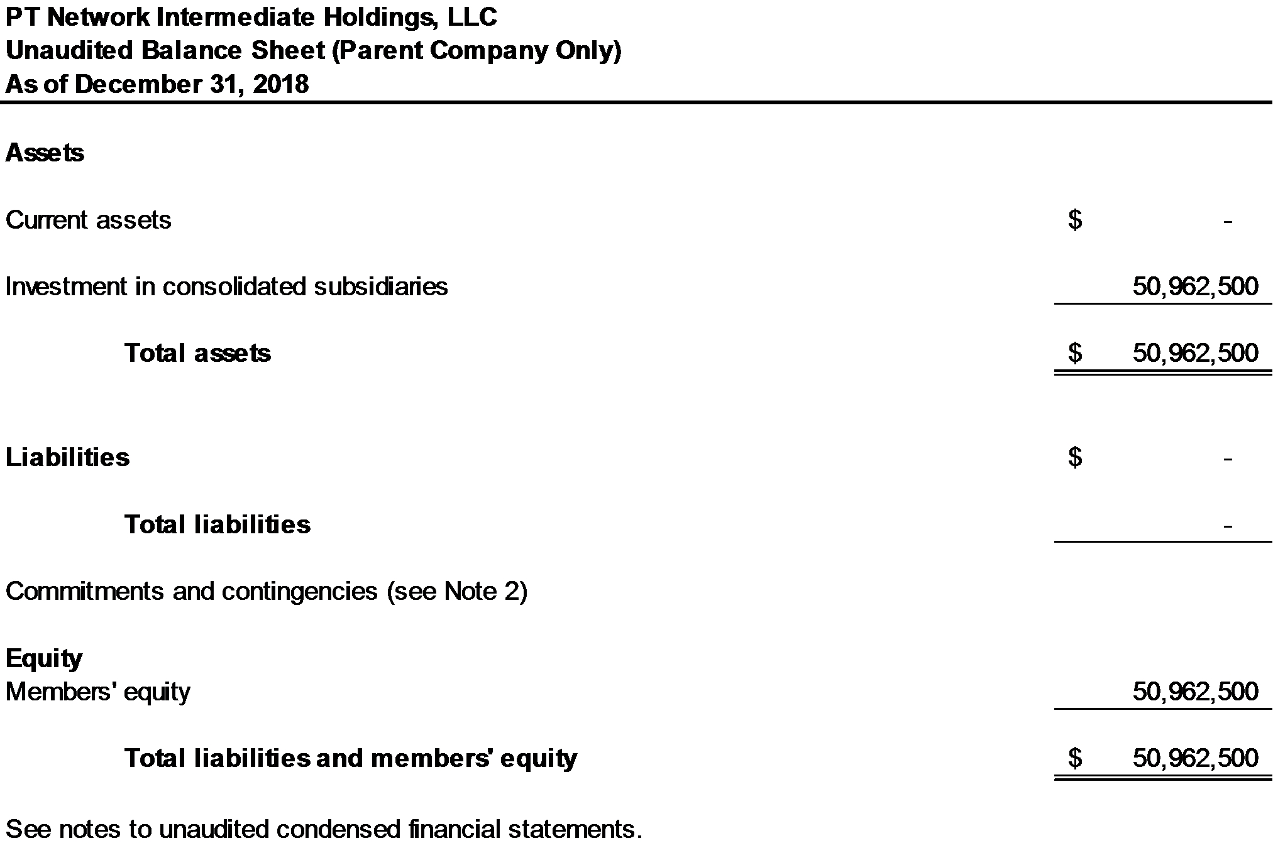

19

Schedule I: Unaudited Condensed Parent Company Financial Statements (continued)

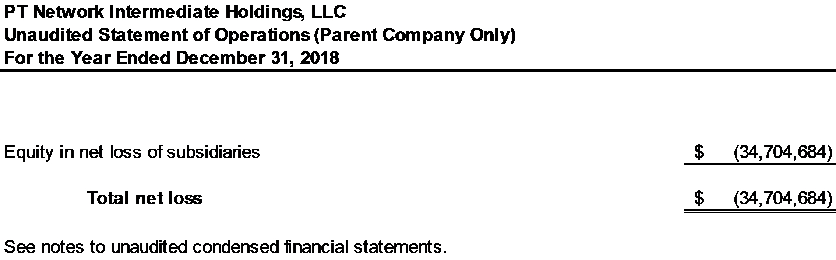

20

Schedule I: Unaudited Condensed Parent Company Financial Statements (continued)

PT Network Intermediate Holdings, LLC (PTNIH) does not maintain a bank account as all cash transactions are at the PT Network, LLC (PTN) level or other consolidated subsidiaries. There was no cash activity for the year ended December 31, 2018 at the PTNIH level.

PTNIH had the following non-cash investing and financing activity for the period:

Acquisition of additional equity interest in a consolidated subsidiary in exchange for issuance of common interests in PTNIH | $ 10,500,000

21

Note 1. Basis of Presentation

PTNIH is a holding company and conducts substantially all of its business operations through its subsidiaries. These condensed Parent Company financial statements and related notes have been prepared in accordance with Rule 12-04, Schedule I of Regulation S-X, as the restricted net assets of the subsidiaries of PTNIH exceed 25% of the consolidated net assets of PTNIH as stipulated by Rule 5-04, Section I from Regulation S-X. The ability of the operating subsidiaries to pay dividends is restricted due to the terms of the subsidiaries’ credit agreement as defined in Note 5 to the consolidated financial statements. The total amount of such restricted net assets totaled $50,962,500 at December 31, 2018. Any information, other than listed herein, is omitted as the information is either not applicable or has been furnished in the consolidated financial statements or notes thereto. These statements should be read in conjunction with the consolidated financial statements and the notes to the consolidated financial statements.

Note 2. Guarantees

All loans under the credit agreements discussed in Note 5 of the Consolidated Financial Statements are collateralized by all of PT Network, LLC's assets and PTNIH’s member equity interest.

See Note 5 of the Consolidated Financial Statements in this Report for information regarding the guarantees provided by PTNIH.

22

EXHIBIT 99.8
Consent of Independent Auditor
We hereby consent to the incorporation by reference in the Registration Statement on Form N-2 of PennantPark Investment Corporation of our report dated March 22, 2021 relating to the consolidated financial statements of PT Network Intermediate Holdings, LLC as of and for the years ended December 31, 2020 and 2019, respectively, which appear in this Annual Report on Form 10-K.
/s/ Dixon Hughes Goodman LLP

Tampa, Florida
March 22, 2021

