SCHEDULE 14A

(RULE 14a-101)

Information Required in Proxy Statement
Schedule 14A Information
Proxy Statement Pursuant to Section 14(a) of the
Securities Exchange Act of 1934

Filed by the Registrant ☒ Filed by a Party other than the Registrant ☐

Check the appropriate box:

- Preliminary Proxy Statement

- Confidential, for Use of the Commission Only (as permitted by Rule 14a-6(e)(2))

☒ Definitive Proxy Statement

- Definitive Additional Material

- Soliciting Material Pursuant to Rule 14a-12

PennantPark Investment Corporation

PennantPark Floating Rate Capital Ltd.

(Name of Registrant as Specified in Its Charter)

(Name of Person(s) Filing Proxy Statement if other than the Registrant)

Payment of Filing Fee (Check the appropriate box):

- No fee required.

- Fee computed on table below per Exchange Act Rules 14a-6(i)(1) and 0-11.

  - Title of each class of securities to which transaction applies:

  - Aggregate number of securities to which transaction applies:

  - Per unit price or other underlying value of transaction computed pursuant to Exchange Act Rule 0-11 (Set forth the amount on which the filing fee is calculated and state how it was determined):

  - Proposed maximum aggregate value of transaction:

  - Total fee paid:

- Fee paid previously with preliminary materials

- Check box if any part of the fee is offset as provided by Exchange Act Rule 0-11(a)(2) and identify the filing for which the offsetting fee was paid previously. Identify the previous filing by registration statement number, or the form or schedule and the date of its filing.
  - Amount previously paid:

  - Form, schedule or registration statement no.:

  - Filing party:

  - Date filed:

December 8, 2016

Dear Stockholder:

You are cordially invited to attend the 2017 Joint Annual Meeting of Stockholders of PennantPark Investment Corporation (“PNNT”) and PennantPark Floating Rate Capital Ltd. (“PFLT” and PNNT each, a “Company” and together, the “Companies”) to be held on February 7, 2017 at 9:30 a.m., Eastern Time, at the offices of Dechert LLP, located at 1095 Avenue of the Americas, New York, New York.

The Notice of Joint Annual Meeting of Stockholders and the Joint Proxy Statement of the Companies, which is accessible on the Internet or by request, provides an outline of the business to be conducted at the Joint Annual Meeting of Stockholders. At the meeting, you will be asked to: (1) elect two directors for PNNT and/or one director for PFLT and (2) ratify the selection of RSM US LLP as your Company’s independent registered public accounting firm for the fiscal year ending September 30, 2017. I will also report on the progress of the Companies during the past year and respond to stockholders’ questions.

It is important that your shares be represented at the Joint Annual Meeting of Stockholders. If you are unable to attend the meeting in person, I urge you to follow the instructions on the Notice of Internet Availability of Proxy Materials to vote your proxy on the Internet. We encourage you to vote via the Internet, as it saves us significant time and processing costs. However, on the Notice of Internet Availability of Proxy Materials you also will find instructions on how to request a hard copy of the Joint Proxy Statement and proxy card(s) for your Company free of charge and you may vote your proxy by returning your proxy card(s) to us after you request the hard copy materials.

Your vote and participation in the governance of your Company is very important to us.

Sincerely yours,

Arthur H. Penn

Chief Executive Officer

PennantPark Investment Corporation

PennantPark Floating Rate Capital Ltd.

590 Madison Avenue, 15th Floor

New York, New York 10022

212-905-1000

PENNANTPARK INVESTMENT CORPORATION

PENNANTPARK FLOATING RATE CAPITAL LTD.

NOTICE OF JOINT ANNUAL MEETING OF STOCKHOLDERS

TO BE HELD ON FEBRUARY 7, 2017

December 8, 2016

Notice is hereby given to the owners of shares of common stock (the “Stockholders”) of PennantPark Investment Corporation (“PNNT”) and PennantPark Floating Rate Capital Ltd. (“PFLT” and PNNT each, a “Company” and together, the “Companies”) that:

The 2017 Joint Annual Meeting of Stockholders of the Companies (the “Annual Meeting”) will be held at the offices of Dechert LLP, located at 1095

Avenue of the Americas, New York, New York, on February 7, 2017 at 9:30 a.m., Eastern Time, for the following purposes, as to each Company:

- For the Stockholders of PNNT: To elect two directors to the Board of the Company, who will each serve until the 2020 annual meeting of stockholders and until his successor is duly elected and qualifies; and
- For the Stockholders of PFLT: To elect one director to the Board of the Company, who will serve until the 2020 annual meeting of stockholders and until his successor is duly elected and qualifies; and
- To ratify the selection of RSM US LLP to serve as the Company’s independent registered public accounting firm for the fiscal year ending September 30, 2017.

You have the right to receive notice of, and to vote at, the Annual Meeting if you were a stockholder of record of PNNT and/or a stockholder of record of PFLT at the close of business on November 30, 2016. The Companies are furnishing a Joint Proxy Statement and proxy card(s) to their Stockholders on the Internet, rather than mailing printed copies of those materials to each Stockholder. If you received a Notice of Internet Availability of Proxy Materials by mail, you will not receive a printed copy of the Joint Proxy Statement and proxy card(s) unless you request them. Instead, the Notice of Internet Availability of Proxy Materials will instruct you as to how you may access and review the Joint Proxy Statement, and vote your proxy, on the Internet.

Your vote is extremely important to us. If you are unable to attend the Annual Meeting, we encourage you to vote your proxy on the Internet by following the instructions provided on the Notice of Internet Availability of Proxy Materials. You may also request from us free of charge hard copies of the Joint Proxy Statement and proxy card(s) for your Company by following the instructions on the Notice of Internet Availability of Proxy Materials. As to each Company, in the event there are not sufficient votes for a quorum or to approve that Company’s proposals at the time of the Annual Meeting, the Annual Meeting may be adjourned in order to permit further solicitation of proxies by that Company.

EACH COMPANY’S BOARD OF DIRECTORS, INCLUDING THE INDEPENDENT DIRECTORS, UNANIMOUSLY RECOMMENDS THAT YOU VOTE “FOR” EACH OF THE PROPOSALS.

By Order of the Boards of Directors,

Thomas J. Friedmann

Secretary

PennantPark Investment Corporation

PennantPark Floating Rate Capital Ltd.

590 Madison Avenue, 15th Floor

New York, New York 10022

212-905-1000

This is an important meeting. To ensure proper representation at the meeting, please follow the instructions on the Notice of Internet Availability of Proxy Materials to vote your proxy via the Internet or request, complete, sign, date and return a proxy card. Even if you vote your shares prior to the meeting, you still may attend the meeting and vote your shares in person should you wish to change your vote.

PENNANTPARK INVESTMENT CORPORATION

PENNANTPARK FLOATING RATE CAPITAL LTD.

590 Madison Avenue, 15th Floor

New York, New York 10022

- 905-1000

JOINT PROXY STATEMENT

for

2017 Joint Annual Meeting of Stockholders

To be held on February 7, 2017

This document will give you the information you need to vote on the matters listed on the accompanying Notice of Joint Annual Meeting of Stockholders (“Notice of Annual Meeting”). Much of the information in this Joint Proxy Statement is required under the rules and regulations of the Securities and Exchange Commission (the “SEC”), and some of it is technical in nature. If there is anything you do not understand, please contact us at 212-905-1000.

This Joint Proxy Statement is furnished in connection with the solicitation of proxies by the Boards of Directors (each, a “Board” and together, the “Boards”) of PennantPark Investment Corporation (“PNNT”) and PennantPark Floating Rate Capital Ltd. (“PFLT” and PNNT each, a “Company” and together, the “Companies,” “we,” “us” or “our”) for use at the Companies’ 2017 Joint Annual Meeting of Stockholders (the “Meeting”) to be held on Tuesday, February 7, 2017 at 9:30 a.m., Eastern Time, at the offices of Dechert LLP, located at 1095 Avenue of the Americas, New York, New York, and at any postponements or adjournments thereof. This Joint Proxy Statement and each Company’s Annual Report for the fiscal year ended September 30, 2016 are being provided to the stockholders thereof (the “Stockholders”) via the Internet on or about December 14, 2016. In addition, a Notice of Annual Meeting and a Notice of Internet Availability of Proxy Materials are being sent to Stockholders of record of PNNT and Stockholders of record of PFLT as of November 30, 2016 (the “Record Date”).

Although each Company is a separate business development company that holds an annual meeting of stockholders, the Companies’ Proxy Statements have been combined into this Joint Proxy Statement to reduce expenses of each of the Companies of soliciting proxies for the Meeting.

We encourage you to vote your shares, either by voting in person at the Meeting or by voting by proxy (i.e., authorizing someone to vote your shares). Shares represented by duly executed proxies will be voted in accordance with your instructions. If you execute a proxy without specifying your voting instructions, your shares will be voted in accordance with the recommendation of your Company’s Board. If any other business is brought before the Meeting, your shares will be voted by the appropriate proxy’s discretion unless you specifically state otherwise on your proxy.

You may revoke a proxy at any time before it is exercised by notifying the Companies’ Secretary in writing, by submitting a properly executed, later-dated proxy or by voting in person at the Meeting. Any Stockholder entitled to vote at the Meeting may attend the Meeting and vote in-person, whether or not he or she has previously voted his or her shares via proxy or wishes to change a previous vote.

You will be eligible to vote your shares electronically via the Internet, by telephone or by mail.

Purpose of Meeting

At the Meeting, you will be asked to vote on the following proposals for your Company:

- (a) To elect two directors to the Board of PNNT, who will each serve until the 2020 annual meeting of stockholders and until his successor is duly elected and qualifies; and

1

  - To elect one director to the Board of PFLT, who will serve until the 2020 annual meeting of stockholders and until his successor is duly elected and qualifies (together with clause (a) above, “Proposal 1”); and

- To ratify the selection of RSM US LLP to serve as the Company’s independent registered public accounting firm for the fiscal year ending September 30, 2017 (“Proposal 2”).

Voting Securities

You may vote your shares at the Meeting only if you were a Stockholder of record of PNNT and/or a Stockholder of record of PFLT at the close of business on November 30, 2016. There were 71,060,836 shares of PNNT common stock and 26,730,074 shares of PFLT common stock (the “Common Stock”) outstanding on the Record Date. Stockholders are entitled to one vote for each share of Common Stock of their Company held. Stockholders can vote only on matters affecting a Company in which they hold shares of Common Stock. Because the proposals stated above and in the Notice of Annual Meeting are separate for each Company, it is essential that Stockholders who own shares in both Companies vote by Internet, telephone or mail in accordance with the instructions on the proxy card(s), with respect to each proxy card they receive.

Quorum Required

For a Company to conduct business at the Meeting, a quorum of Stockholders of that Company must be present at the Meeting. The presence at the Meeting, in person or by proxy, of the holders of a majority of the shares of Common Stock of a Company outstanding on the Record Date will constitute a quorum of such Company. Abstentions and Broker Non-Votes (as defined below) will be treated as shares present at the Meeting for quorum purposes. If there are not enough votes for a quorum of a Company, the chairman of the Meeting will adjourn the Meeting with respect to that Company to permit the further solicitation of proxies.

Votes Required

Election of Director(s)

For PNNT, the election of a director to the Board of the Company requires the affirmative vote of a majority of the Company’s outstanding shares of Common Stock. If you vote “Withhold Authority” with respect to a nominee, your shares will not be voted with respect to the person indicated. Because a director is elected by a majority of the votes of the outstanding Common Stock of PNNT, votes to withhold authority, as well as abstentions and Broker Non-Votes, will have the effect of a vote against the nominee.

For PFLT, the election of a director to the Board of the Company requires the affirmative vote of a majority of the votes cast for and affirmatively withheld at the Meeting in person or by proxy. If you vote “Withhold Authority” with respect to a nominee, your shares will not be voted with respect to the person indicated. Votes to withhold authority with respect to a nominee will be included in determining the number of votes cast and, as a result, will have the effect of a vote against the nominee. Abstentions and Broker Non-Votes will have no effect on the result of the vote.

Stockholders of a Company may not cumulate their votes.

Ratification of Independent Registered Public Accounting Firm

For each Company, the affirmative vote of a majority of the votes of that Company cast at the Meeting in person or by proxy is required to ratify the appointment of RSM US LLP to serve as such Company’s independent registered public accounting firm. Abstentions will not be included in determining the number of votes cast and, as a result, will have no effect on this proposal.

2

Broker Non-Votes

“Broker Non-Votes” are votes that are not cast by a broker, bank or other nominee (the “Broker”) on a non-routine matter because the shares entitled to cast the vote are held in “street name”, the Broker lacks discretionary authority to vote the shares and the Broker has not received voting instructions from the beneficial owner. Proposal 1 is a non-routine matter for both Companies. As a result, if you hold shares of a Company’s Common Stock in street name, your Broker will not be permitted to exercise voting discretion with respect to Proposal 1 for that Company. Thus, if you are a Stockholder of PNNT and you do not vote or give your Broker specific instructions on how to vote for you, your shares will have the effect of a vote against Proposal 1.

For this reason, it is imperative that Stockholders of PNNT vote or provide instructions to their Brokers as to how to vote with respect to Proposal

1.

Proposal 2 is a routine matter for both Companies. As a result, if you beneficially own shares of Common Stock of a Company and you do not vote or provide your Broker with proxy instructions, your Broker will be able to vote your shares for you on Proposal 2.

Adjournment and Additional Solicitation

As to each Company, if there appears not to be enough votes to approve a proposal at the Meeting, the chairman of the Meeting may adjourn the Meeting with respect to that Company to permit further solicitation of proxies.

A Stockholder vote may be taken on any of the proposals in this Joint Proxy Statement prior to any such adjournment if there are sufficient votes for approval of such proposal.

Information Regarding This Solicitation

Each Company will bear the expense of its solicitation of proxies for the Meeting, including its portion of the cost of preparing and posting this Joint Proxy Statement and the Annual Report to the Internet and the cost of mailing the Notice of Annual Meeting, the Notice of Internet Availability of Proxy Materials and any requested proxy materials to its respective Stockholders. The Companies intend to use the services of Broadridge Financial Solutions, Inc., a leading provider of investor communications solutions, to aid in the distribution and collection of proxy votes. The Companies expect to pay market rates for such services. If brokers, trustees or fiduciaries and other institutions holding shares in their own names or in the names of their nominee, which shares are beneficially owned by others, forward the Joint Proxy Statement and relevant proxy card(s) to, and obtain proxies from, such beneficial owners, the applicable Company will reimburse such persons for their reasonable expenses in so doing.

In addition to the solicitation of proxies by the use of the Internet, proxies may be solicited in person and/or by telephone, mail or facsimile transmission by directors or officers of the Companies, officers or employees of PennantPark Investment Advisers, LLC, the Companies’ investment adviser (the “Adviser”), PennantPark Investment Administration, LLC, the Companies’ administrator (the “Administrator”), and/or by a retained solicitor. No additional compensation will be paid to such directors, officers or regular employees for such services. If the Companies retain a solicitor, the Companies have estimated that they will pay an aggregate of approximately $60,000 for such services. If the Companies engage a solicitor, you could be contacted by telephone on behalf of your Company and be urged to vote. The solicitor will not attempt to influence how you vote your shares, but will only ask that you take the time to cast a vote. You may also be asked if you would like to vote over the telephone and to have your vote transmitted to our proxy tabulation firm. The address of each of the Adviser and the Administrator is 590 Madison Avenue, 15th Floor, New York, New York 10022.

Stockholders may provide their voting instructions through the Internet, by telephone or by mail by following the instructions on the Notice of Internet Availability of Proxy Materials. These options require

3

Stockholders to input the Control Number, which is provided with the Notice of Internet Availability of Proxy Materials. If you vote using the Internet, after visiting www.proxyvote.com and inputting your Control Number, you will be prompted to provide your voting instructions. Stockholders will have an opportunity to review their voting instructions and make any necessary changes before submitting them and terminating their Internet link. Stockholders who vote via the Internet, in addition to confirming their voting instructions prior to submission, will receive upon request an e-mail confirming their instructions.

If a Stockholder wishes to participate in the Meeting, but does not wish to give a proxy by Internet, the Stockholder may attend the Meeting in person or request and submit a proxy card by following the instructions on the Notice of Internet Availability of Proxy Materials.

Any proxy authorized pursuant to this solicitation may be revoked by notice from the person giving the proxy at any time before it is exercised. A revocation may be effected by (i) resubmitting voting instructions via the Internet voting site, by telephone, by obtaining and properly completing another proxy card that is dated later than the original proxy and returning it, by mail, in time to be received before the Meeting, (ii) by attending the Meeting and voting in person or (iii) by a notice, provided in writing and signed by the Stockholder, delivered to the Companies’ Secretary on any business day before the date of the Meeting.

Security Ownership of Certain Beneficial Owners and Management

As of the Record Dates, to our knowledge, no person would be deemed to “control” (as such term is defined in the Investment Company Act of 1940, as amended (the “1940 Act”)) either Company.

Each Company’s Board is composed of the same individuals. Our directors consist of an interested director and four independent directors. An interested director is an “interested person” of the Companies, as defined in the 1940 Act, and independent directors are all other directors (the “Independent Directors”).

The following table sets forth, as of December 2, 2016, certain ownership information with respect to each Company’s Common Stock for those persons who directly or indirectly own, control or hold with the power to vote, five percent or more of a Company’s outstanding Common Stock and all officers and directors of the Companies, as a group.

 |  |  |  |  |  |  |  | Percentage of
Name and address⁽¹⁾ |  | Type of ownership⁽³⁾ |  |  |  |  |  | Common Stock
 |  |  |  | Shares Owned |  |  |  | Outstanding
 |  |  |  | PNNT |  | PFLT |  | PNNT |  | PFLT
Independent directors
Adam K. Bernstein |  | Record/Beneficial |  | 46,230 |  | 5,000 |  | * |  | *
Marshall Brozost |  | Record/Beneficial |  | 19,993 |  | — |  | * |  | *
Jeffrey Flug |  | Record/Beneficial |  | 325,268 |  | 15,500 |  | * |  | *
Samuel L. Katz |  | Record/Beneficial |  | 189,291 |  | 120,100 |  | * |  | *
Interested director
Arthur H. Penn(2) |  | Record/Beneficial |  | 663,323 |  | 149,209 |  | * |  | *
Executive officer
Aviv Efrat |  | Record/Beneficial |  | 96,102 |  | 28,750 |  | * |  | *
All directors and executive officer as a group (6 persons) |  |  |  | 1,340,207 |  | 318,559 |  | 1.9% |  | 1.2%

- The address for each officer and director is c/o PennantPark, 590 Madison Avenue, 15th Floor, New York, New York 10022.

- Mr. Penn is the Managing Member of the Adviser and may therefore be deemed to own beneficially the 469,923 shares of PNNT and 149,209 shares of PFLT held by the Adviser.
- Sole voting power.

- Less than 1 percent.

4

Section 16(a) Beneficial Ownership Reporting Compliance

Pursuant to Section 16(a) of the Securities Exchange Act of 1934, as amended (the “Exchange Act”), each Company’s directors and other executive officer and any persons holding more than 10% of that Company’s Common Stock are required to report their beneficial ownership and any changes therein to the SEC and the Company. Specific due dates for those reports have been established, and the Companies are required to report herein any failure to file such reports by those due dates. Based on the Companies’ review of Forms 3, 4 and 5 filed by such persons and information provided by the Companies’ directors and other executive officer, the Companies believe that, during the fiscal year ended September 30, 2016, all Section 16(a) filing requirements applicable to such persons were met in a timely manner.

Dollar Range of Securities Beneficially Owned by Directors

The following table sets forth the dollar range of each Company’s Common Stock beneficially owned by each of our directors as of December 2, 2016.

Information as to beneficial ownership is based on information furnished to the Companies by such persons.

Directors of the Companies |  |  | Dollar Range of the Common Stock of the Companies⁽¹⁾
 |  | PNNT |  | PFLT |  | Total
Independent directors
Adam K. Bernstein |  | $100,001 - $500,000 | $50,001 - $100,000 |  |  | $100,001 - $500,000
Marshall Brozost |  | $100,001 - $500,000 |  | None |  | $100,001 - $500,000
Jeffrey Flug |  | Over $1,000,000 | $100,001 - $500,000 |  |  | Over $1,000,000
Samuel L. Katz |  | Over $1,000,000 |  | Over $1,000,000 |  | Over $1,000,000
Interested director
Arthur H. Penn(2) |  | Over $1,000,000 |  | Over $1,000,000 |  | Over $1,000,000

- Dollar ranges are as follows: None; $1-$10,000; $10,001-$50,000; $50,001-$100,000; $100,001-$500,000; $500,001-$1,000,000 or over $1,000,000.

- Also reflects holdings of the Adviser.

5

PROPOSAL 1: ELECTION OF DIRECTORS

In accordance with its bylaws, each of the Companies currently has five members on its Board. Directors are divided into three classes and are elected for staggered terms of three years each, with a term of office of one of the three classes of directors expiring each year. Each director will hold office for the term to which he is elected and until his successor is duly elected and qualifies. After this election, the terms of Class I, II and III directors will expire as follows:

Companies |  | Class I |  | Class II |  | Class III
PennantPark | Investment Corporation |  | 2020 |  | 2018 |  | 2019
PennantPark Floating Rate Capital Ltd. |  | 2018 |  | 2019 |  | 2020

A Stockholder can vote for, or withhold his or her vote from, any nominee for his or her Company’s Board. In the absence of instructions to the contrary, it is the intention of the persons named as proxies to vote such proxy FOR the election of each nominee named below. If a nominee should decline or be unable to serve as a director, it is intended that the proxy will be voted for the election of such person as is nominated by the relevant Board as a replacement. Neither Board has reason to believe that its nominee(s) will be unable or unwilling to serve.

EACH BOARD, INCLUDING ITS INDEPENDENT DIRECTORS, UNANIMOUSLY RECOMMENDS THAT YOU VOTE FOR THE ELECTION OF THE NOMINEES NAMED IN THIS JOINT PROXY STATEMENT.

Information about the Nominees and Directors

Certain information with respect to the nominees for election at the Meeting, as well as each of the other directors, is set forth below, including their names, ages, a brief description of their recent business experience, including present occupations and employment, certain directorships that each person holds and the year in which each person became a director of each Company. The nominees currently serve as directors of each Company.

Each of Mr. Marshall Brozost and Mr. Samuel L. Katz has been nominated for election as a Class I director of PNNT for a three-year term expiring in 2020. Neither Mr. Brozost nor Mr. Katz is being proposed for election pursuant to any agreement or understanding between either Mr. Brozost or Mr. Katz and PNNT.

Mr. Arthur H. Penn has been nominated for election as a Class III director of PFLT for a three-year term expiring in 2020. Mr. Penn is not being proposed for election pursuant to any agreement or understanding between Mr. Penn and PFLT.

6

Name, Address and Age ⁽¹⁾ |  | Position(s) held
 |  | with Company
Independent Directors
Adam K. Bernstein (53) |  | Director
 |  | Director

Marshall Brozost (49) Director

Nominee

Director

Company,
Term of Office

and Length of

Time Served

PNNT - Class II Director since February 2007; Term Expires 2018

PFLT - Class II Director since October 2010; Term Expires 2019

PNNT - Class I

Director since

February 2007;

Term Expires, if

elected, 2020

PFLT - Class I Director since October 2010; Term Expires 2018

7

Principal
Occupation(s) During the
Past 5 Years

President of The Bernstein Companies, a Washington, D.C.-based real estate investment and development firm, since 1995 and President and Chief Executive Officer of Consortium Atlantic Realty Trust, Inc., a private real estate investment trust operating in the Mid-Atlantic region, from 2006. Also, Mr. Bernstein has served on the Board of Overseers of the School of Arts and Sciences at the University of Pennsylvania since 2012.

Partner at Orrick, Herrington & Sutcliffe LLP, where he practices in the real estate and private equity groups, since July 2016. Prior to Orrick, Herrington & Sutcliffe LLP Mr. Brozost practiced law at Schulte Roth & Zabel from May 2012 to July 2016 and at Dewey & LeBoeuf LLP from 2005 to 2012.

Other
Directorships

Held by Director

or Nominee for Director During

the Past 5 Years ⁽²⁾

None.

None.

Name, Address and Age ⁽¹⁾ |  | Position(s) held
 |  | with Company
Independent Directors | (continued)
Jeffrey Flug (53) |  | Director
 |  | Director

Samuel L. Katz (51) Director

Nominee

Director

Company,
Term of Office

and Length of

Time Served

PNNT - Class II Director since February 2007; Term Expires 2018

PFLT - Class II Director since October 2010; Term Expires 2019

PNNT - Class I

Director since

February 2007;

Term Expires, if

elected, 2020

PFLT - Class I

Director since

October 2010;

Term Expires

2018

8

 |  | Other
 |  | Directorships
 |  | Held by Director
Principal |  | or Nominee for
Occupation(s) During the |  | Director During
Past 5 Years |  | the Past 5 Years ⁽²⁾
Mr. Flug was President of Union | Shake Shack Inc, since
Square Hospitality Group, an | September 2014; Sears
exclusive chain of restaurants, from | Hometown and Outlet
2009 to June 2015. Mr. Flug served | Stores, Inc., from
as Chief Executive Officer and | October 2012 to
Executive Director of Millennium | September 2015.
Promise Alliance, Inc., a non-profit
organization whose mission is to
eradicate extreme global poverty,
from 2006 to 2008. From 2000 to
2006, Mr. Flug was a Managing
Director and Head of North
American Institutional Sales at JP
Morgan’s Investment Bank.
Managing Partner of TZP Group |  | None.
LLC, a private equity fund, since
2007. Before joining TZP Group,
Mr. Katz was Chief Executive
Officer of MacAndrews & Forbes
Acquisition Holdings, Inc. from
2006 to 2007. Prior to that position,
Mr. Katz was Chairman and Chief
Executive Officer of the Cendant
Travel Distribution Services
Division from 2001 to 2005.

Name, Address and Age ⁽¹⁾ |  | Position(s) held
Name, Address and Age ⁽¹⁾ |  | with Company
Interested Director

Company,
Term of Office |  | Principal
and Length of |  | Occupation(s) During the
Time Served |  | Past 5 Years

Other
Directorships

Held by Director

or Nominee for Director During

the Past 5 Years ⁽²⁾

Arthur H. Penn (53)(3) Director

Chief Executive

Officer and

Chairman of the

Board of

Directors

Director

Nominee

Chief Executive

Officer and

Chairman of the

Board of

Directors

PNNT - Class III Director since February 2007; Term Expires 2019

PFLT - Class III

Director since

October 2010;

Term Expires, if elected, 2020

Founder, Chairman and Chief Executive Officer of PNNT and of PFLT from their inception in 2007 and 2010, respectively. Mr. Penn also is the Founder and Managing Member of the Adviser. Before founding PNNT, Mr. Penn was the Co-Founder of Apollo Investment Management, where he was a Managing Partner from 2004 to 2006. He also served as Chief Operating Officer of Apollo Investment Corporation from inception in 2004 to 2006 and served as President and Chief Operating Officer in 2006. He formerly was a Managing Partner of Apollo Value Fund L.P. (formerly Apollo Distressed Investment Fund, L.P.) from 2003 to 2006.

None.

- The address for each officer and director is c/o PennantPark, 590 Madison Avenue, 15th Floor, New York, New York 10022.

- No director otherwise serves as a director of an investment company subject to the 1940 Act.

- Mr. Penn is an interested director due to his position as an officer of each Company and of the Adviser.

9

Corporate Governance

Each Company believes that maintaining the highest standards of corporate governance is a crucial part of its business, and is committed to having in place the necessary controls and procedures designed to ensure compliance with applicable laws, rules and regulations, as well as its own ethical standards of conduct.

Director Independence

NASDAQ corporate governance rules require listed companies to have a board of directors with at least a majority of independent directors. Under NASDAQ corporate governance rules, in order for a director to be deemed independent, the Board of each Company must determine that the individual does not have a relationship that would interfere with the director’s exercise of independent judgment in carrying out his responsibilities. On an annual basis, each director is required to complete an independence questionnaire designed to provide information to assist the Companies’ Boards in determining whether the director is independent under NASDAQ corporate governance rules, the 1940 Act and applicable corporate governance guidelines. Each Board has determined that each of its directors, other than Mr. Penn, is independent under the applicable listing standards of the NASDAQ Global Select Market and the New York Stock Exchange and under the Exchange Act and the 1940 Act. Each Company’s governance guidelines require any director who has previously been determined to be independent to inform the Chairman of the Board, the Chairman of the Nominating and Corporate Governance Committee and the Company’s Corporate Secretary of any change in circumstance that may cause his status as an Independent Director to change. Each Board limits membership on its Audit Committee, its Nominating and Corporate Governance Committee and its Compensation Committee to Independent Directors.

Boards’ Oversight Role in Management

Each Board performs its risk oversight function primarily through (1) its three standing committees, which report to the entire Board and are comprised solely of Independent Directors and (2) monitoring by the Company’s Chief Compliance Officer (the “CCO”) in accordance with the Company’s compliance policies and procedures.

As described below in more detail, each Board’s Audit Committee, Nominating and Corporate Governance Committee and Compensation Committee assist the Board in fulfilling its risk oversight responsibilities. Each Audit Committee’s risk oversight responsibilities include overseeing the Company’s accounting and financial reporting processes, including the annual audit of the Company’s financial statements, the Company’s systems of internal controls regarding finance and accounting, pre-approving the engagement of an independent registered public accounting firm to render audit and/or permissible non-audit services and evaluating the qualifications, performance and independence of the independent registered public accounting firm. Each Nominating and Corporate Governance Committee’s risk oversight responsibilities include selecting, researching and nominating directors for election by the Company’s Stockholders, developing and recommending to its Board a set of corporate governance principles and overseeing the evaluation of the Board and the Company’s management. Each Compensation Committee’s risk oversight responsibilities include determining, or recommending to its Board for determining, the compensation of the Company’s chief executive officer and all other executive officers, paid directly by the Company, if any, and assisting its Board with matters related to compensation, as directed by each Board.

Each Board also performs its risk oversight responsibilities with the assistance of a CCO, who is the same individual for both Companies. The Companies’ CCO prepares a written report annually discussing the adequacy and effectiveness of the compliance policies and procedures of the Companies and certain of their service providers. The CCO’s report, which is reviewed by the Boards, addresses, at a minimum: (1) the operation of the compliance policies and procedures of the Companies and certain of their service providers since the last report; (2) any material changes to such policies and procedures since the last report; (3) any recommendations for material changes to such policies and procedures as a result of the CCO’s annual review; and (4) any compliance

10

matter that has occurred since the date of the last report about which the Boards would reasonably need to know to oversee the Companies’ compliance activities and risks. In addition, the CCO meets separately in executive session with the Independent Directors at least once each year and presents quarterly reports to the Boards.

Each Company believes that its Board’s role in risk oversight is effective and appropriate given the extensive regulation to which it is already subject as a business development company. Specifically, as a business development company, each Company must comply with certain regulatory requirements that control the levels of risk in its business and operations. For example, the ability of each Company to incur indebtedness is limited by the asset coverage ratio set forth in the 1940 Act (as modified by any exemptive relief granted by the SEC) and each Company generally must invest at least 70% of its total assets in “qualifying assets.” Each Company also has elected to be treated as a regulated investment company (a “RIC”) under Subchapter M of the Internal Revenue Code of 1986, as amended. As a RIC, each Company must, among other things, meet certain income source and asset diversification requirements.

Each Company believes that the extent of its Board’s and its committees’ roles in risk oversight complements the Board’s leadership structure. Because they are comprised solely of Independent Directors, the Audit Committees, the Nominating and Corporate Governance Committees and Compensation Committees are able to exercise their oversight responsibilities without any conflict of interest that might discourage critical questioning and review. Through regular executive session meetings with the Companies’ independent registered public accounting firm, their CCO and their Chief Executive Officer, the Independent Directors have similarly established direct communication and oversight channels that the Boards believe foster open communication and early detection of issues of concern.

Each Company believes that its Board’s role in risk oversight must be evaluated on a case by case basis and that the current configuration and allocation of responsibilities among the Board and its committees with respect to the oversight of risk is appropriate. However, each Board and its committees continually re-examine the manner in which they administer their respective risk oversight functions, including through formal annual assessments of performance, to ensure that they meet their Company’s needs.

Boards’ Composition and Leadership Structure

The 1940 Act requires that at least a majority of each Company’s directors not be “interested persons” (as defined in the 1940 Act) of the Company. Currently, four of the five directors on each Board are Independent Directors; however, the Chairman of the Boards is an interested person of each Company. The Independent Directors believe that the combined position of Chief Executive Officer of the Companies and Chairman of the Boards of the Companies results in greater efficiencies in managing the Companies, by eliminating the need to transfer substantial information quickly and repeatedly between the Chief Executive Officer and the Chairman, and the ability to capitalize on the specialized knowledge acquired from the duties of the roles. The Boards have not identified a lead Independent Director; however, each Board has determined that its leadership structure, in which 80% of the directors are Independent Directors and, as such, are not affiliated with the Adviser or the Administrator, is appropriate in light of the services that the Adviser and the Administrator provide to the Company and the potential conflicts of interest that could arise from these relationships.

Information about Each Director’s Experience, Qualifications, Attributes or Skills

Below is additional information about each director (supplementing the information provided in the table above) that describes some of the specific experiences, qualifications, attributes and/or skills that each director possesses, and which each Board believes has prepared each director to be an effective director. Each Board believes that the significance of each director’s experience, qualifications, attributes and/or skills is an individual matter (meaning that experience that is important for one director may not have the same value for another) and that these factors are best evaluated at the Board level, with no single director, or particular factor, being indicative of Board effectiveness. However, each Board believes that directors need to have the ability to review,

11

evaluate, question and discuss critical information provided to them, and to interact effectively with management, service providers and counsel, in order to exercise effective business judgment in the performance of their duties. Each Board believes that its members satisfy this standard. Experience relevant to having this ability may be achieved through a director’s educational background, business or professional training or practice (e.g., finance, accounting or law), public service or academic positions, experience from service as a board member (including the Boards of the Companies) or as an executive of investment companies, public companies or significant private or not-for-profit entities or other organizations and/or other life experiences. To assist them in evaluating matters under federal and state law, the Independent Directors have their own independent legal counsel, who participates in Board meetings and interacts with the Adviser and the Companies’ counsel. Both the Independent Directors’ and the Companies’ counsels have significant experience advising funds and fund board members. Each of the Boards and its committees has the ability to engage other experts as appropriate. Each Board evaluates its performance on an annual basis.

Role of the Chairman and Chief Executive Officer

As Chairman of each Board and Chief Executive Officer of each Company, Mr. Penn assumes a leading role in strategic planning and supports major transaction initiatives of the Companies. Mr. Penn also manages the day-to-day operations of the Companies, with the support of the other investment professionals and officers. As Chief Executive Officer, Mr. Penn has general responsibility for the implementation of the policies of the Companies, as determined by the Boards, and for the management of the business and affairs of the Companies.

Experience, Qualifications, Attributes and/or Skills that Led to the Boards’ Conclusion that such Members Should Serve as Directors of the Companies

Each Board believes that, collectively, the directors have balanced and diverse experience, qualifications, attributes and skills, which allow the Board to operate effectively in governing the Company and protecting the interests of its Stockholders. Below is a description of the various experiences, qualifications, attributes and/or skills with respect to each director considered by the Boards.

Arthur H. Penn

Each Board benefits from Mr. Penn’s business leadership and experience and knowledge of senior lending, mezzanine lending, leveraged finance, distressed debt and private equity businesses, as well as diverse management practices. Mr. Penn is the Founder, Chairman and Chief Executive Officer of the Companies and Managing Member of the Adviser and the Administrator. Mr. Penn co-founded Apollo Investment Management in 2004, where he was a Managing Partner from 2004 to 2006. He also served as Chief Operating Officer of Apollo Investment Corporation from its inception in 2004 to 2006, and served as President and Chief Operating Officer of that company in 2006. Mr. Penn was a Managing Partner of Apollo Value Fund L.P. (formerly Apollo Distressed Investment Fund, L.P.) from 2003 through 2006. From 2002 to 2003, prior to joining Apollo, Mr. Penn was a Managing Director of CDC-IXIS Capital Markets. Mr. Penn served as Global Head of Leveraged Finance at UBS Warburg LLC (now UBS Investment Bank) from 1999 through 2001. Prior to joining UBS Warburg, Mr. Penn was Global Head of Fixed Income Capital Markets for BT Securities and BT Alex Brown Incorporated from 1994 to 1999. In these capacities, Mr. Penn oversaw groups responsible for more than 200 high-yield and leveraged bank financings aggregating over $34 billion in capital raised. From 1992 to 1994, Mr. Penn served as Head of High Yield Capital Markets at Lehman Brothers. Mr. Penn’s longstanding service as Chairman and Chief Executive Officer of the Companies and Managing Member of the Adviser and the Administrator provide him with a specific and valuable understanding of the Companies, their operations and the business and regulatory issues facing them.

Adam K. Bernstein

Mr. Bernstein brings to the Boards 30 years of experience at a real estate development, investment and management business in the Mid-Atlantic region of the United States. Mr. Bernstein affords the Boards his vast

12

experience in the area of strategic and financial planning and capital and risk management. Mr. Bernstein is currently President of The Bernstein Companies, a Washington, D.C.-based real estate investment and development firm which he joined in 1986. Mr. Bernstein runs a diversified company that includes a Hotel division, a Private Real Estate Investment Trust, and a structured financed group that focuses on tax credit syndication and project lending for community development projects nationwide. In 2012, Mr. Bernstein was appointed to the Board of Overseers of the School of Arts and Sciences at the University of Pennsylvania.

Marshall Brozost

Mr. Brozost brings to the Boards 22 years of experience in the areas of finance, private equity, mergers and acquisitions and restructurings. Since July 2016, Mr. Brozost has been a Partner at Orrick, Herrington & Sutcliffe LLP, where he practices in the real estate and private equity groups. Prior to Orrick, Herrington & Sutcliffe LLP, Mr. Brozost practiced law at Schulte Roth & Zabel, LLP from May 2012 to July 2016, from Dewey & LeBoeuf LLP from 2005 to 2012, at Solomon & Weinberg LLP from 2004 to 2005 and at O’Melveny & Myers LLP from 2001 to 2004. Mr. Brozost also served as a Vice President of Nomura Asset Capital Corporation from 1997 through 2000.

Jeffrey Flug

Mr. Flug brings to the Boards expertise in fixed income, investment banking, accounting and business operations. From 2009 to June 2015, Mr. Flug held a variety of senior positions, including, most recently, President, with Union Square Hospitality Group, an exclusive chain of restaurants. Since September 2014, Mr. Flug has served as a director of Shake Shack, Inc. From October 2012 to September 2015, Mr. Flug was a director of Sears Hometown and Outlet Stores, Inc. Mr. Flug was Chief Executive Officer and Executive Director of Millennium Promise Alliance, Inc. from 2006 to 2008. Millennium Promise is a non-profit organization whose mission is to eradicate extreme global poverty. Mr. Flug was Managing Director and Head of North American Institutional Sales at JP Morgan’s Investment Bank from 2000 to 2006. From 1988 to 2000, Mr. Flug was Managing Director for Goldman Sachs & Co. in its Fixed Income Division.

Samuel L Katz

Mr. Katz brings to the Boards a diverse knowledge of business and finance as a result of his career over the past 30 years. Mr. Katz is the Managing Partner of TZP Group LLC, a private equity fund he formed in 2007. Prior to joining TZP Group, Mr. Katz was Chief Executive Officer of MacAndrews & Forbes Acquisition Holdings, Inc. from 2006 through 2007. From 1996 through 2005, Mr. Katz held a variety of senior positions at Cendant Corporation, including, most recently, Chairman and Chief Executive Officer of the Cendant Travel Distribution Services Division from 2001 to 2005. From 1992 to 1995, Mr. Katz invested in private and public equity as Co-Chairman of Saber Capital, Inc. and Vice President of Dickstein Partners Inc. From 1988 to 1992, Mr. Katz was an Associate and Vice President at The Blackstone Group, where he worked on numerous private equity transactions, including the initial leveraged buyouts of several hotel franchise brands which created the predecessor to Cendant Corporation. From 1986 to 1988, Mr. Katz was a Financial Analyst at Drexel Burnham Lambert.

Committees of the Boards

Each Board has established an Audit Committee, a Nominating and Corporate Governance Committee and a Compensation Committee. For the fiscal year ended September 30, 2016, the Boards of both PNNT and PFLT held five board meetings, four Audit Committee meetings, one Nominating and Corporate Governance Committee meeting and one Compensation Committee meeting. All directors attended at least 75% of the aggregate number of meetings of the respective Board and of the respective committees on which they served. The Companies require each director to make a diligent effort to attend all Board and committee meetings, and encourage directors to attend the Companies’ joint annual stockholders’ meetings. Last year, four members of each Board attended the joint annual stockholders’ meeting.

13

Audit Committees

The members of the Audit Committee of each Company are Messrs. Bernstein, Brozost, Flug and Katz, each of whom is independent for purposes of the 1940 Act and the NASDAQ corporate governance rules. Messrs. Flug and Katz serve as Co-Chairmen of the Audit Committees. Each Audit Committee operates pursuant to a separate Audit Committee Charter approved by its Board. Each charter sets forth the responsibilities of the Audit Committee, which include: selecting or retaining each year an independent registered public accounting firm (the “auditors”) to audit the accounts and records of the Company; reviewing and discussing with management and the auditors the annual audited financial statements of the Company, including disclosures made in management’s discussion and analysis of financial condition and results of operations, and recommending to the Board whether the audited financial statements should be included in the Company’s annual report on Form 10-K; reviewing and discussing with management and the auditors the Company’s quarterly financial statements prior to the filings of their quarterly reports on Form 10-Q; pre-approving the auditors’ engagement to render audit and/or permissible non-audit services; reviewing and approving all related party transactions; and evaluating the qualifications, performance and independence of the auditors. The Audit Committees are also responsible for aiding the Boards in fair valuing the Companies’ portfolio securities that are not publicly traded or for which current market values are not readily available. The Boards and Audit Committees use the services of nationally recognized independent valuation firms to help them determine the fair value of certain securities held by the Companies. Each Board has determined that each of Messrs. Flug and Katz is an “audit committee financial expert” as that term is defined under Item 407 of Regulation S-K under the Exchange Act. Each Audit Committee Charter is available on the Companies’ website (http://www.pennantpark.com).

Nominating and Corporate Governance Committees

The members of the Nominating and Corporate Governance Committee of each Company are Messrs. Bernstein, Brozost, Flug and Katz, each of whom is independent for purposes of the 1940 Act and the NASDAQ corporate governance rules. Messrs. Bernstein and Brozost serve as Co-Chairmen of the Nominating and Corporate Governance Committees. Each Nominating and Corporate Governance Committee is responsible for selecting, researching and nominating directors for election by the Company’s Stockholders, selecting nominees to fill vacancies on the Board or a committee of the Board, developing and recommending to the Board a set of corporate governance principles and overseeing the evaluation of the Board and the Company’s management. The Nominating and Corporate Governance Committee of each Company has adopted a written Nominating and Corporate Governance Committee Charter that is available on the Companies’ website (http://www.pennantpark.com).

Each Nominating and Corporate Governance Committee will consider Stockholder recommendations for possible nominees for election as directors when such recommendations are submitted in accordance with the Company’s bylaws, the Nominating and Corporate Governance Committee Charter and any applicable law, rule or regulation regarding director nominations. Nominations should be sent to Thomas J. Friedmann, Secretary, c/o PennantPark, 590 Madison Avenue, 15th Floor, New York, New York 10022. When submitting a nomination to a Company for consideration, a Stockholder must provide all information that would be required under applicable SEC rules to be disclosed in connection with election of a director, including the following minimum information for each director nominee: full name, age and address; principal occupation during the past five years; directorships on publicly held companies and investment companies during the past five years; number of shares of the Company’s Common Stock owned, if any; and a written consent of the individual to stand for election if nominated by the Board and to serve if elected by the Stockholders.

Criteria considered by the Nominating and Corporate Governance Committees in evaluating the qualifications of individuals for election as director of the Boards include: compliance with the independence and other applicable requirements of the NASDAQ corporate governance rules and the 1940 Act, and all other applicable laws, rules, regulations and listing standards; the criteria, policies and principles set forth in the

14

Companies’ Nominating and Corporate Governance Committee Charters; and the ability to contribute to the effective management of the Companies, taking into account the needs of the Companies and such factors as the individual’s experience, perspective, skills and knowledge of the industry in which the Companies operate. The Nominating and Corporate Governance Committee has adopted a formal policy with regard to the consideration of diversity in identifying individuals for election as members of the Board, but the Nominating and Corporate Governance Committees will consider such factors as they may deem are in the best interests of the Companies and their Stockholders. Those factors may include a person’s differences of viewpoint, professional experience, education and skills, as well as his or her race, gender and national origin. In addition, as part of each Board’s annual-self assessment, the members of the Nominating and Corporate Governance Committee evaluates the membership of the Board and whether the Board maintains satisfactory policies regarding membership selection.

Compensation Committees

The Compensation Committee is responsible for determining, or recommending to the Board for determining, the compensation of the Company’s chief executive officer and all other executive officers, paid directly by the Company, if any. The Compensation Committee also assists each Board with all matters related to compensation, as directed by each Board. The current members of the Compensation Committee are Messrs. Bernstein, Brozost, Flug and Katz, each of whom is independent for purposes of the 1940 Act and the NASDAQ corporate governance rules. As discussed below, none of our executive officers is directly compensated by either Company and, as a result, the Compensation Committees do not produce and/or review and report on executive compensation practices. Each Compensation Committee Charter is available on the Companies’ website (http://www.pennantpark.com).

Communication with the Boards of Directors

Stockholders with questions about a Company are encouraged to contact the Companies’ Investor Relations Department at 590 Madison Avenue, 15th Floor, New York, New York 10022 or by visiting the investor relations web page on our website (http://www.pennantpark.com). However, if Stockholders believe that their questions have not been addressed, they may communicate with the relevant Board by sending their communications to Thomas J. Friedmann, Secretary, c/o PennantPark, 590 Madison Avenue, 15th Floor, New York, New York 10022. All Stockholder communications received in this manner will be delivered to one or more members of the relevant Board.

15

Information about the Executive Officer Who is Not a Director

The following information pertains to our executive officer who is not a director of the Companies.

Name, Address |  | Position(s) held
and Age ⁽¹⁾ |  | with the Companies |  | Principal Occupation(s) During the Past 5 Years
Aviv Efrat (52)
 |  | PNNT and PFLT - Chief Financial |  | Chief Financial Officer and Treasurer of PNNT and PFLT from their inception in 2007 and
 |  | Officer and Treasurer |  | 2010, respectively. Managing Director of the Administrator from inception in 2007. Mr. Efrat
 |  |  |  | was a Director at BlackRock, Inc., where he was responsible for a variety of administrative,
 |  |  |  | operational, and financial aspects of closed-end and open-end registered investment companies
 |  |  |  | from 1997 to 2007. From 1994 to 1997, Mr. Efrat was in the Investment Companies Business
 |  |  |  | Unit at Deloitte & Touche LLP. He is a member of the American Institute of Certified Public
 |  |  |  | Accountants and the New York State Society of Certified Public Accountants.

- The business address of the executive officer is c/o PennantPark, 590 Madison Avenue, 15th Floor, New York, New York 10022.

Information about Chief Compliance Officer

The following information pertains to our CCO who is not a director of the Companies.

Name, Address |  | Position held
and Age ⁽¹⁾ |  | with the Companies |  | Principal Occupation(s) During the Past 5 Years
Guy F. Talarico (61)
 |  | PNNT and PFLT - Chief Compliance |  | Chief Compliance Officer of PNNT and PFLT from May 2008 and March 2011,
 |  | Officer |  | respectively. Mr. Talarico has held the position of Chief Compliance Officer for a
 |  |  |  | number of investment advisers, private funds and investment companies from 2004
 |  |  |  | when he founded Alaric Compliance Services, LLC, of which he is chief executive
 |  |  |  | officer.

- The business address of the CCO is c/o PennantPark, 590 Madison Avenue, 15th Floor, New York, New York 10022.

Code of Conduct and Code of Ethics

We expect each of our officers and directors, as well as any person affiliated with our operations, to act in accordance with the highest standards of personal and professional integrity at all times, and to comply with the Companies’ policies and procedures and all laws, rules and regulations of any applicable international, federal, provincial, state or local government. To this effect, each Company has adopted a Joint Code of Conduct, which is posted on the Companies’ website (http://www.pennantpark.com). The Joint Code of Conduct applies to the directors, officers and their respective staffs.

As required by the 1940 Act, each Company maintains a Joint Code of Ethics with the Adviser that establishes procedures that apply to the Companies’ directors, officers, their respective staffs and the employees of the Adviser with respect to their personal investments and investment transactions. The Joint Code of Ethics generally does not permit investments by a Company’s directors, officers or any other covered person in securities that may be purchased or held by the Company. PNNT and PFLT each filed its Joint Code of Ethics as Exhibit 14.1 to its Annual Report on Form 10-K, filed with the SEC on November 21 and 22, 2016, respectively. You may access the Joint Codes of Ethics via the Internet site of the SEC (http://www.sec.gov) or our website

16

(http://www.pennantpark.com). Each Company intends to disclose any material amendments to or waivers of required provisions of its Joint Code of Conduct or its Joint Code of Ethics on Form 8-K.

Compensation of Independent Directors

For PNNT, each Independent Director receives an annual payment of $110,000 for services performed on behalf of PNNT as a director. The Independent Directors also receive $2,500 plus reimbursement of reasonable out-of-pocket expenses incurred in connection with attending each Board meeting and receive $1,000 plus reimbursement of reasonable out-of-pocket expenses incurred in connection with attending each committee meeting (unless combined with a Board meeting). In addition, each Co-Chairman of the Audit Committee receives an annual fee of $12,500 and each Co-Chairman of any other committee receives an annual fee of $2,500 for his additional services in these capacities. Also, PNNT has purchased directors’ and officers’ liability insurance on behalf of its directors and officers and indemnifies such persons against certain losses. Independent Directors have the option to receive their directors’ fees paid in shares of PNNT’s Common Stock issued at a price per share equal to the greater of net asset value or the market price at the time of payment. No compensation is expected to be paid to directors who are “interested persons” (as defined in the 1940 Act).

For PFLT, each Independent Director receives an annual payment of $50,000 for services performed on behalf of PFLT as a director. The Independent Directors also receive $2,500 plus reimbursement of reasonable out-of-pocket expenses incurred in connection with attending each Board meeting and receive $500 plus reimbursement of reasonable out-of-pocket expenses incurred in connection with attending each committee meeting (unless combined with a Board meeting). In addition, each Co-Chairman of the Audit Committee receives an annual fee of $3,750 and each Co-Chairman of any other committee receives an annual fee of $1,250 for his additional services in these capacities. Also, PFLT has purchased directors’ and officers’ liability insurance on behalf of its directors and officers and indemnifies such persons against certain losses. Independent Directors have the option to receive their directors’ fees paid in shares of PFLT’s Common Stock issued at a price per share equal to the greater of net asset value or the market price at the time of payment. No compensation is expected to be paid to directors who are “interested persons” (as defined in the 1940 Act).

Compensation of Directors and Executive Officer

The following table shows information regarding the compensation paid by the Companies to our directors for the fiscal year ended September 30, 2016.

No compensation is paid directly by either Company to any interested director or executive officer of the Companies.

 |  |  |  |  |  |  |  |  |  | PNNT |  |  |  |  |  |  |  | PFLT
 |  |  |  |  |  |  |  |  |  |  |  |  |  |  |  |  |  | Pension or
 |  |  |  |  |  |  |  |  |  | Pension or |  |  |  |  |  |  |  | retirement
 |  |  |  |  |  |  |  | Aggregate |  | retirement |  |  |  |  |  | Aggregate |  | benefits
 |  |  |  |  |  |  | compensation |  |  | benefits accrued |  |  |  |  | compensation |  |  | accrued as
 |  |  |  |  |  |  |  | from the |  | as part of our |  | Total paid to |  |  |  | from the |  | part of our |  | Total paid to
Name |  |  |  |  |  |  |  | Company |  | expense ⁽¹⁾ |  | director/officer |  |  |  | Company |  | expense ⁽¹⁾ |  | director/officer
 | Independent directors
 | Adam K. Bernstein |  |  |  |  | $ |  | 122,500 |  | None |  | $ | 122,500 |  | $ | 61,250 |  | None |  | $ | 61,250
 | Marshall Brozost |  |  |  |  | $ |  | 122,500 |  | None |  | $ | 122,500 |  | $ | 61,250 |  | None |  | $ | 61,250
 | Jeffrey Flug |  |  |  |  | $ |  | 132,500 |  | None |  | $ | 132,500 |  | $ | 63,750 |  | None |  | $ | 63,750
 | Samuel L. Katz |  |  |  |  | $ |  | 132,500 |  | None |  | $ | 132,500 |  | $ | 63,750 |  | None |  | $ | 63,750
Interested director
 | Arthur H. Penn |  |  |  |  |  |  | None |  | None |  |  | None |  |  | None |  | None |  |  | None
Executive officer
 | Aviv Efrat(2) |  |  |  |  |  |  | None |  | None |  |  | None |  |  | None |  | None |  |  | None

- We do not have a profit sharing or retirement plan, and directors do not receive any pension or retirement benefits from us.

- Mr. Efrat also is an employee of the Administrator.

17

Certain Relationships and Related Party Transactions

Each Company’s investment activities are managed by the Adviser and supervised by its Board, of which 80% of the members are Independent Directors. Each Company’s Investment Management Agreement with the Adviser was re-approved by its Board, including a majority of the Independent Directors, in February 2016. Under each Company’s Investment Management Agreement, the Adviser, subject to the overall supervision of the Board, manages the day-to-day operations of and provides investment advisory services to the Company. For providing these services, the Adviser receives a fee from each Company, consisting of two components: a base management fee and an incentive fee. For the fiscal year ended September 30, 2016, the Adviser earned a base management fee of $20.9 million (after a waiver of $4.0 million) million and an incentive fee of $13.5 million (after a waiver of $2.5 million) from PNNT, and a base management fee of $5.0 million and an incentive fee of $3.7 million (before $1.1 million on net unrealized gains accrued but not payable) from PFLT.

Each Company’s Administration Agreement with the Administrator was re-approved by its Board, including a majority of the Independent Directors, in February 2016. Under each Company’s Administration Agreement, the Company has agreed to reimburse the Administrator for its allocable portion of overhead and other expenses incurred by the Administrator in performing its obligations under the Administration Agreement, including rent and the Company’s allocable portion of the costs of compensation and related expenses of the CCO, Chief Financial Officer and their respective staffs. Aviv Efrat, each Company’s Chief Financial Officer, is the Managing Director of the Administrator. For the fiscal year ended September 30, 2016, the Adviser and the Administrator, collectively, were reimbursed $3.7 million from PNNT and $0.8 million from PFLT, for the services described above.

The Adviser has granted a non-exclusive, royalty-free license to each Company to use the name “PennantPark.”

In addition, pursuant to the terms of each Administration Agreement, the Administrator provides the Companies with the office facilities and administrative services necessary to conduct their day-to-day operations. The Adviser is the sole member of, and controls, the Administrator.

The Audit Committee of each Company, in consultation with the Companies’ Chief Executive Officer, CCO and legal counsel, has established a written policy to govern the review of potential related party transactions. The Audit Committee of each Company conducts quarterly reviews of any potential related party transactions and, during these reviews, it also considers any conflicts of interest brought to its attention pursuant to the Company’s Joint Code of Conduct or Joint Code of Ethics.

18

PROPOSAL 2: RATIFICATION OF SELECTION OF INDEPENDENT REGISTERED PUBLIC ACCOUNTING FIRM

RSM US LLP (“RSM”), has been selected as the independent registered public accounting firm to audit the consolidated financial statements of each Company and its subsidiaries on and during the Company’s fiscal year ending September 30, 2017. RSM was selected by each Audit Committee, and that selection was ratified by a majority of each Company’s Board, including all of the Independent Directors, by a vote cast in person. This selection is subject to ratification or rejection by the stockholders of the Companies. The Companies do not know of any direct or indirect financial interest of RSM in the Companies. Representative(s) of RSM will attend the Meeting and will have the opportunity to make a statement if they desire to do so and will be available to answer questions.

Principal Accountant Fees and Services

The following aggregate fees by RSM were billed to the Companies for work attributed to audit, tax and other services provided to the Companies for the fiscal years ended September 30, 2016 and 2015.

 |  |  |  |  |  | PNNT |  |  |  |  |  | PFLT
 |  |  | September 30, 2015 |  |  |  | September 30, 2016 |  |  | September 30, 2015 |  |  | September 30, 2016
 | Audit Fees |  | $ | 302,564 |  |  | $ | 208,715 |  | $ | 231,432 |  | $ | 187,900
 | Audit Related Fees | $ |  | 131,350 |  | $ |  | — |  | $ | 65,638 | $ |  | 57,600
 | Tax Fees | $ |  | 2,600 |  | $ |  | 27,210 |  | $ | — | $ |  | 13,710
 | All Other Fees | $ |  | — |  | $ |  | — |  | $ | 10,000 | $ |  | 15,000
 | Total | $ |  | 436,514 |  | $ |  | 235,925 |  | $ | 307,070 | $ |  | 274,210

Audit Fees: Audit fees consist of fees billed for professional services rendered for the audit of our year-end financial statements and services that were normally provided in connection with statutory and regulatory filings.

Audit-Related Fees: Audit-related services consist of fees billed for assurance and related services that are reasonably related to the performance of the audit or review of our financial statements and are not reported under “Audit Fees.” These services include attestation services that are not required by statute or regulation and consultations concerning financial accounting and reporting standards.

Tax Fees: Tax fees consist of fees billed for professional services for tax compliance. These services include assistance regarding federal, state and local tax compliance.

All Other Fees: Other fees would include fees billed for products and services other than the services reported above.

Each Audit Committee has established a pre-approval policy that describes the permitted audit, audit-related, tax and other services to be provided by RSM, as the Company’s independent registered public accounting firm. The policy requires that the Audit Committee pre-approve the audit and permissible non-audit services performed by the independent registered public accounting firm in order to assure that the provision of such service does not impair the auditors’ independence with respect to the Company. In addition, all audit-related, tax and other services provided by RSM to the Companies during the fiscal year ended September 30, 2016 were approved by the Audit Committees in accordance with such policy.

Any requests for audit, audit-related, tax and other services that have not received general pre-approval must be submitted to the Audit Committee of the relevant Company for specific pre-approval and cannot commence until such approval has been granted. Normally, pre-approval is provided at regularly scheduled meetings of the Audit Committees. However, each Audit Committee may delegate pre-approval authority to one or more of its members. The member or members to whom such authority is delegated shall report any pre-approval decisions

19

to the Audit Committee at its next scheduled meeting. The Audit Committees do not delegate their responsibilities to pre-approve services performed by the independent registered public accounting firm to Company management.

EACH BOARD, INCLUDING ITS INDEPENDENT DIRECTORS, UNANIMOUSLY RECOMMENDS THAT YOU VOTE FOR RATIFICATION OF RSM AS INDEPENDENT REGISTERED PUBLIC ACCOUNTING FIRM TO YOUR COMPANY FOR THE FISCAL YEAR ENDING SEPTEMBER 30, 2017.

20

Audit Committee Report (1)

The following is the joint report of the Audit Committees with respect to each Company’s audited financial statements for the fiscal year ended September 30, 2016.

Each Audit Committee has reviewed and discussed the Company’s audited financial statements with management and RSM, the Companies’ independent registered public accounting firm, with and without management present. Each Audit Committee included in its review results of RSM’s audits, the Company’s internal controls and the quality of the Company’s financial reporting. Each Audit Committee also reviewed the Company’s procedures and internal control processes designed to ensure full, fair and adequate financial reporting and disclosures, including procedures for certifications by the Company’s Chief Executive Officer and Chief Financial Officer that are required in periodic reports filed by the Company with the SEC. The Audit Committees are satisfied that the Companies’ internal control systems are adequate and that the Companies employ appropriate accounting procedures.

Each Audit Committee also has discussed with RSM matters relating to RSM’s assessment about the quality, as well as the acceptability, of the Company’s accounting principles as applied in its financial reporting as required by PCAOB Auditing Standard 16 (Communications with Audit Committees). In addition, each Audit Committee has discussed with RSM its independence from management and the Company, as well as the matters in the written disclosures received from RSM and required by Public Company Accounting Oversight Board Rule 3520 (Auditor Independence). Each Audit Committee received a report from RSM confirming its independence and discussed the report with RSM. Each Audit Committee discussed and reviewed with RSM the Company’s critical accounting policies and practices, internal controls, other material written communications to management and the scope of RSM’s audits and all fees paid to RSM during the fiscal year. Each Audit Committee adopted guidelines requiring review and pre-approval by the Audit Committee of audit and non-audit services performed by RSM for the Company. Each Audit Committee has reviewed and considered the compatibility of RSM’s performance of non-audit services with the maintenance of RSM’s independence as the Company’s independent registered public accounting firm.

Based on each Audit Committee’s review and discussions referred to above, each Audit Committee recommended to its Board (and the Board has approved) that the Company’s audited financial statements be included in the Company’s Annual Report on Form 10-K for the fiscal year ended September 30, 2016 for filing with the SEC.

November 15, 2016

The Audit Committees

Jeffrey Flug, Co-Chair

Samuel L. Katz, Co-Chair

Adam K. Bernstein

Marshall Brozost

- The material in this report is not “soliciting material,” is not deemed “filed” with the SEC and is not to be incorporated by reference into any filing of the Companies under the Securities Act of 1933, as amended, or under the Exchange Act, whether made before or after the date hereof and irrespective of any general incorporation language in any such filing.

21

OTHER BUSINESS

The Boards know of no other matter that is likely to come before the Meeting or that may properly come before the Meeting, apart from the consideration of an adjournment or postponement.

If there appears not to be enough votes for a quorum of a Company or to approve a proposal at the Meeting, the chairman of the Meeting may adjourn the Meeting with respect to that Company to permit the further solicitation of proxies.

ANNUAL AND QUARTERLY REPORTS

Copies of the Companies’ Annual Reports on Form 10-K, Quarterly Reports on Form 10-Q and Current Reports on Form 8-K are available at our website (http://www.pennantpark.com) or without charge upon request. Please direct your request to PennantPark, Attention: Investor Relations, 590 Madison Avenue, 15th Floor, New York, New York 10022. Copies of such reports are also posted via EDGAR on the SEC’s website (http://www.sec.gov).

SUBMISSION OF STOCKHOLDER PROPOSALS

The Companies expect to hold their 2018 Joint Annual Meeting of Stockholders in February 2018, but the exact date, time and location of such meeting have yet to be determined. A Stockholder of either Company who intends to present a proposal at that meeting, including nomination of a director, must submit the proposal in writing addressed to Thomas J. Friedmann, Secretary, c/o PennantPark, 590 Madison Avenue, 15th Floor, New York, New York 10022. Notices of intention to present proposals, including nomination of a director, at the 2018 Joint Annual Meeting of Stockholders must be received by the relevant Company between July 4, 2017 and August 3, 2017. The submission of a proposal does not guarantee its inclusion in the Companies’ joint proxy statement or presentation at the meeting unless certain securities law requirements are met. The Companies reserve the right to reject, rule out of order or to take other appropriate action with respect to any proposal that does not comply with these and other applicable requirements.

The Audit Committee of each Company has established guidelines and procedures regarding the receipt, retention and treatment of complaints regarding accounting, internal accounting controls or auditing matters (collectively, “Accounting Matters”). Persons with complaints or concerns regarding Accounting Matters may submit their complaints to the CCO. Persons who are uncomfortable submitting complaints to the CCO, including complaints involving the CCO, may submit complaints directly to the Audit Committees’ Co-Chairs. Complaints may be submitted on an anonymous basis.

The CCO may be contacted at:

Mr. Guy F. Talarico

PennantPark

Chief Compliance Officer

590 Madison Avenue, 15th Floor

New York, New York 10022

The Audit Committees’ Co-Chairs may be contacted at:

Messrs. Jeffrey Flug and/or Samuel L. Katz

PennantPark

Audit Committee Co-Chair

590 Madison Avenue, 15th Floor

New York, New York 10022

22

You are cordially invited to attend our Joint Annual Meeting of Stockholders in person. Whether or not you plan to attend the Meeting, you are requested to vote in accordance with the voting instructions in the Notice of Internet Availability of Proxy Materials, or by requesting hard copy proxy materials from us and returning a proxy card(s).

By Order of the Boards of Directors

Thomas J. Friedmann

Secretary

New York, New York

December 8, 2016

23

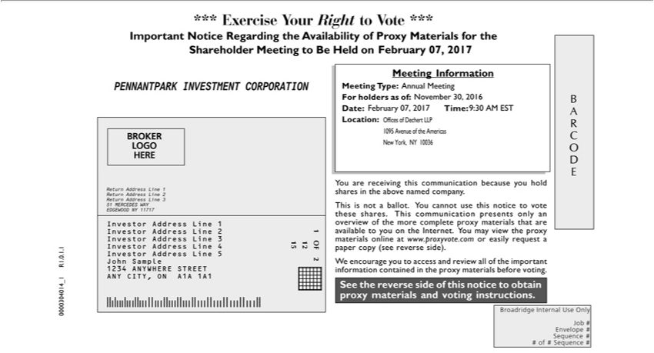

*** Exercise Your Right to Vote *** Important Notice Regarding the Availability of Proxy Materials for the Shareholder Meeting to Be Held on < February 07, 2017 PENNANTPARK INVESTMENT CORPORATION BROKER LOGO HERE Return Address Line 1 Return Address Line 2 Return Address Line 3 51 MERCEDES WA EDGEWOOD NY 11717 Investor Address Line 1 Investor Address Line21InvestorAddressLine3InvestorAddressLine41512OFInvestorAddressLine5JohnSample21234ANYWHERESTREETCITY,ONA1A1A1MeetingInformationMeetingType:Annual
Meeting For holders as of: November 30, 2016 Date: February 07, 2017^{This}ime: 9:30 AM EST Location: Offices of Dechert LLP 1095 ANYvenue of the Americas New York, NY 10036 You are receiving this
communication because you hold shares in the above named company. is not_{materials}ballot. You cannot use this notice to vote these shares. This communication presents only an overview of the more complete
proxy materials that are available to you_{contained}theInternet. You may view the proxy online at www.proxyvote.com or easily request_{materials}paper copy (see reverse side). We encourage you to access and
review all of the important information in the proxy materials before voting. See the reverse side of this notice to obtain proxy and voting instructions. B A R C O D E Broadridge Internal Use Only Job # Envelope # Sequence # # of # Sequence # 0000304014_1 R1.0.1.1

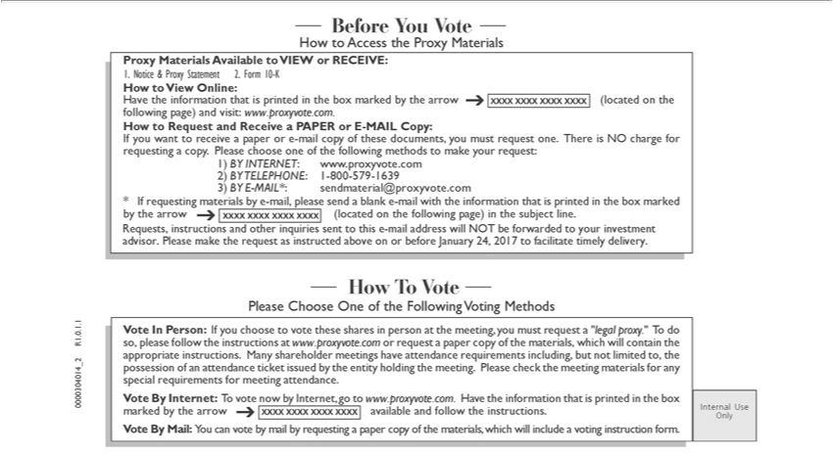

Before You Vote How to Access the Proxy Materials Proxy Materials Available to VIEW or RECEIVE: 1. Notice & Proxy |  |  |  | 2. Form 10-K How to View Online: Have the | that is printed in
the box marked by the arrow ? (located on the following page) and visit: www.proxyvote.com. How to Request and ReceiveStatementPAPER or E-MAIL Copy: If you want to receive a paperinformatione-mail copy of these
documents, you must request one. There is NO charge for requesting a copy. Please choose |  | of the following | to make your request: 1) BY INTERNET: www.proxyvote.com 2) BY TELEPHONE: 1-
800-579-1639 3) BY E-MAIL*: sendmaterial@proxyvote.com * If requesting materials by one-mail, please send a methodsblank-mail with the information that printed in the box marked by the arrow (located on the
following p ge) in the subject line. ? Requests, instructions and other inquiries sent to this |  | -mail address will NOT be forwarded to your investment advisor. Please make the request as instructed above on or
before | 24, 2017 to facilitate timely delivery. How T Vote Please Choose One of the Following Voting Methods Vote In Person: If you choose to vote these shares person at the meeting, you must
requestJanuary“legal proxy.” To do so, please follow the instructions at www.proxyvote.com or request a paper copy of the materials, which will contain the appropriate instructions. Many shareholder meetings have _{attendance} requirements including, but not limited to, the possession of an attendance ticket issued by the entity holding the meeting. Please check the meeting materials for any special requirements for meeting
. Vote By Internet: To vote now by Internet, go to www.proxyvote.com. Have the information that is printed in the box marked by the arrow ? available and follow the instructions. Vote By Mail: You can vote by mail by requesting a paper copy of the materials, which will include a voting instruction form. Internal Use Only 0000304014_2 R1.0.1.1

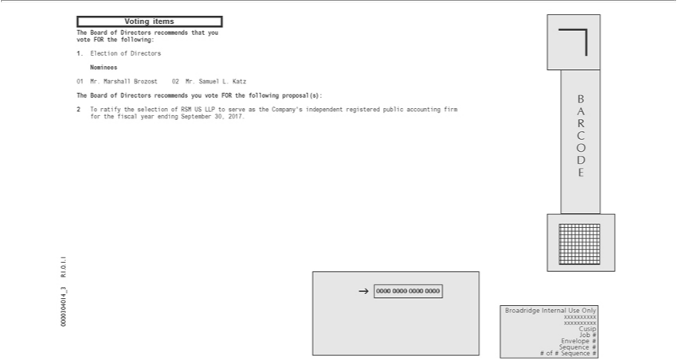

Voting items The Board of Directors _{recommends} that you vote FOR the following: 1. Election of _{Directors} Nominees 01 Mr. Marshall Brozost 02 Mr. Samuel L. Katz The Board of Directors recommends you

vote FOR the following proposal(s): 2 T ratify the selection of RSM US LLP to serve as the Company’ independent registered public accounting firm for the fiscal year ending September 30, 2017. 0000304014_3 R1.0.1.1 B A R C O D E Broadridge Internal Use Only xxxxxxxxxx xxxxxxxxxx Cusip Job # Envelope # Sequence # # of # Sequence #

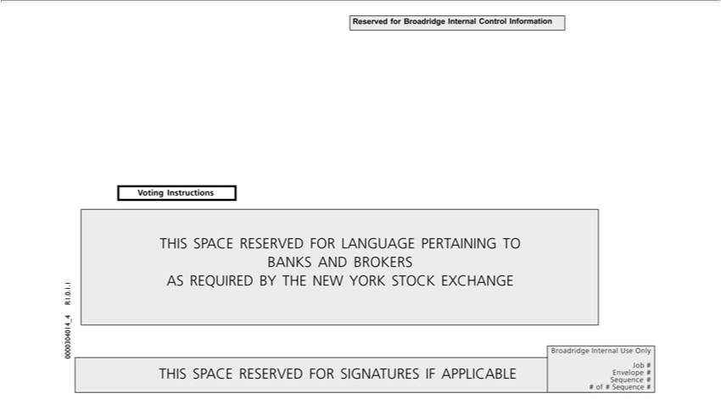

Reserved for Broadridge Internal Control Information Voting Instructions THIS SPACE RESERVED FOR LANGUAGE PERTAINING TO BANKS AND BROKERS AS REQUIRED BY THE NEW YORK STOCK EXCHANGE 0000304014_4 R1.0.1.1 THIS SPACE RESERVED FOR SIGNATURES IF APPLICABLE Broadridge Internal Use Only P99999-010 12 Job # Envelope # Sequence 15 # # of # Sequence

# OF##

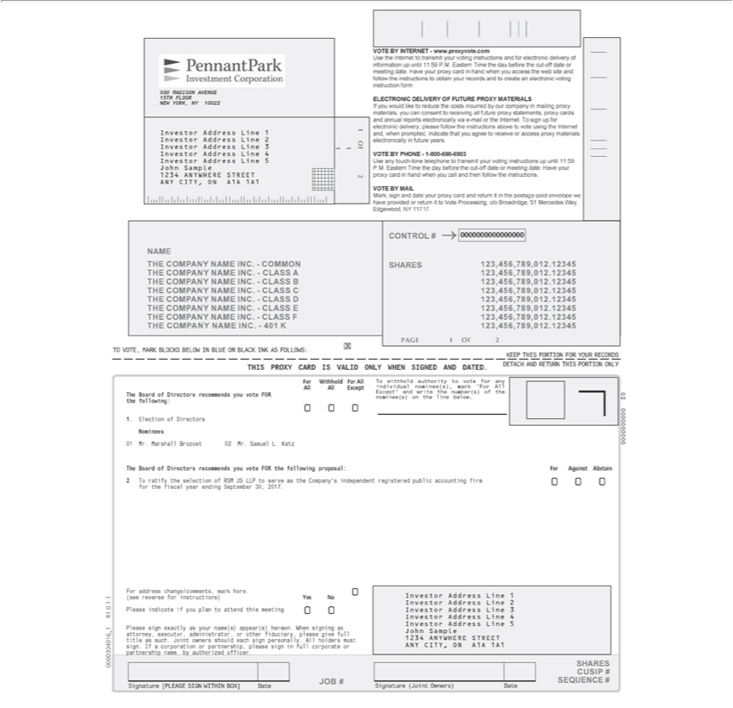

590 MADISON AVENUE 15TH FLOOR NEW YORK, NY 10022 Investor Address Line 1 Investor Address Line 2 Investor Address Line 3 Investor Address Line 4 Investor Address Line 5 John Sample 1234
ANYWHERE STREET ANY CITY, ON A1A 1A1 VOTE BY INTERNET—www.proxyvote.com Use the Internet to transmit your voting instructions and for electronic delivery of information up until 11:59
P.M. Eastern Time the day before the cut-off date or meeting date. Have your proxy card in hand when you access the web site and follow the |  |  | to obtain your records and to create an electronic voting
instruction form. ELECTRONIC DELIVERY OF FUTURE PROXY MATERIALS If you would like to reduce the costs incurred by our companyinstructionsmailing proxy materials, |  |  |  | can consent to receiving all
future proxy statements, proxy cards and annual reports electronically via -mail or the Internet. To sign up for electronic delivery, please follow the instructions above to vote youing the Internet and, when
prompted, indicate that you agree to receive or access proxy materials electronically in future years. VOTE BY PHONE—1-800-690-6903 Use any touch-tone telephone to transmit your voting instructions up
until 11:59 P.M. Eastern Time the day before the cut-off date or meeting date. Have your proxy card in hand when you call and then follow the instructions. VOTE BY MAIL Mark, sign and date your proxy card
and return it in the postage-paid envelope we have provided or return it to Vote Processing, c/o Broadridge, 51 Mercedes Way, Edgewood, NY 11717. NAME THE COMPANY NAME INC.—COMMON THE
OMPANY NAME INC.—CLASS A THE COMPANY NAME INC.—CLASS B THE COMPANY NAME INC.—CLASS C THE COMPANY NAME INC.—CLASS D THE COMPANY NAME INC.—
CLASS E THE COMPANY NAME INC.—CLASS F THE COMPANY NAME INC.—401 K CONTROL # ? SHARES |  | .12345 123,456,789,012.12345 123,456,789,012.12345
123,456,789,012.12345 123,456,789,012.12345 123,456,789,012.12345 123,456,789,012.12345 123,456,789,012.12345 123,456,789,012AGEOFxTO VOTE, MARK BLOCKS BELOW IN BLUE OR BLACK INK AS
FOLLOWS: KEEP THIS PORTION FOR YOUR RECORDS DETACH AND RETURN THIS PORTION ONLY THIS PROXY CARD IS VALID ONLY WHEN SIGNED AND DATED. For Withhold For All
To withhold authority to vote for any All All Except individual nominee(s), mark “For All Except” and write the number(s) of the The Board of Directors recommends you vote FOR 0 the following: nominee(s)
on the line | . 2 0 0 0 1. Election of Directors Nominees 0000000000 01 Mr. Marshall Brozost 02 Mr. Samuel L. Katz The Board of Directors recommends you vote FOR the following proposal: For Against
Abstain 2 Tbelowratify the selection of RSM US LLP to serve as the Company’ independent registered public accounting firm 0 0 0 for the fiscal year ending September 30, 2017. For address change/comments,
mark here. 0 Investor Address Line 1 (see reverse for instructions) Yes No Investor Address Line 2 R1.0.1.1 Please indicate if you plan |  | attend this meeting 0 0 Investor Address Line 3 Investor Address Line 4
should each sign personally. All holders must 1234 ANYWHERE STREET sign. If a corporation or partnership, please sign full corporateadministratorANY CITY, ON A1A 1A1 partnership name, by authorized
Investor Address Line 5 1 Please sign exactly as your name(s) appear(s) hereon. When signing as _ John Sample attorney, executor, |  |  | , or other fiduciary, please give full title as such. Joint owners
officer. 0000304016 SHARES CUSIP # JOB # SEQUENCE # Signature [PLEASE SIGN WITHIN BOX] Date Signature (Joint Owners) Date

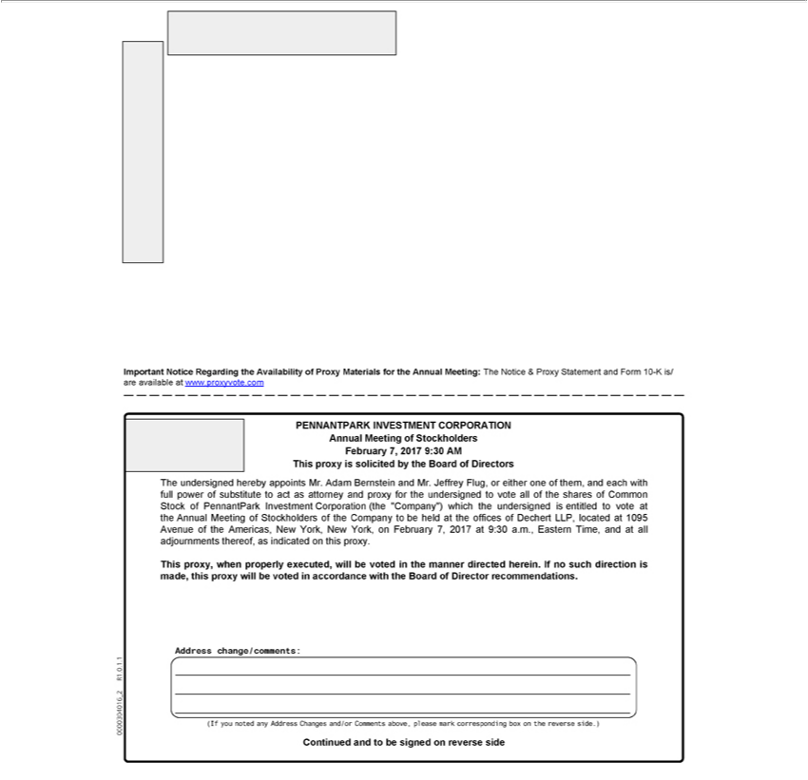

INVESTMENTmportantNotice Regarding the Availability of Proxy Materials for the Annual Meeting: The Notice & Proxy Statement and Form 10-K is/ are available at www.proxyvote.com PENNANTPARK
Mr. Jeffrey Flug,CORPORATIONoreitheroneofthem,AnnualandMeetingeachwithof fullStockholderspowerof substituteFebruary 7,to 2017actas9:30attorneyAM Thisand proxyproxy forissolicitedtheundersignedbytheBoardtovoteofallDirectorsofthesharesTheundersignedofCommonherebyStock ofappointsPennantParkMr.AdamInvestmentBernsteinCorporationand (the “Company”) which the undersigned is entitled to vote at the Annual Meeting of Stockholders of the Company to be held at the offices of Dechertexecuted,LLP located at 1095 Avenue of the Americas, New York,
directionNewYork,is onmade,Februarythisproxy7,2017willcorrespondingatbe9:30voteda.m.,accordanceEasternTime,withandtheatBoardalljournmentsofDirector thereof,recommendationsasindicated.reverseAddronthisss proxy.change/comments:Thisproxy, whenR1.0.1.1properly_20000304016will(If youbevotednotedinanytheAddressmanner Changesdirected herein.and/or If no such Comments above, please mark box on the reverse side.) Continued and to be signed side

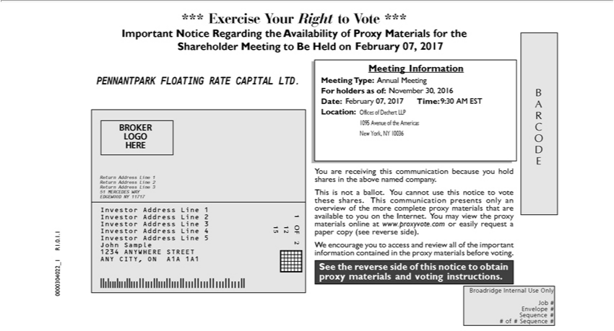

*** Exercise Your Right to Vote *** Important Notice Regarding the Availability of Proxy Materials for the Shareholder Meeting to Be Held on February 07, 2017 PENNANTPARK FLOATING RATE
CAPITAL LTD. BROKER LOGO HERE Return Address Line 1 Return Address Line 2 Return Address Line 3 51 MERCEDES WA EDGEWOOD NY | 1717 Investor Address Line 1 Investor Address Line 2
1 Investor Address Line 3 Investor Address Line 4 15 12 OF Investor Address Line 5 John Sample 2 1234 ANYWHERE STREET ANY CITY, ON A1A 1A1 0000304022_1 R1.0.1.1 Meeting Information
Meeting Type: Annual Meeting For holders as of: November 30, 2016 Date: February 07, 2017 Time: 9:30 AM EST Location: Offices of Dechert LLP 1095 Avenue of the Americas New York, NY 10036 You
are receiving this communic tion because you hold shares in the above named company. This is not ballot. You cannot use this notice to vote these shares. This communication presents only an overview of the
more complete proxy materials that are available to you the Internet. You may view the proxy materials online at www.proxyvote.com or easily request | paper copy (see reverse side). We encourage you to
access and review all of the important information contained in the proxy materials before voting. See the reverse side of this notice to obtain proxy materials and voting instructions. B A R C O D E Broadridge Internal Use Only Job # Envelope # Sequence # # of # Sequence #

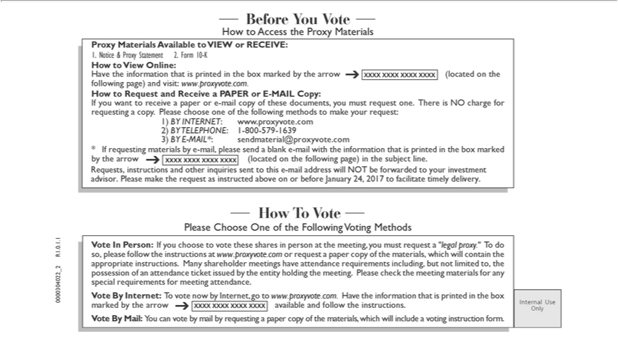

Before You Vote How to Access the Proxy Materials Proxy Materials Available to VIEW or RECEIVE: 1. Notice & Proxy |  |  |  | 2. Form 10-K How to View Online: Have the | that is printed in
the box marked by the arrow ? (located on the following page) and visit: www.proxyvote.com. How to Request and ReceiveStatementPAPER or E-MAIL Copy: If you want to receive a paperinformatione-mail copy of these
documents, you must request one. There is NO charge for requesting a copy. Please choose |  | of the following | to make your request: 1) BY INTERNET: www.proxyvote.com 2) BY TELEPHONE: 1-
800-579-1639 3) BY E-MAIL*: sendmaterial@proxyvote.com * If requesting materials by one-mail, please send a methodsblank-mail with the information that printed in the box marked by the arrow ? (located on the
following p ge) in the subject line. Requests, instructions and other inquiries sent to this e-mail address will NOT be forwarded to your investment advisor. Please make the request as instructed above on or
requestJanuary“legal proxy.” To do R1.0.1.1 so, please follow the instructions at www.proxyvote.com or request a paper copy of the materials, which will contain the appropriate instructions. Many shareholder
before | 24, 2017 to facilitate timely delivery. How To Vote Please Choose One of the Following Voting Methods Vote In Person: If you choose to vote these shares in person at the meeting, you must
meetings have attendance requirements including, but not limited to, the _ 2 possession of an attendance ticket issued by the entity holding the meeting. Please check the meeting materials for any special
requirements for meeting attendance. 0000304022 Vote By Internet: To vote now by Internet, go to www.proxyvote.com. Have the |  |  |  | that is printed in the box marked by the arrow available and follow
the instructions. Internal Use ? Only Vote By Mail: You can vote by mail by requesting a paper copy of the materials, which will includeinformationvoting instruction form.

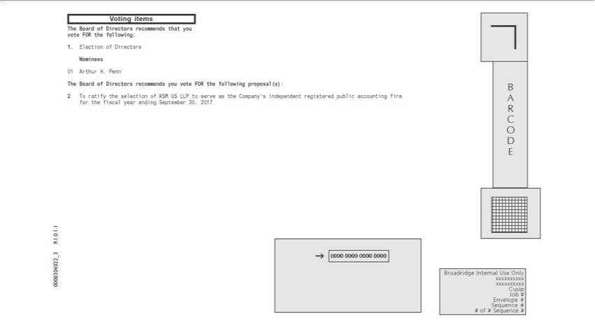

Voting items ^{The} Board of Directors recommends that you vote FOR the following: 1. Election of Directors Nominees 01 Arthur H. Penn The Board of Directors recommends you vote FOR the following
proposal(s): 2 o ratify the selection of RSM US LLP to serve as the Company’s independent registered public accounting firm for the fiscal year ending September 30, 2017. 0000304022_3 R1.0.1.1 B A R C O D E Broadridge Internal Use Only xxxxxxxxxx xxxxxxxxxx Cusip Job # Envelope # Sequence # # of # Sequence #

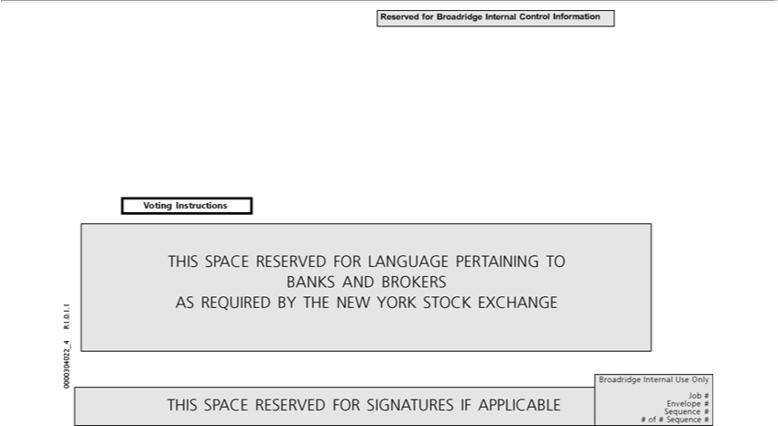

Reserved for Broadridge Internal Control Information Voting Instructions THIS SPACE RESERVED FOR LANGUAGE PERTAINING T^{FOR}BANKS AND BROKERS 1 . AS REQUIRED BY THE NEW
YORK STOCK EXCHANGE . 1 . 0 R1 _ 4 0000304022 Broadridge Internal Use Only P99999-010 12 Job # THIS SPACE RESERVED SIGNATURES IF APPLICABLE Envelope # Sequence 15 # # of # Sequence # OF##

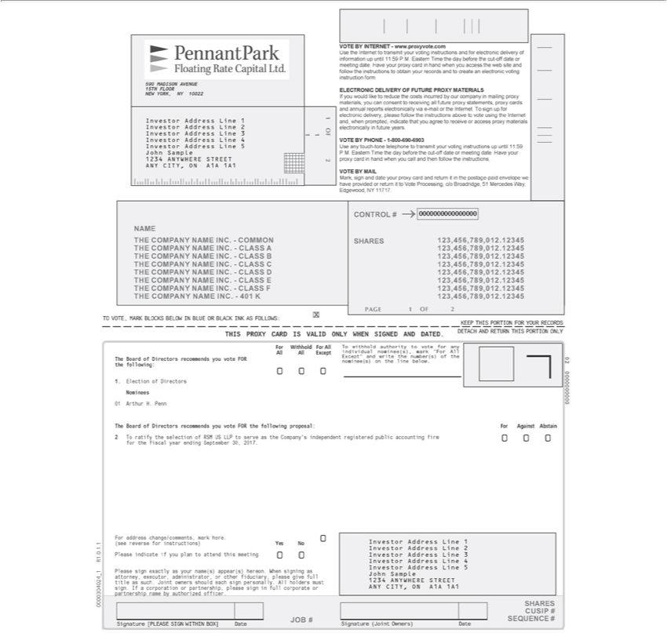

590 MADISON VENUE 15TH FLOOR NEW |  | NY 10022 1 Investor Address Line 1 Investor Address Line 2 Investor Address Line 3 1 1 OF Investor Address Line 4 Investor Address Line 5 John
Sample | ANYWHERE STREET 2 ANY CITYYORK,ON A1A 1A1 VOTE BY INTERNET—www.proxyvote.com Use the Internet to transmit your voting instructions and for electronic delivery of information
up until 12341:59 P.M. Eastern Time the day before the cut-off date or meeting date. Have your proxy card in hand when you access the web site and follow the |  |  |  | to obtain your records and to create an
electronic voting instruction form. ELECTRONIC DELIVERY OF FUTURE PROXY MATERIALS If you |  |  | like to reduce the costs incurred by our companyinstructionsmailing proxy materials, you can consent
to receiving all future proxy statements, proxy cards and annual reports electronically via -mail or the Internet.would sign up for electronic delivery, please follow the instructions above to vote using the Internet
and, when prompted, indicate that you agree to receive |  | access proxy materials electronically in future years. VOTE BY PHONE—1-800-690-6903 Use any touch-tone telephone to transmit your voting
instructions up until 11:59 P.M. Eastern Time the day before the cut-off date or meeting date. Have your proxy card in hand when you call and then follow the instructions. VOTE BY MAIL Mark, sign and date
your proxy card and return it in the postage-paid envelope we have provided or return it to Vote Processing, c/o Broadridge, 51 Mercedes Way, Edgewood, NY 11717. NAME THE COMPANY NAME INC.—
COMMON THE COMPANY NAME INC.—CLASS A THE COMPANY NAME INC.—CLASS B THE COMPANY NAME INC.—CLASS C THE COMPANY NAME INC.—CLASS D THE COMPANY
NAME INC.—CLASS E THE COMPANY NAME INC.—CLASS F THE COMPANY NAME INC.—401 K CONTROL # SHARES 123,456,789,012.12345 123,456,789,012.12345 123,456,789,012.12345
123,456,789,012.12345 123,456,789,012.12345 123,456,789,012.12345 123,456,789,012.12345 123,456,789,012.12345 AGE 1 OF 2 x TO VOTE, MARK BLOCKS BELOW IN BLUE OR BLACK INK AS
FOLLOWS: KEEP THIS PORTION FOR YOUR RECORDS DETACH AND RETURN THIS PORTION ONLY THIS PROXY CARD IS VALID ONLY WHEN SIGNED AND DATED. For Withhold For All
To withhold authority to vote for any All All Except individual nominee(s), mark “For All Except” and write the number(s) of the The Board of Directors recommends you vote FOR 0 the |  |  |  |  | nominee(s)
the line below. 2 0 0 0 1. Election of Directors |  | 0000000000 01 Arthur H. Penn The Board of Directors recommends you vote FOR the following proposal: For Against Abstainfollowing:2Tratify the
selection of RSM US LLP to serve as the Company’Nomineesindependent registered public accounting firm 0 0 0 for the fiscal year ending September 30, 2017. For address change/comments, mark here. 0 Investor
Address Line 1 (see reverse for instructions) Yes No Investor Address Line 2 R1.0.1.1 Please indicate if you plan to attend this meeting 0 0 Investor Address Line 3 Investor Address Line 4 Investor Address
Line 5 1 Please sign exactly as your name(s) appear(s) hereon. When signing as _ John Sample attorney, executor, |  |  | , or other fiduciary, please give full title as such. Joint owners should each sign
personally. All holders must 1234 ANYWHERE STREET sign. If a corporation or partnership, please sign in full corporateadministratorANY CITY, ON A1A 1A1 partnership name by authorized officer. 0000304024 SHARES CUSIP # JOB # SEQUENCE # Signature [PLEASE SIGN WITHIN BOX] Date Signature (Joint Owners) Date

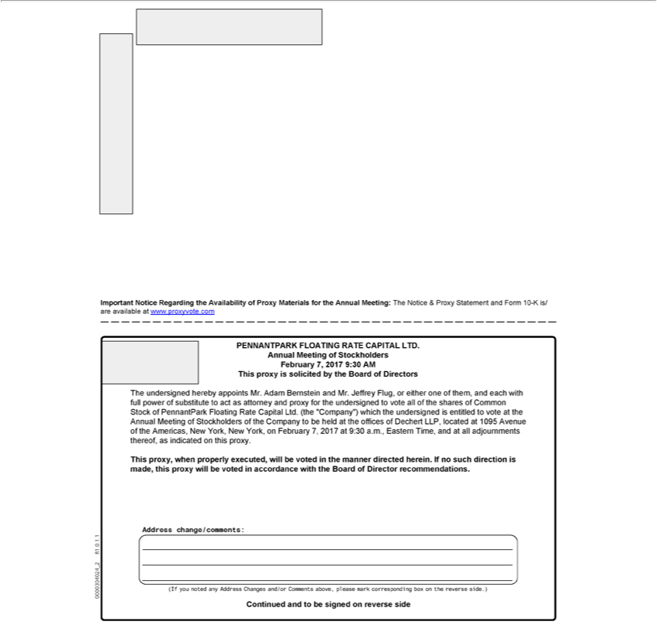

Important Notice Regarding the Availability of Proxy Materials for the Annual Meeting: The Notice & Proxy Statement and Form 10-K is/ are available at www.proxyvote.com PENNANTPARK FLOATING RATE CAPITAL LTD. Annual Meeting of Stockholders February 7, 2017 9:30 AM This proxy is solicited by the Board of Directors The undersigned hereby appoints Mr. Adam Bernstein and Mr. Jeffrey Flug, or either one of them, and each with full power of substitute to act as attorney and proxy for the undersigned to vote all of the shares of Common Stock of PennantPark Floating Rate Capital Ltd. (the “Company”) which the undersigned is entitled to vote at the Annual Meeting of Stockholders of the Company to be held at the offices of Dechert LLP, located at 1095 Avenue of the Americas, New York, New directionYork, February 7, 2017 at 9:30 a.m., Eastern Time, and at all adjournments thereof,recommendationsasindicated this proxy. This proxy, when properly executed, will be voted in the manner directed herein. If no suchismade,thisproxywillcorrespondingbevotedaccordancewiththeBoardofDirector.reverseAddrsschange/comments:R1.0.1.1_20000304024(IfyounotedanyAddressChangesand/orCommentsabove,pleasemarkboxonthereverseside.)Continuedandtobesignedside

